

Colonial First State -

Virtual Data Center – As-Built and Operations Guide - P.WP1.DL21

April 2022

# **Document Overview**

|  |  |
| --- | --- |
| **Project Title** | CFS Core IT Phase 2.1 |
| **Author** | Avanade:  Ben Letham  ATCP:  Rey San Juan  Alyze Panganiban  Mark Joseph Muyano |
| **Reviewer** | John Stannard |
| **Current Version** | Release 2.1 |
| **File Name** | P.WP1.DL21 - CFS - Virtual Data Center - As-Built and Operations Guide.docx |
| **Publication Date** | 24/06/2022 |

## Revision History

|  |  |  |  |
| --- | --- | --- | --- |
| Version | Date | Author | Changes |
| 0.1 | 16/05/2022 | ATCP | Initial Version |
| 2.1 | 24/06/2022 | ATCP, Kevin | Added content.  Updated version numbers.  Submitted to client for endorsement, file sent as “P.WP1.DL21 - CFS - Virtual Data Center - As-Built and Operations Guide-FINAL-v2.1.docx” |
|  |  |  |  |
|  |  |  |  |
|  |  |  |  |
|  |  |  |  |

Table of Contents

**1** **Document Overview** ii

**1.1** Revision History ii

**2** **Introduction** 6

3 Phase 1 – Platform-Core 7

**3.1** Initial Setup Tasks 13

3.1.1 Elevate access to manage all subscriptions and management groups 13

3.1.2 Create service connection for tenant root group 15

3.1.3 Set role assignment to service account as owner of root “/” scope 16

3.1.4 Set role assignment to service account as owner to billing enrolment account 17

3.1.5 Set enrolment account role assignment – PUT 18

3.1.6 Request for parallelism request for Azure DevOps 20

**3.2** Platform-Core deployment 21

3.2.1 Management Group and Subscription 21

3.2.2 Service Principal 24

3.2.3 Service Connection 27

3.2.4 Platform-core (BICEP) 27

3.2.5 Platform-core (BICEP/ YAML / Azure DEVOPS) 45

3.2.6 Additional Requests - VM Deployment 46

3.2.7 Naming standards 50

3.2.8 Commit, Review and PR Code 55

3.2.9 Maintenance 57

4 Phase 2.1 – Landing Zone 58

**4.1** Initial Setup Tasks 62

4.1.1 Management Group and Subscription 62

4.1.2 Service Principal 65

4.1.3 Service Connection 67

**4.2** Landing Zone deployment 68

4.2.1 How to deploy Landing Zone 68

4.2.2 Role Assignment to Landing Zone Subscription 71

4.2.3 Route Table and Network Security Group 72

4.2.4 Virtual Network 72

4.2.5 NSG Rules 73

4.2.6 UDR – Route Rules 74

4.2.7 Storage Account 74

4.2.8 Recovery Service Vault 75

4.2.9 Key Vault 75

4.2.10 Network Peering 76

5 Phase 2.1 - Common Requests 78

**5.1** VM Build Requests 78

5.1.1 Preparing parameter files 78

5.1.2 Pipeline deployment 79

5.1.3 Deployment Monitoring 81

5.1.4 Validation 82

**5.2** NSG and Route Table 82

5.2.1 Preparing parameter files 82

5.2.2 Pipeline deployment 83

5.2.3 Deployment Monitoring 85

5.2.4 Validation 86

**5.3** NSG rules 86

5.3.1 Preparing parameter files 86

5.3.2 Pipeline deployment 87

5.3.3 Deployment Monitoring 89

5.3.4 Validation 90

6 Phase 2.1 – Azure Service (Application) 91

**6.1** Azure App Service Environment 91

6.1.1 Key Components 91

6.1.2 Task Details 91

6.1.3 Parameter File 92

6.1.4 Deployment File 92

6.1.5 Module File 92

6.1.6 ADO Deployment 92

**6.2** Azure API-Management 92

6.2.1 Key Components 93

6.2.2 Task Details 93

6.2.3 Parameter File 93

6.2.4 Deployment File 93

6.2.5 Module File 93

6.2.6 ADO Deployment 94

**6.3** Azure Application gateway/Web Application Firewall 94

6.3.1 Key Components 94

6.3.2 Task Details 95

6.3.3 Deployment File 96

6.3.4 Module File 96

6.3.5 ADO Deployment 96

**6.4** Azure Container Registry 96

6.4.1 Key Components 97

**6.4.2** **Tasks Details** 97

6.4.3 Parameter File 97

6.4.4 Deployment File 97

6.4.5 Module File 97

6.4.6 ADO Deployment 97

**6.5** Azure Data Factory 98

**6.5.1** **Key Components** 98

**6.5.2** **Tasks Details** 98

6.5.3 Parameter File: cfs-application-platform-common\CFS.Application.Platform.Common\bicep-templates\deployment\03-Application-Services\parameter-files\deploy-ADF\deploy-ADF-param.json 99

6.5.4 Deployment File: cfs-application-platform-common\CFS.Application.Platform.Common\bicep-templates\deployment\03-Application-Services\deployment-templates\azureContainerRegistry.bicep 99

6.5.5 Module File: 99

6.5.6 ADO Deployment 99

**6.6** Azure SQL IaaS 99

6.6.1 Key Components 100

6.6.2 Task Details 100

6.6.3 Parameter File 100

6.6.4 Deployment File 100

6.6.5 Module File 100

6.6.6 ADO Deployment 100

**6.7** Azure SQL PaaS (Single Database and Elastic Pools) 101

6.7.1 Key Components 101

6.7.2 Task Details 101

6.7.3 Parameter File 102

6.7.4 Deployment File 102

6.7.5 Module File 102

6.7.6 ADO Deployment 102

7 Phase 2.1 – IaaS OS patching Solution 104

**7.1** Azure Automation Account 104

**7.2** WSUS 105

7.2.1 GPO Settings 106

7.2.2 WSUS Settings 108

# **Introduction**

**Purpose**

The scope of this document is to provide details of the Phase 1 and Phase 2.1 CFS Core IT – VDC Built. This document outlines the overall As-Build view and Ops Guide for CFS Core IT – VDC Stream.

**Guidelines**

Images and screenshots have been taken from a mixture of non-production and production instances. In almost all cases, production and non-production instances are configured in the same/equivalent way.

# Phase 1 – Platform-Core

Platform core consists of (4) four subscriptions, Connectivity, Identity, Operations and Security. The following table lists the component names and specifications for the Platform Core.

**Connectivity**

|  |  |  |  |  |  |
| --- | --- | --- | --- | --- | --- |
| **Resources** | | **Non-Production** | | **Production** | |
| **EDC** | **SDC** | **EDC** | **SDC** |
| **Governance** | **Parent Management Group Name** | CFSCoNonProd | | CFSCoProd | |
| **Sub Management Group Name** | Platform-Core | | LandingZone | |
| **Management Group Name** | mg-np-connectivity-001 | | mg-prd-connectivity-001 | |
| **Subscription** | subsc-np-connectivity-001 | | subsc-prd-connectivity-001 | |
| **Service Connections** | sc-subsc-np-connectivity-001 | | sc-subsc-prd-connectivity-001 | |
| **Service Principal** | sp-subsc-np-connectivity-001 | | sp-subsc-prd-connectivity-001 | |
| **Owner Group** | SG-AA-build-conn-owner | | SG-AA-build-conn-owner | |
| **Contributor Group** | SG-AA-build-conn-contributor | | SG-AA-build-conn-contributor | |
| **Reader Group** | SG-AA-build-conn-reader | | SG-AA-build-conn-reader | |
| **Network** | **Resource Group** | rg-np-edc-hub-netw-001 | rg-np-sdc-hub-netw-001 | rg-prd-edc-hub-netw-001 | rg-prd-sdc-hub-netw-001 |
| **VNET Name** | vnet-np-edc-hub-001 | vnet-np-sdc-hub-001 | vnet-prd-edc-hub-001 | vnet-prd-sdc-hub-001 |
| **CIDR Allocation** | 10.40.1.0/24 | 10.60.1.0/24 | 10.20.0.0/23 | 10.30.0.0/23 |
| **DNS Servers** | 10.40.1.68 | 10.60.1.68 | 10.20.0.68 | 10.30.0.68 |
| **Subnet Name** | GatewaySubnet | GatewaySubnet | GatewaySubnet | GatewaySubnet |
| **Subnet Address Prefix** | 10.40.1.0/26 | 10.60.1.0/26 | 10.20.0.0/26 | 10.30.0.0/26 |
| **Subnet Name** | AzureFirewallSubnet | AzureFirewallSubnet | AzureFirewallSubnet | AzureFirewallSubnet |
| **Subnet Address Prefix** | 10.40.1.64/26 | 10.60.1.64/26 | 10.20.0.64/26 | AzureFirewallSubnet |
| **Subnet Name** | AzureBastionSubnet | AzureBastionSubnet | AzureBastionSubnet | AzureBastionSubnet |
| **Subnet Address Prefix** | 10.40.1.128/26 | 10.60.1.128/26 | 10.20.0.128/26 | 10.30.0.128/26 |
| **Subnet Name** | sub-np-edc-mgmt-001 | sub-np-sdc-mgmt-001 | sub-prd-edc-mgmt-001 | sub-prd-sdc-mgmt-001 |
| **Subnet Address Prefix** | 10.40.1.192/26 | 10.60.1.192/26 | 10.20.1.0/24 | 10.30.1.0/24 |
| **Network Security Group** | nsg-np-edc-mgmt-001  nsg-AzureBastionSubnet | nsg-np-sdc-mgmt-001  nsg-AzureBastionSubnet | nsg-prd-edc-mgmt-001  nsg-AzureBastionSubnet | nsg-prd-sdc-mgmt-001  nsg-AzureBastionSubnet |
| **Route Table Name** | rt-GatewaySubnet  rt-AzureFirewallSubnet  rt-np-edc-mgmt-001 | rt-GatewaySubnet  rt-AzureFirewallSubnet  rt-np-sdc-mgmt-001 | rt-GatewaySubnet  rt-AzureFirewallSubnet  rt-prd-edc-mgmt-001 | rt-GatewaySubnet  rt-AzureFirewallSubnet  rt-prd-sdc-mgmt-001 |
| **Storage** | **Resource Group** | rg-np-edc-hub-stor-001 | rg-np-sdc-hub-stor-001 | rg-prd-edc-hub-stor-001 | rg-prd-sdc-hub-stor-001 |
| **Storage Account Name** | stonpedchub004 | stonpsdchub004 | stoprdedchub001 | stoprdsdchub001 |
| **Storage Account Type** | StorageV2 | StorageV2 | StorageV2 | StorageV2 |
| **RSV** | **Resource Group** | N/A | N/A | N/A | N/A |
| **Recovery Service Vault** | N/A | N/A | N/A | N/A |
| **Key Vault** | **Resource Group** | rg-np-edc-hub-kv-001 | rg-np-sdc-hub-kv-001 | rg-prd-edc-hub-kv-001 | rg-prd-sdc-hub-kv-001 |
| **Key Vault Name** | kv-np-edc-hub-001 | kv-np-sdc-hub-001 | kv-prd-edc-hub-001 | kv-prd-sdc-hub-001 |

**Identity**

|  |  |  |  |  |  |
| --- | --- | --- | --- | --- | --- |
| **Resources** | | **Non-Production** | | **Production** | |
| **EDC** | **SDC** | **EDC** | **SDC** |
| **Governance** | **Parent Management Group Name** | CFSCoNonProd | | CFSCoProd | |
| **Sub Management Group Name** | Platform-Core | | Platform-Core | |
| **Management Group Name** | mg-np-identity-001 | | mg-prd-identity-001 | |
| **Subscription** | subsc-np-identity-001 | | subsc-prd-identity-001 | |
| **Service Connections** | sc-subsc-np-identity-001 | | sc-subsc-prd-identity-001 | |
| **Service Principal** | sp-subsc-np-identity-001 | | sp-subsc-prd-identity-001 | |
| **Owner Group** | SG-AA-build-iden-owner | | SG-AA-build-iden-owner | |
| **Contributor Group** | SG-AA-build-iden-contributor | | SG-AA-build-iden-contributor | |
| **Reader Group** | SG-AA-build-iden-reader | | SG-AA-build-iden-reader | |
| **Network** | **Resource Group** | rg-np-edc-iden-netw-001 | rg-np-sdc-iden-netw-001 | rg-prd-edc-iden-netw-001 | rg-prd-sdc-iden-netw-001 |
| **VNET Name** | vnet-np-edc-iden-001 | vnet-np-sdc-iden-001 | vnet-prd-edc-identity-001 | vnet-prd-sdc-identity-001 |
| **CIDR Allocation** | 10.40.2.0/24 | 10.60.2.0/24 | 10.20.2.0/24 | 10.30.2.0/24 |
| **DNS Servers** | 10.40.1.68 | 10.60.1.68 | 10.20.0.68 | 10.30.0.68 |
| **Subnet Name** | sub-np-edc-identity-001 | sub-np-sdc-identity-001 | sub-prd-edc-identity-001 | sub-prd-sdc-identity-001 |
| **Subnet Address Prefix** | 10.40.2.0/25 | 10.60.2.0/25 | 10.20.2.0/25 | 10.30.2.0/25 |
| **Subnet Name** | sub-np-edc-identity-002 | sub-np-sdc-identity-002 | sub-prd-edc-identity-002 | sub-prd-sdc-identity-002 |
| **Subnet Address Prefix** | 10.40.2.128/25 | 10.60.2.128/25 | 10.20.2.128/25 | 10.30.2.128/25 |
| **Network Security Group** | nsg-np-edc-identity-001  nsg-np-edc-identity-002 | nsg-np-sdc-identity-001  nsg-np-sdc-identity-002 | nsg-prd-edc-identity-001  nsg-prd-edc-identity-002 | nsg-prd-sdc-identity-001  nsg-prd-sdc-identity-002 |
| **Route Table Name** | rt-np-edc-identity-001  rt-np-edc-identity-002 | rt-np-sdc-identity-001  rt-np-sdc-identity-002 | rt-prd-edc-identity-001  rt-prd-edc-identity-002 | rt-prd-sdc-identity-001  rt-prd-sdc-identity-002 |
| **Storage** | **Resource Group** | rg-np-edc-iden-stor-001 | rg-np-sdc-iden-stor-001 | rg-prd-edc-iden-stor-001 | rg-prd-sdc-iden-stor-001 |
| **Storage Account Name** | stonpedciden001 | stonpsdciden001 | stoprdedciden001 | stoprdsdciden001 |
| **Storage Account Type** | StorageV2 | StorageV2 | StorageV2 | StorageV2 |
| **RSV** | **Resource Group** | rg-np-edc-iden-rsv-001 | rg-np-sdc-iden-rsv-001 | rg-prd-edc-iden-rsv-001 | rg-prd-sdc-iden-rsv-001 |
| **Recovery Service Vault** | rsv-np-edc-identity-001 | rsv-np-sdc-identity-001 | rsv-prd-edc-identity-001 | rsv-prd-sdc-identity-001 |
| **Key Vault** | **Resource Group** | rg-np-edc-iden-kv-001 | rg-np-sdc-iden-kv-001 | rg-prd-edc-iden-kv-001 | rg-prd-sdc-iden-kv-001 |
| **Key Vault Name** | kv-np-edc-identity-001 | kv-np-sdc-identity-001 | kv-prd-edc-identity-001 | kv-prd-sdc-identity-001 |

**Operations**

|  |  |  |  |  |  |
| --- | --- | --- | --- | --- | --- |
| **Resources** | | **Non-Production** | | **Production** | |
| **EDC** | **SDC** | **EDC** | **SDC** |
| **Governance** | **Parent Management Group Name** | CFSCoNonProd | | CFSCoProd | |
| **Sub Management Group Name** | Platform-Core | | Platform-Core | |
| **Management Group Name** | mg-np-operations-001 | | mg-prd-operations-001 | |
| **Subscription** | subsc-np-operations-001 | | subsc-prd-operations-001 | |
| **Service Connections** | sc-subsc-np-operations-001 | | sc-subsc-prd-operations-001 | |
| **Service Principal** | sp-subsc-np-operations-001 | | sp-subsc-prd-operations-001 | |
| **Owner Group** | SG-AA-build-ops-owner | | SG-AA-build-ops-owner | |
| **Contributor Group** | SG-AA-build-ops-contributor | | SG-AA-build-ops-contributor | |
| **Reader Group** | SG-AA-build-ops-reader | | SG-AA-build-ops-reader | |
| **Network** | **Resource Group** | rg-np-edc-oper-netw-001 | rg-np-sdc-oper-netw-001 | rg-prd-edc-oper-netw-001 | rg-prd-sdc-oper-netw-001 |
| **VNET Name** | vnet-np-edc-oper-001 | vnet-np-sdc-oper-001 | vnet-prd-edc-operations-001 | vnet-prd-sdc-operations-001 |
| **CIDR Allocation** | 10.40.4.0/24 | 10.60.4.0/24 | 10.20.128.0/17 | 10.30.128.0/17 |
| **DNS Servers** | 10.40.1.68 | 10.60.1.68 | 10.20.0.68 | 10.30.0.68 |
| **Subnet Name** | sub-np-edc-operations-001 | sub-np-sdc-operations-001 | sub-prd-edc-operations-001 | sub-prd-sdc-operations-001 |
| **Subnet Address Prefix** | 10.40.4.0/25 | 10.60.4.0/25 | 10.20.128.0/23 | 10.30.128.0/23 |
| **Subnet Name** | sub-np-edc-operations-002 | sub-np-sdc-operations-002 | sub-prd-edc-operations-002 | sub-prd-sdc-operations-002 |
| **Subnet Address Prefix** | 10.40.4.128/25 | 10.60.4.128/25 | 10.20.130.0/23 | 10.30.130.0/23 |
| **Network Security Group** | nsg-np-edc-operations-001  nsg-np-edc-operations-002 | nsg-np-sdc-operations-001  nsg-np-sdc-operations-002 | nsg-prd-edc-operations-001  nsg-prd-edc-operations-002 | nsg-prd-sdc-operations-001  nsg-prd-sdc-operations-002 |
| **Route Table Name** | rt-np-edc-operations-001  rt-np-edc-operations-002 | rt-np-sdc-operations-001  rt-np-sdc-operations-002 | rt-prd-edc-operations-001  rt-prd-edc-operations-002 | rt-prd-sdc-operations-001  rt-prd-sdc-operations-002 |
| **Storage** | **Resource Group** | N/A | N/A | N/A | N/A |
| **Storage Account Name** | N/A | N/A | N/A | N/A |
| **Storage Account Type** | N/A | N/A | N/A | N/A |
| **RSV** | **Resource Group** | N/A | N/A | N/A | N/A |
| **Recovery Service Vault** | N/A | N/A | N/A | N/A |
| **Key Vault** | **Resource Group** | N/A | N/A | N/A | N/A |
| **Key Vault Name** | N/A | N/A | N/A | N/A |

**Security**

|  |  |  |  |  |  |
| --- | --- | --- | --- | --- | --- |
| **Resources** | | **Non-Production** | | **Production** | |
| **EDC** | **SDC** | **EDC** | **SDC** |
| **Governance** | **Parent Management Group Name** | CFSCoNonProd | | CFSCoProd | |
| **Sub Management Group Name** | Platform-Core | | Platform-Core | |
| **Management Group Name** | mg-np-security-001 | | mg-prd-security-001 | |
| **Subscription** | subsc-np-security-001 | | subsc-prd-security-001 | |
| **Service Connections** | sc-subsc-np-security-001 | | sc-subsc-prd-security-001 | |
| **Service Principal** | sp-subsc-np-security-001 | | sp-subsc-prd-security-001 | |
| **Owner Group** | SG-AA-build-sec-owner | | SG-AA-build-sec-owner | |
| **Contributor Group** | SG-AA-build-sec-contributor | | SG-AA-build-sec-contributor | |
| **Reader Group** | SG-AA-build-sec-reader | | SG-AA-build-sec-reader | |
| **Network** | **Resource Group** | rg-np-edc-sec-netw-001 | rg-np-sdc-sec-netw-001 | rg-prd-edc-sec-netw-001 | rg-prd-sdc-sec-netw-001 |
| **VNET Name** | vnet-np-edc-sec-001 | vnet-np-sdc-sec-001 | vnet-prd-edc-security-001 | vnet-prd-sdc-security-001 |
| **CIDR Allocation** | 10.40.3.0/24 | 10.60.3.0/24 | 10.20.3.0/24 | 10.30.3.0/24 |
| **DNS Servers** | 10.40.1.68 | 10.60.1.68 | 10.20.0.68 | 10.30.0.68 |
| **Subnet Name** | sub-np-edc-security-001 | sub-np-sdc-security-001 | sub-prd-edc-security-001 | sub-prd-sdc-security-001 |
| **Subnet Address Prefix** | 10.40.3.0/25 | 10.60.3.0/25 | 10.20.3.0/25 | 10.30.3.0/25 |
| **Subnet Name** | sub-np-edc-security-002 | sub-np-sdc-security-002 | sub-prd-edc-security-002 | sub-prd-sdc-security-002 |
| **Subnet Address Prefix** | 10.40.3.128/25 | 10.60.3.128/25 | 10.20.3.128/25 | 10.30.3.128/25 |
| **Network Security Group** | nsg-np-edc-security-001  nsg-np-edc-security-002 | nsg-np-sdc-security-001  nsg-np-sdc-security-002 | nsg-prd-edc-security-001  nsg-prd-edc-security-002 | nsg-prd-sdc-security-001  nsg-prd-sdc-security-002 |
| **Route Table Name** | rt-np-edc-security-001  rt-np-edc-security-002 | rt-np-sdc-security-001  rt-np-sdc-security-002 | rt-prd-edc-security-001  rt-prd-edc-security-002 | rt-prd-sdc-security-001  rt-prd-sdc-security-002 |
| **Storage** | **Resource Group** | rg-np-edc-sec-stor-001 | rg-np-sdc-sec-stor-001 | rg-prd-edc-sec-stor-001 | rg-prd-sdc-sec-stor-001 |
| **Storage Account Name** | stonpedcdiagnlogs003 | stonpsdcdiagnlogs003 | stoprdedcdiagnlogs001 | stoprdsdcdiagnlogs001 |
| **Storage Account Type** | StorageV2 | StorageV2 | StorageV2 | StorageV2 |
| **RSV** | **Resource Group** | N/A | N/A | N/A | N/A |
| **Recovery Service Vault** | N/A | N/A | N/A | N/A |
| **Key Vault** | **Resource Group** | N/A | N/A | N/A | N/A |
| **Key Vault Name** | N/A | N/A | N/A | N/A |

## Initial Setup Tasks

This section of the document lists the tasks that must be performed before the creation of Virtual Data Center Landing Zones in Non-production and Production environment. This is a combination of tasks implemented in Azure Portal and Azure DevOps Portal. Most of the tasks are done manually that used privilege account (such as CFS Service Account). Some of these tasks may also need to be performed again; for example, if new subscription and management group will be required to be created deploy New-Subscription-Pipeline task will be required.

### Elevate access to manage all subscriptions and management groups

As a Global Administrator in Azure Active Directory (Azure AD), you might not have access to all subscriptions and management groups in your directory. This section will describe the ways that you can elevate your access to all subscriptions and management groups.

**Prerequisites:**

* Azure Portal access (Service Account or Privilege Account)

As presented on the screenshot below, even though the user is logged in using the CFS Service Account user, there is a prompt that “You are not authorized to view this Management Group” in Tenant Root Group.

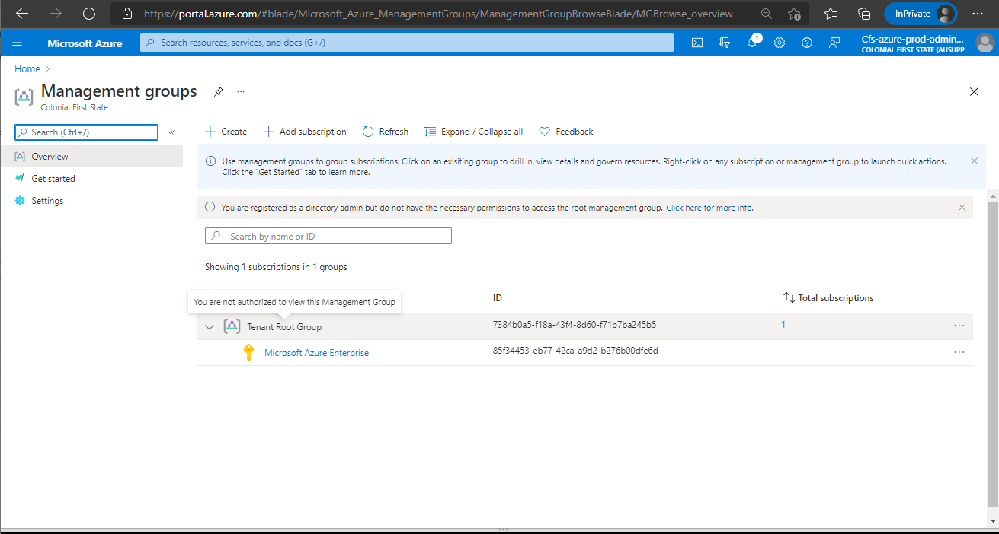

|  |  |
| --- | --- |
|  | ***Important Note***  This is a one-time configuration required for newly created tenant. During Phase 1, this was only encountered in CFS Production Tenant and was configured using CFS Service Account: Cfs-azure-prod-admin@ausupprod.onmicrosoft.com |

Reference:[Elevate access to manage all Azure subscriptions and management groups | Microsoft Docs](https://docs.microsoft.com/en-us/azure/role-based-access-control/elevate-access-global-admin)

1. In **Azure Active Directory**, Under **Manage**, select **Properties**
2. Under **Access management for Azure resources**, select the toggle to **Yes**.
3. Click **Save** to save settings
4. Sign out and refresh access
5. Expected output: CFS Account will be User Access Administrator of Tenant Root Group

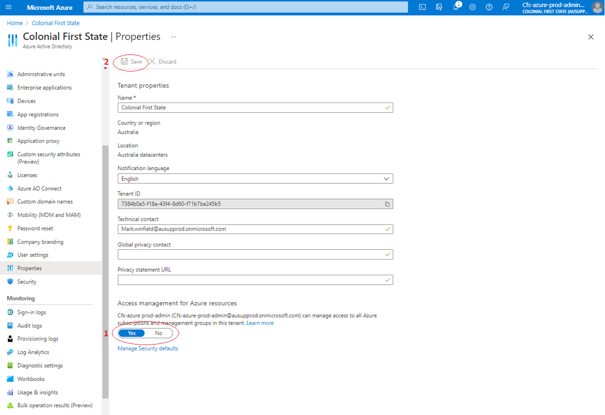

As a result, CFS-azure-prod-admin was given a User Access Administrator role assignment in Tenant Root Group.

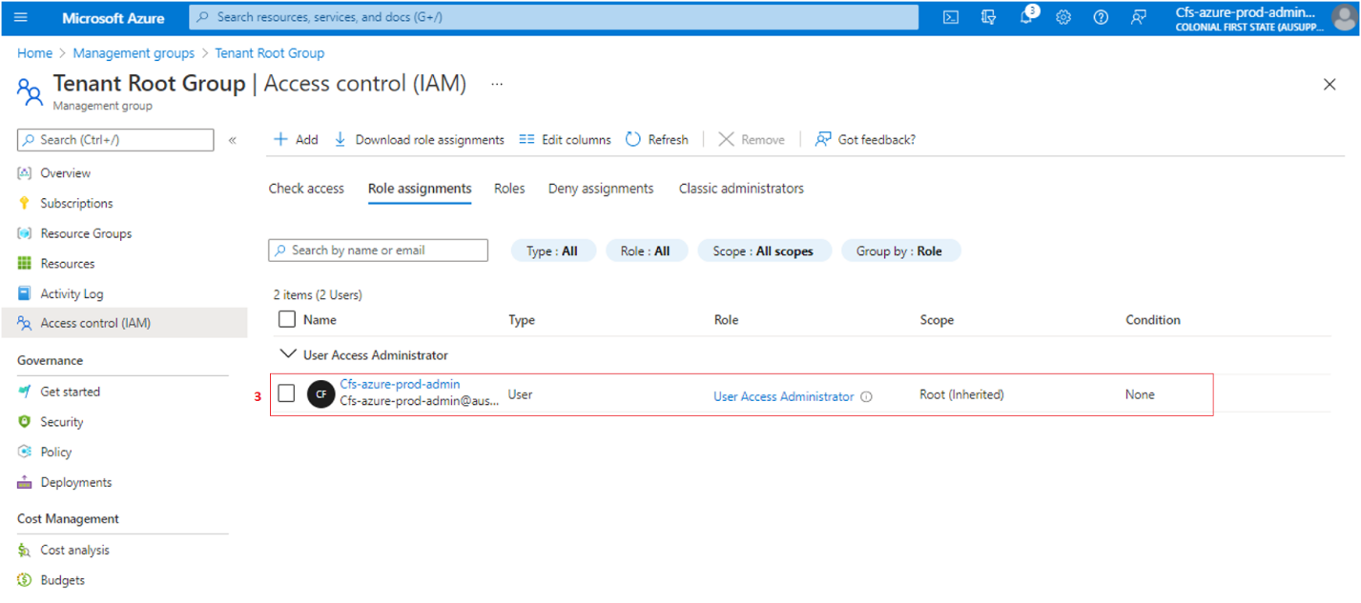

### Create service connection for tenant root group

A service connection enables you to connect to customer tenants to execute tasks in a job. CFS uses a service connection to connect to subscription and run the tasks in azure pipeline.

This will section guide you on how to create a service connection for tenant root group that will be used for creation of new management groups and subscriptions.

**Prerequisites:**

* CFS Service Account or any user that has User Access Administrator Role to Tenant Root Group
* Access to Azure DevOps Portal and Azure Portal

|  |  |
| --- | --- |
|  | ***Important Note***  *This resolution steps were done using CFS Azure Service Account:* Cfs-azure-nonprod-admin@ausupnonp.onmicrosoft.com  Cfs-azure-prod-admin@ausupprod.onmicrosoft.com |

1. In Azure DevOps Portal, Go to **Project Settings**,Under **Pipelines,** select **Service connections**
2. Select **Create service connection**
3. Under **New service connection,** select **Azure Resource Manager,** click **Next**
4. Under Authentication method, select **Service principal (automatic)**, click **Next**
5. In **Scope level,** select **Management Group**
6. In **Management Group drop-down,** select **Tenant Root Group**
7. In **Details, Service connection name:** input*sc-<environment>-tenant-root-group*
8. Click **Save**
9. Under **Access management for Azure resources**, select the toggle to **Yes**.
10. Click **Save** to save settings

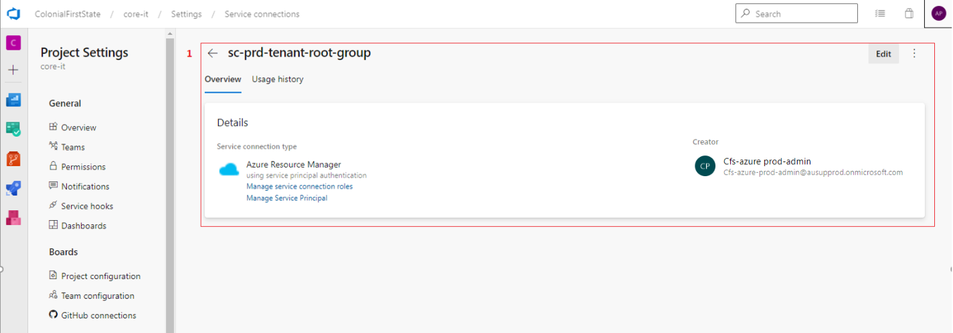

For validation:

1. Click **Manage Service Principal** and page will be redirected to Azure Portal > App Registrations
2. Go to Management Group > Tenant Root Group
3. Access control (IAM) > Role assignments
4. Validate the App Registrations is Owner of the Tenant Root Group

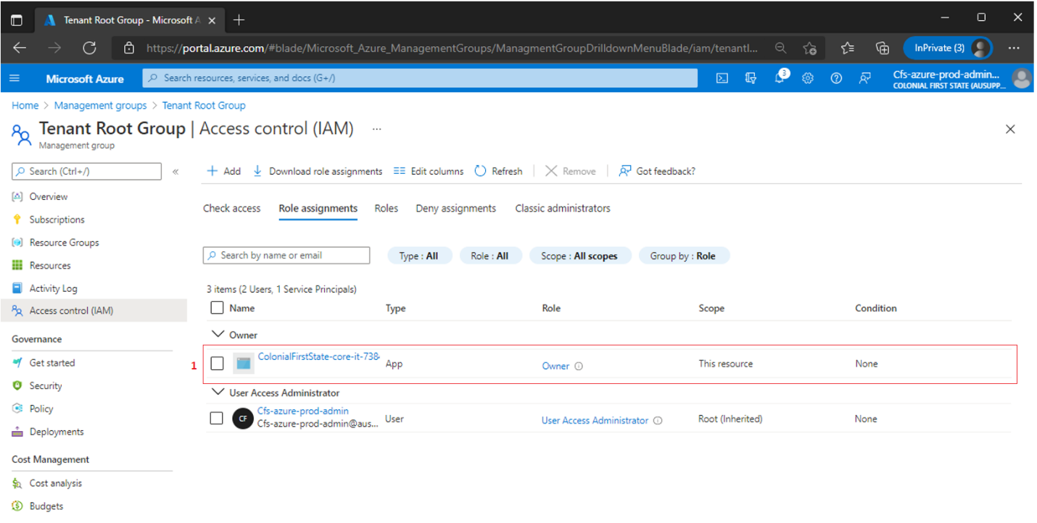

### Set role assignment to service account as owner of root “/” scope

Azure role-based access control (Azure RBAC) is the authorization system used to manage access to Azure Resources. To grant access, roles should be assigned to users, groups, service principal or managed identities at a particular scope.

Assigning owner role at “/” or root scope to the service account is requirement to user that will create the subscriptions and management groups. This section will provide guidelines on how to assign owner role to “/” root in the service account.

**Prerequisites:**

* CFS Service Account or any user that has User Access Administrator Role to Tenant Root Group
* Access to Azure DevOps Portal and Azure Portal
* Object ID of the tenant root group service principal
* Access to Azure CLI or Azure Cloud Shell

|  |  |
| --- | --- |
|  | ***Important Note***  *This resolution steps were done using CFS Azure Service Account:* Cfs-azure-nonprod-admin@ausupnonp.onmicrosoft.com  Cfs-azure-prod-admin@ausupprod.onmicrosoft.com  This command can only be implemented in CLI session. |

1. In Azure Portal, open a Cloud Shell or Azure CLI session
2. Use **command**

|  |
| --- |
| az role assignment create –role ‘Owner’ –scope ‘/’ –assignee-object-id <Object ID> |

1. Expected output: Service Principal will be the Owner of Tenant Root Group

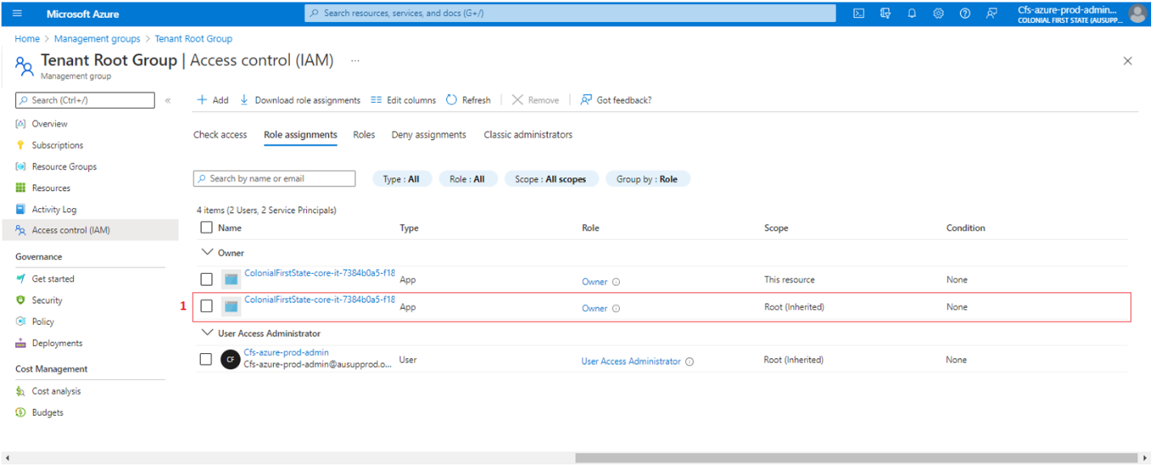

### Set role assignment to service account as owner to billing enrolment account

A billing account is created when you signed up to use Azure. There are different types for billing accounts and CFS is currently using Enterprise Agreement. It is a billing account created when organization sign an Enterprise Agreement (EA) to use Azure.

Access to billing enrolment account is required to programmatically create EA subscriptions. ([Programmatically create Azure Enterprise Agreement subscriptions with the latest APIs | Microsoft Docs](https://docs.microsoft.com/en-us/azure/cost-management-billing/manage/programmatically-create-subscription-enterprise-agreement?tabs=rest)). This section will provide procedure on how to assign “owner” role with service account to billing enrolment account.

**Prerequisites:**

* CFS Service Account or any user that has User Access Administrator Role to Tenant Root Group
* Access to Azure DevOps Portal and Azure Portal
* Billing Scopes
* Azure CLI or Azure Cloud Shell

|  |  |
| --- | --- |
|  | ***Important Note***  *This resolution steps were done using CFS Azure Service Account:* Cfs-azure-nonprod-admin@ausupnonp.onmicrosoft.com  Cfs-azure-prod-admin@ausupprod.onmicrosoft.com  This command can only be implemented in CLI session. |

1. In Azure Portal, open a Cloud Shell or Azure CLI session
2. To retrieve the billing account details, Use **command**

|  |
| --- |
| az billing enrollment-account list |

1. To retrieve billing scope details, In Azure Portal > Go to **Cost Management + Billing**
2. Select Billing Scopes, select the Billing Scope type **“Account”**
3. To set the role assignment, use **command**

|  |
| --- |
| az role assignment create --role Owner –assignee-object-id <service principal object id> --scope /providers/Microsoft.Billing/enrollmentAccounts/XXXXXX |

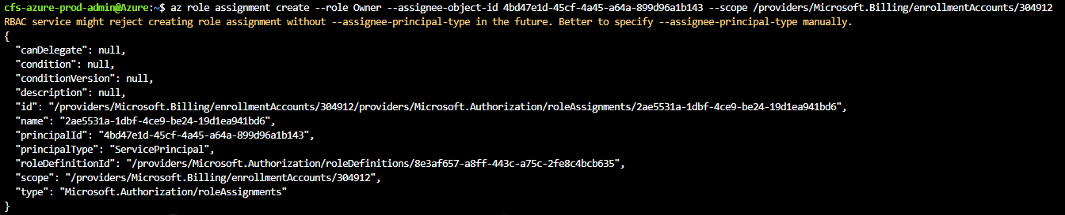

### Set enrolment account role assignment – PUT

|  |  |
| --- | --- |
|  | ***Important Note***  *This resolution steps were done using CFS Azure Service Account:* Cfs-azure-nonprod-admin@ausupnonp.onmicrosoft.com  Cfs-azure-prod-admin@ausupprod.onmicrosoft.com |

Follow the steps in this link: [Enrolment Account Role Assignments - Put - REST API (Azure Billing) | Microsoft Docs](https://docs.microsoft.com/en-us/rest/api/billing/2019-10-01-preview/enrollment-account-role-assignments/put)

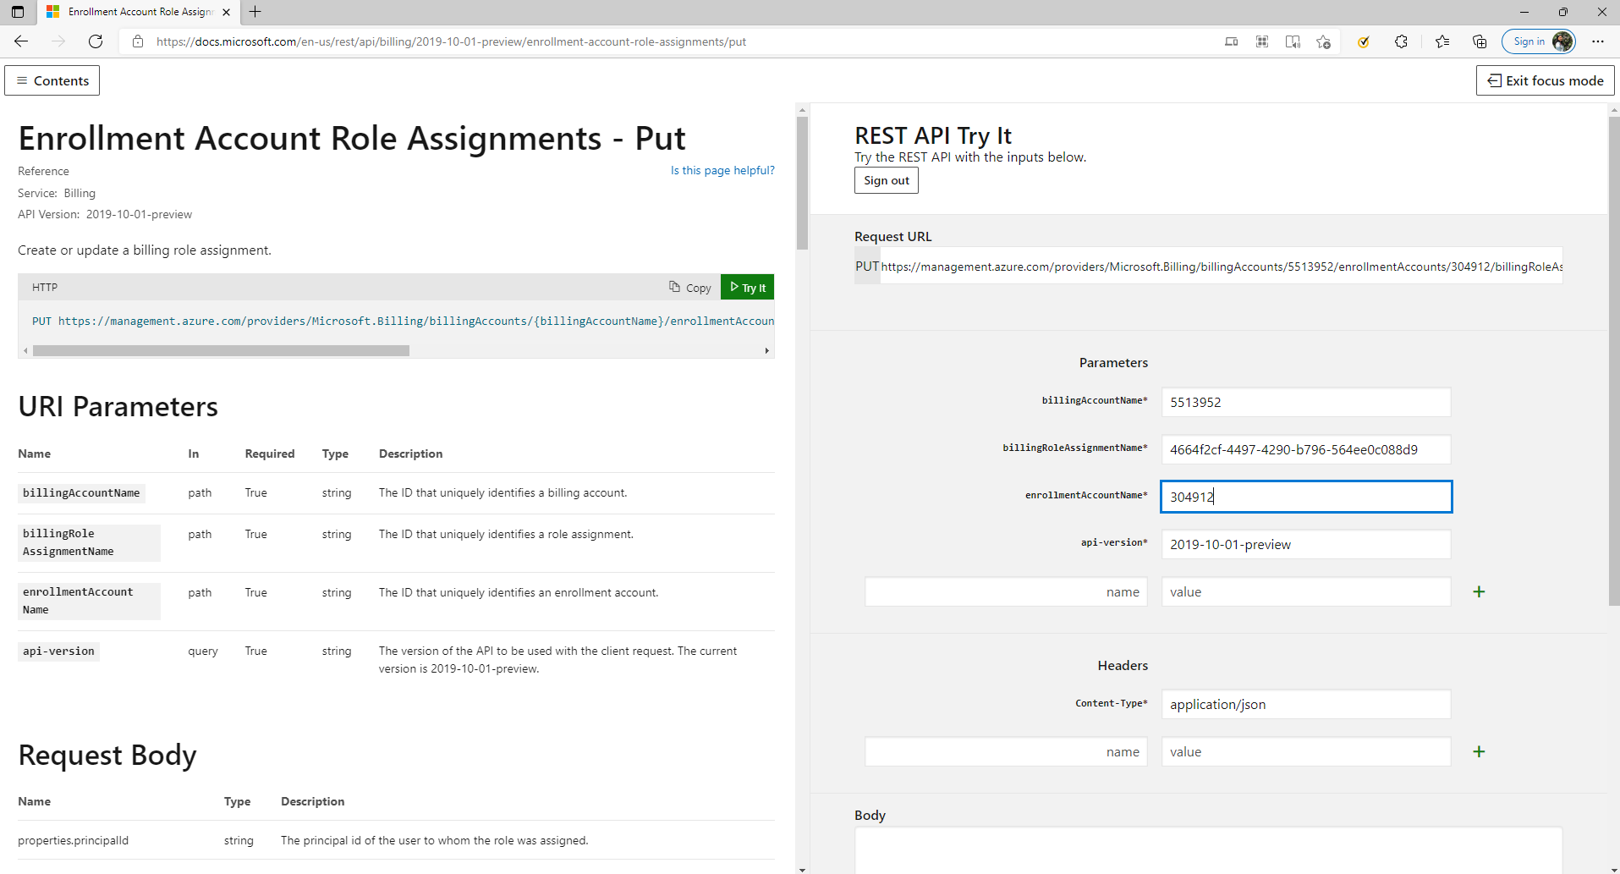

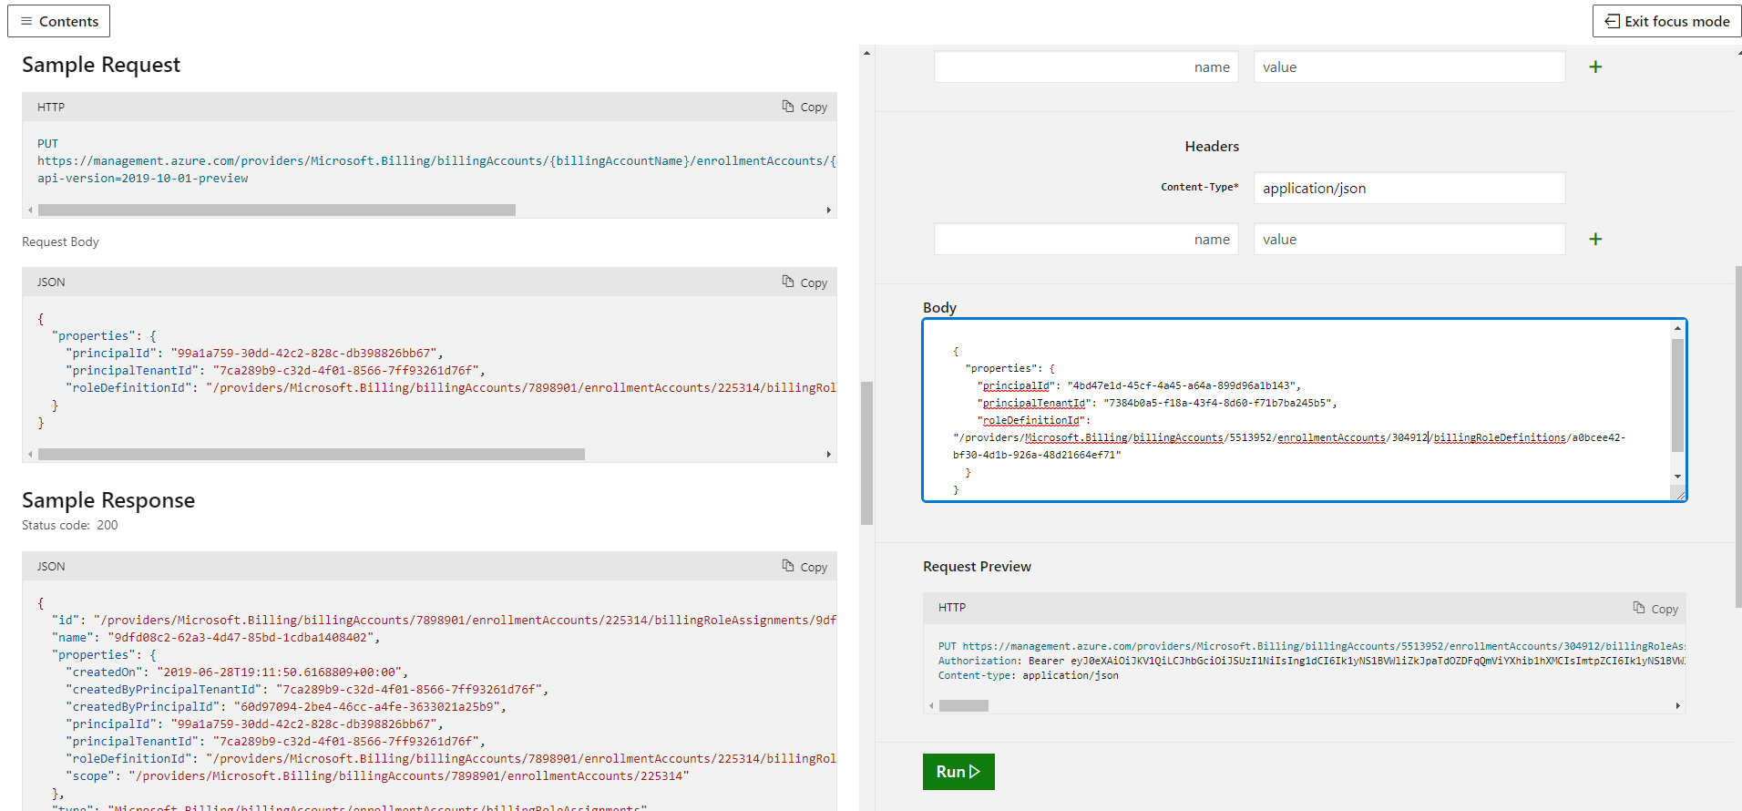



### Request for parallelism request for Azure DevOps

CFS is currently using private project which can get one free job that can run for 60 minutes. During Phase 1, the Azure DevOps organization was newly built and by default the parallel job is not yet granted.

This section will provide instructions on how to submit request to grant parallel jobs for private project.

|  |  |
| --- | --- |
|  | ***Important Note***  *This resolution step was done using own work email account* |

Reference: [Configure and pay for parallel jobs - Azure DevOps | Microsoft Docs](https://docs.microsoft.com/en-us/azure/devops/pipelines/licensing/concurrent-jobs?view=azure-devops&tabs=ms-hosted)

The screenshot below shows a sample parallelism request.

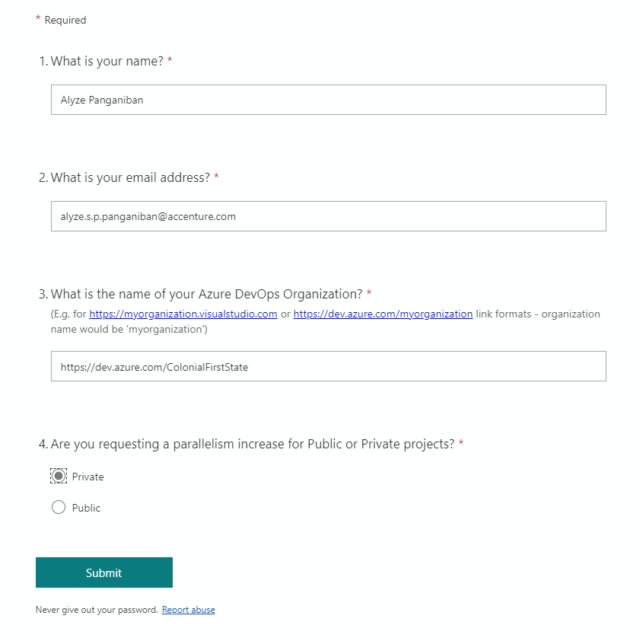

## Platform-Core deployment

This section of the document will show the end-to-end procedures on how Platform-core landing zone was created during Phase 1 of the project. This will include illustrations of the parameter file, instructions on how to run the deployment in Azure DevOps.

### Management Group and Subscription

This section describes the step-by-step procedure on how platform-core management groups and subscriptions were deployed using the **New-Subscription-Pipeline**. Creation of management groups and subscriptions required a privilege account. CFS Service account was used to create management groups and subscriptions for platform-core.

In Visual Studio Code, prepare the parameter file **Platform-Core.param.json** which will be used for **New-Subscription-Pipeline** deployment.

File location: cfs-virtual-data-centre\CFS.VirtualDataCentre\bicep-templates\deployment\deploy-NewSubscription

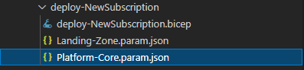

Parameter File structure:

|  |
| --- |
| **subManagementGroupName** = Platform-Core  **subManagementGroupDisplayName** = Platform Core  **instance** = this value will be appended at the end of the subscription name  managementGroup object block:  **name** = management group name  **displayName** =management group display name  subscriptions array block:  **service** = subscription name  workload = Production |

|  |  |
| --- | --- |
|  | ***Important Note***  *In* ***Platform-Core.param.json****, the structure shows that there will be 1 subscription per management group.*  *The complete management group and subscription name is being generated in the bicep template.* |

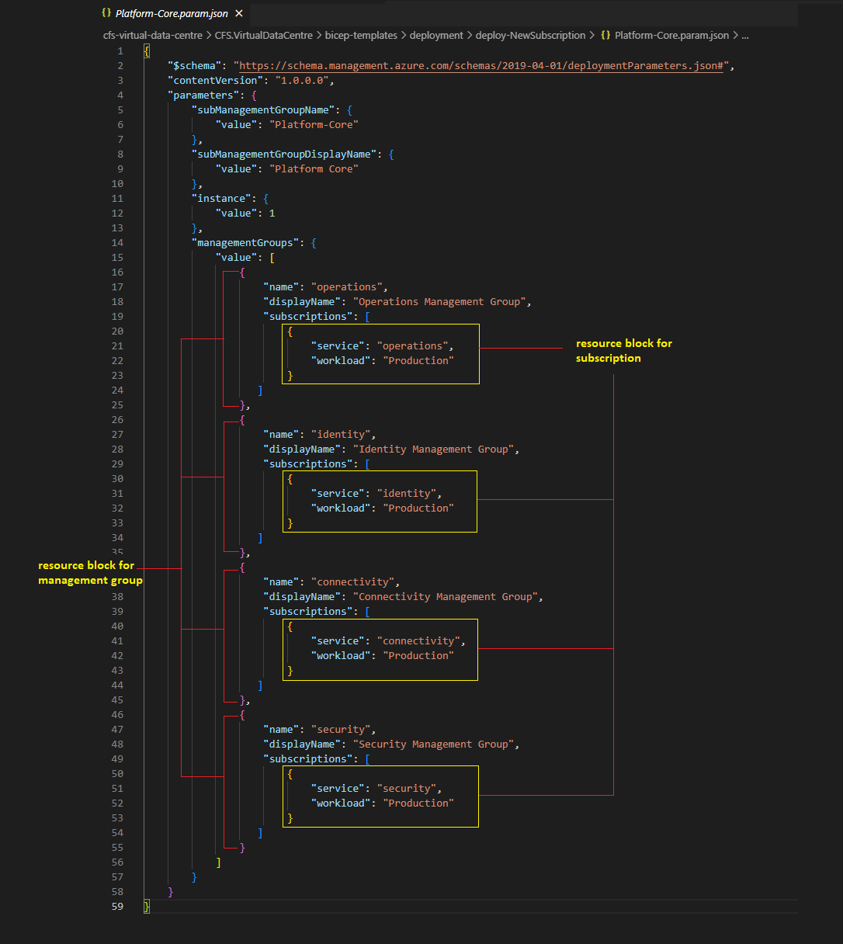

Commit the changes and push the codes in GitHub Repository.

Create a Pull Request to merge codes to develop branch.

|  |  |
| --- | --- |
|  | ***Important Note***  *Develop branch is used for non-production deployment*  *Main branch is used for production deployment* |

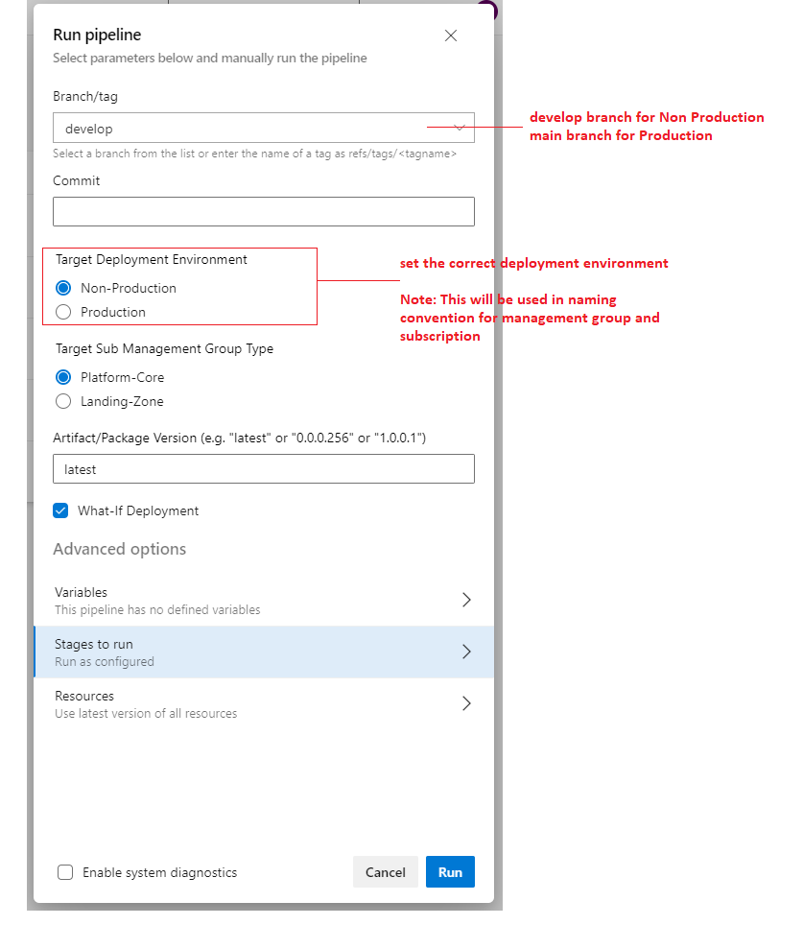

**Validation:**

To validate:

1. Sign in to <https://portal.azure.com> using the CFS Service Account
2. Navigate to Management Groups
3. Validate the Management Groups
4. Expand the Management Groups to verify the subscriptions are created.

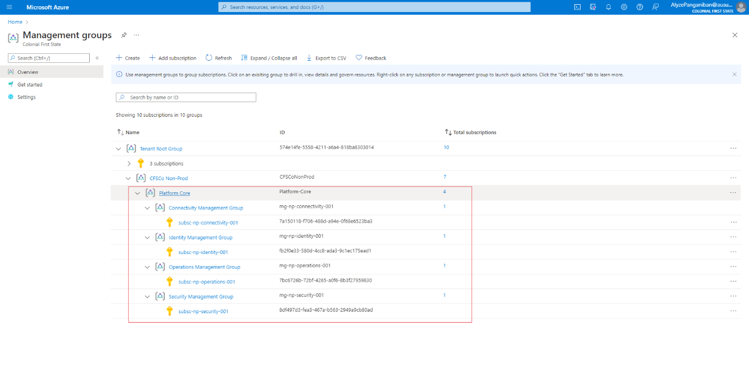

### Service Principal

This section describes the step-by-step procedure on how platform-core service principals were created in Azure Active Directory. The service principals are dependency on creating service connection. Creation of service principals requires privilege account. CFS Service account was used to create service principals for platform-core.

1. Login to **Azure Portal** (<https://portal.azure.com>) using CFS Service Account.
2. Navigate to **Azure Active Directory**, under **Manage**, select **App registrations**
3. click **New Registrations**
4. In Register an application page, input the **service principal** name
5. Use the default selection in **Supported account types** (Accounts in this organizational directory only)
6. Click **Register**

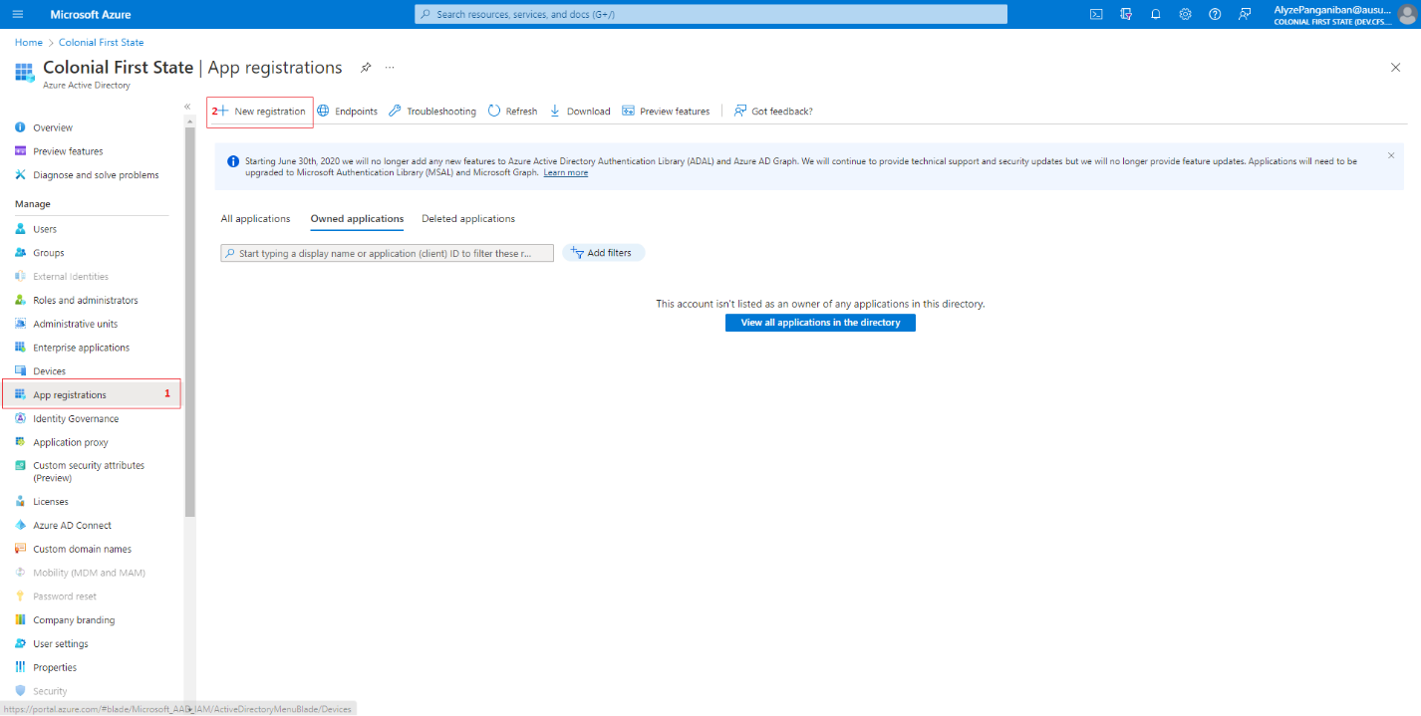

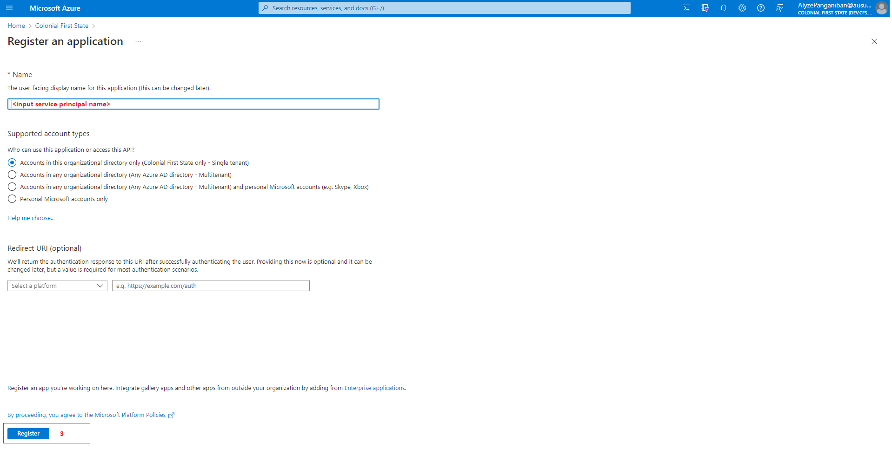

1. Click the **service principal** created
2. under **Manage**, click **Certificates & secrets**
3. select **Client secrets** tab and click **New client secret**
4. in Add a client secret page, in **Description** put the secret name
5. set the **expiry date**, then click **Add**.

|  |  |
| --- | --- |
|  | ***Important Note***  *Make sure to save the secret value since it will be hidden one the page refreshes.*  *Client secret value will be used in step 2.3.3: Create platform-core service connection.* |

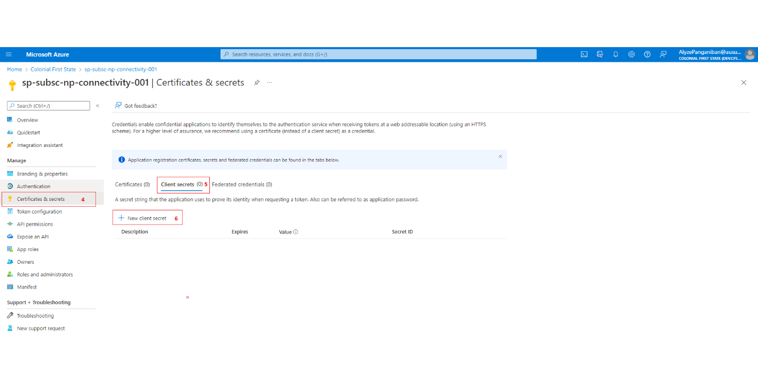

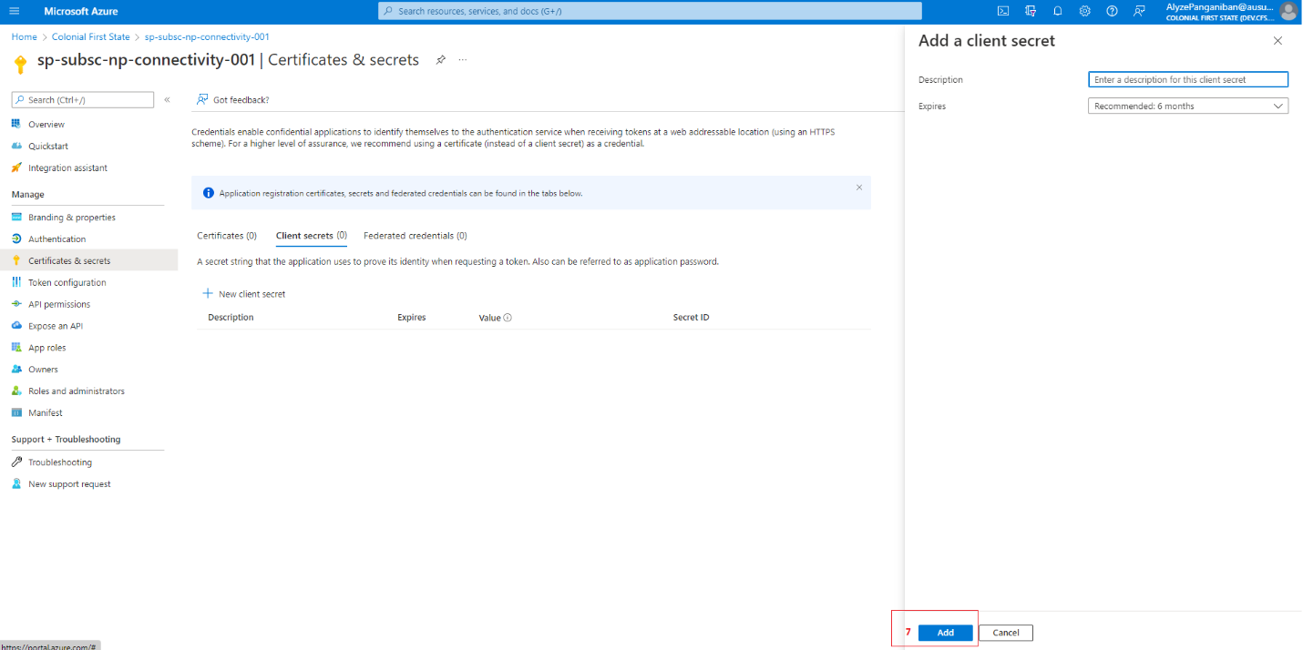

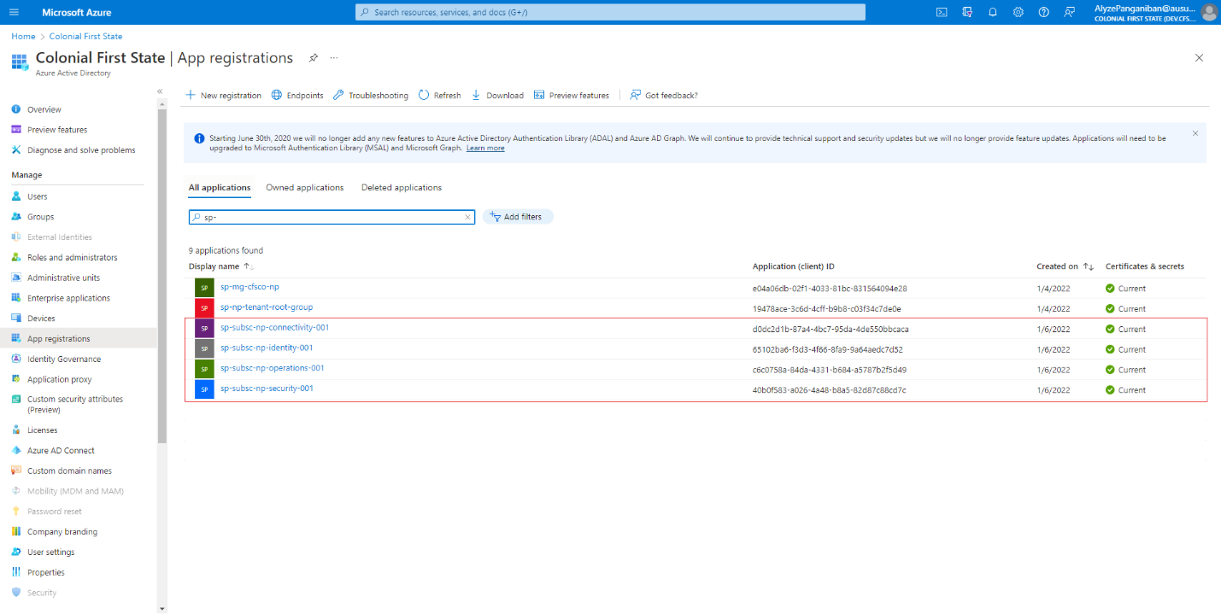

### Service Connection

This section describes the step-by-step procedure on how platform-core service connection were created in Azure DevOps. It is assumed that before doing this step, service principal is completed first. Creation of service connections requires privilege account. CFS Service account was used to create service connections in Azure DevOps.

1. Login to **Azure DevOps** (<https://aex.dev.azure.com/>) using CFS Service Account.
2. click the Azure DevOps Organization: **dev.azure.com/AUSUP**
3. select projects: **core-it**
4. In **Project settings**, under **Pipelines**, select **Service connections**
5. Click **New service connection**

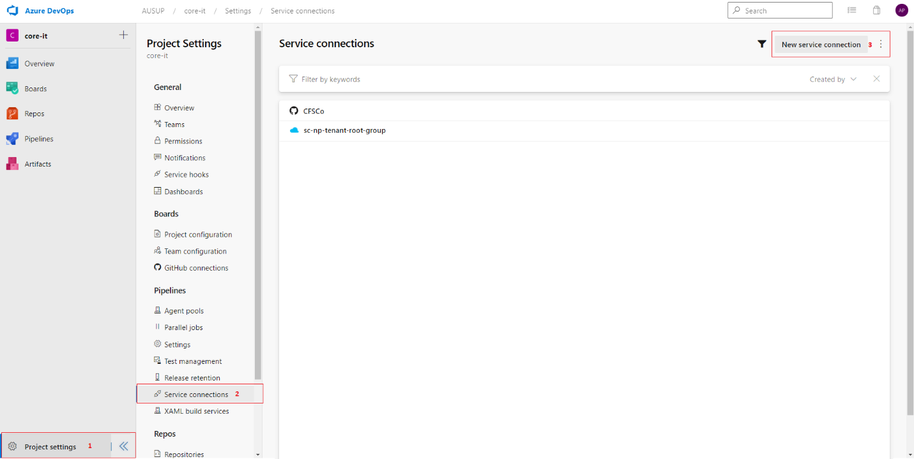

1. In **New service connection** page,select **Azure Resource Manager,** click **Next**
2. In **New Azure service connection** page,select **Service principal (manual)**, click **Next**
3. Environment: Azure Cloud
4. Scope level: Subscription
5. Subscription Id: <put subscription id>
6. Subscription Name: <put subscription name>
7. Service Principal Id: <put Service Principal object ID>
8. Credential: Service principal key
9. Service principal key: <put Service principal secret value>
10. Tenant ID: <input tenant ID or directory ID>
11. Click **Verify** (once the connection is verified)
12. Service connection name: <input service connection name>
13. NOT recommending checking *Grant access permission to all pipelines* box
14. Click **Verify and Save**

Validation:

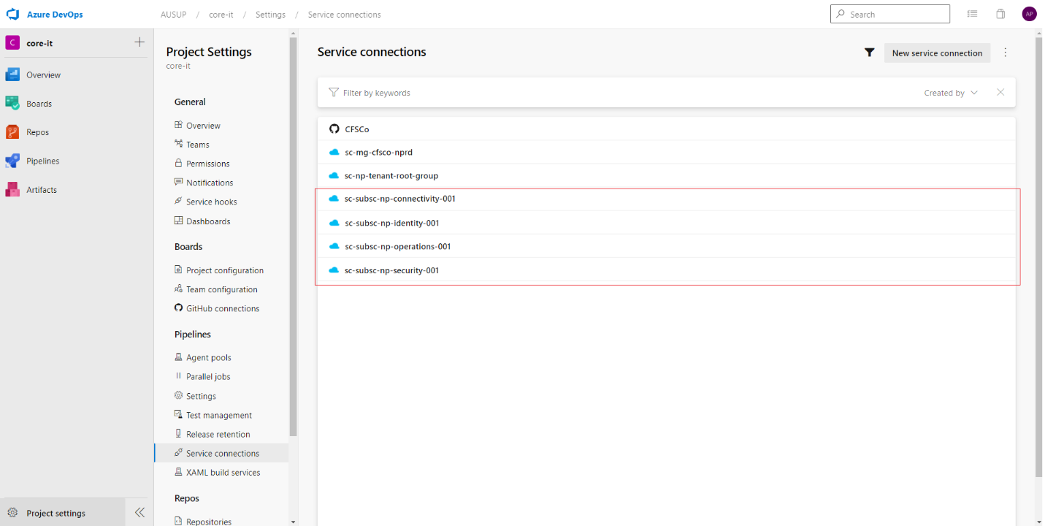

### Platform-core components

This section of the document will discuss the deployment of Platform-core landing zone. Each Azure Services will have its separate set of bicep deployment file and json parameter file. Bicep deployment file calls a bicep module file. To deploy the Azure Services, a CFS Master Pipeline yaml file was used to deploy the Azure Services in Azure DevOps. Each Azure Services have separate stages in yaml pipeline.

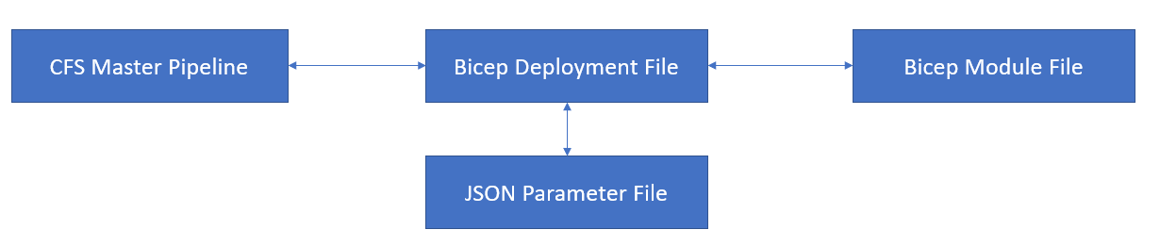

#### **Log Analytics Workspace**

All resources created in Phases 1 and 2.1 have diagnostic settings enabled when option is available. As a prerequisite, Log Analytics Workspace is created.

|  |  |
| --- | --- |
|  | ***Important Note:***  *Currently, Non-Prod and Prod have Log Analytics Workspace deployed only in EDC region.* |

##### Parameter File

**Parameter File**: cfs-virtual-data-centre\CFS.VirtualDataCentre\bicep-templates\deployment\deploy-LogAnalyticsWorkspace\deploy-LogAnalyticsWorkspace.param.json

Log Analytics Workspace uses same parameter file for both non-production and production deployment.

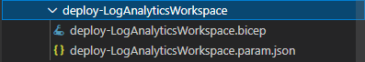

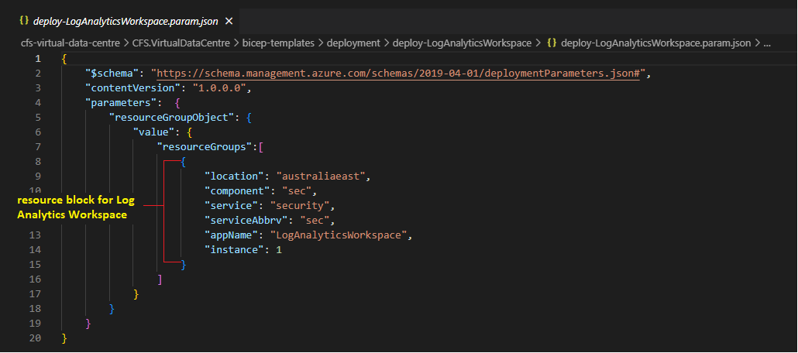

##### Deployment File

**Deployment File:** cfs-virtual-data-centre\CFS.VirtualDataCentre\bicep-templates\deployment\deploy-LogAnalyticsWorkspace\deploy-LogAnalyticsWorkspace.bicep

##### Module File

**Module File:** cfs-virtual-data-centre\CFS.VirtualDataCentre\bicep-templates\modules\Microsoft.OperationalInsights\workspaces\deployLogAnalyticsWorkspace.bicep

##### ADO Deployment

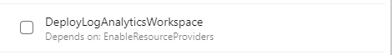

#### **Storage Account**

This section details the preparation of parameter file for Storage Account deployment.

Each subscription and region for platform-core has its own set of parameters. There’s also a separate parameter per environment since the storage account name will be different per environment.

|  |  |
| --- | --- |
|  | ***Important Note***  *Since different use cases requires different types for storage account name. To have more flexibility, it was decided that instead of generating the storage account name from the code, it will be directly identified in the parameter file.* |

##### Parameter File

**Parameter file:** cfs-virtual-data-centre\CFS.VirtualDataCentre\bicep-templates\deployment\deploy-storageAccount

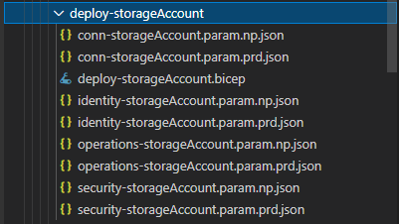

The parameter file uses object type hence can support multiple resource groups and multiple storage accounts inside it. In the image shown below, there are two resource group blocks:

(1) for australiasoutheast

(2) for australiaeast.

Inside each resource group block is a storageAccount block which can support multiple storage accounts.

Currently, there are 1 storage account per region in each subscription (highlighted in Yellow box).

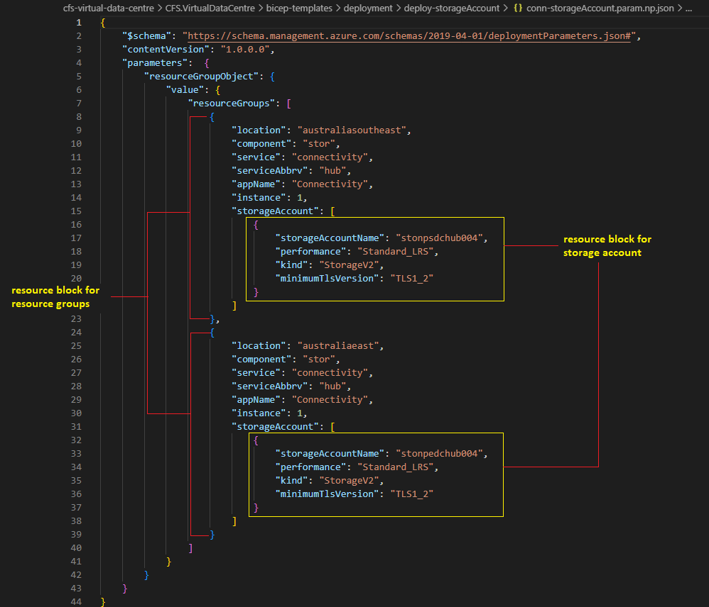

##### Deployment File

**Deployment File**: cfs-virtual-data-centre\CFS.VirtualDataCentre\bicep-templates\deployment\deploy-storageAccount\deploy-storageAccount.bicep

##### Module File

**Module File**: cfs-virtual-data-centre\CFS.VirtualDataCentre\bicep-templates\modules\Microsoft.Storage\deployStorageAccount.bicep

##### ADO Deployment

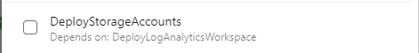

#### **Route Table and Network Security Group**

##### Parameter File

Route Table and Network Security Groups use the same parameter with Virtual Network.

##### Deployment File

**Deployment File**: cfs-virtual-data-centre\CFS.VirtualDataCentre\bicep-templates\deployment\deploy-VDCVirtualNetwork\deployRTandNSG.bicep

##### Module File

**Module File:** cfs-virtual-data-centre\CFS.VirtualDataCentre\bicep-templates\modules\Microsoft.Network\virtualNetwork\deployRTandNSG.bicep

##### ADO Deployment

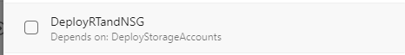

|  |  |
| --- | --- |
|  | ***Important Note***  DeployRTandNSG stage will create empty Route Tables and NSG. Deploying this stage must be planned since it will result to network downtime since all the user defined routes and NSG rules will be removed.  To recreate the route tables run the DeployVDCUDRRules stage and DeployVDCNSGRules for nsg rules. |

#### **Virtual Network**

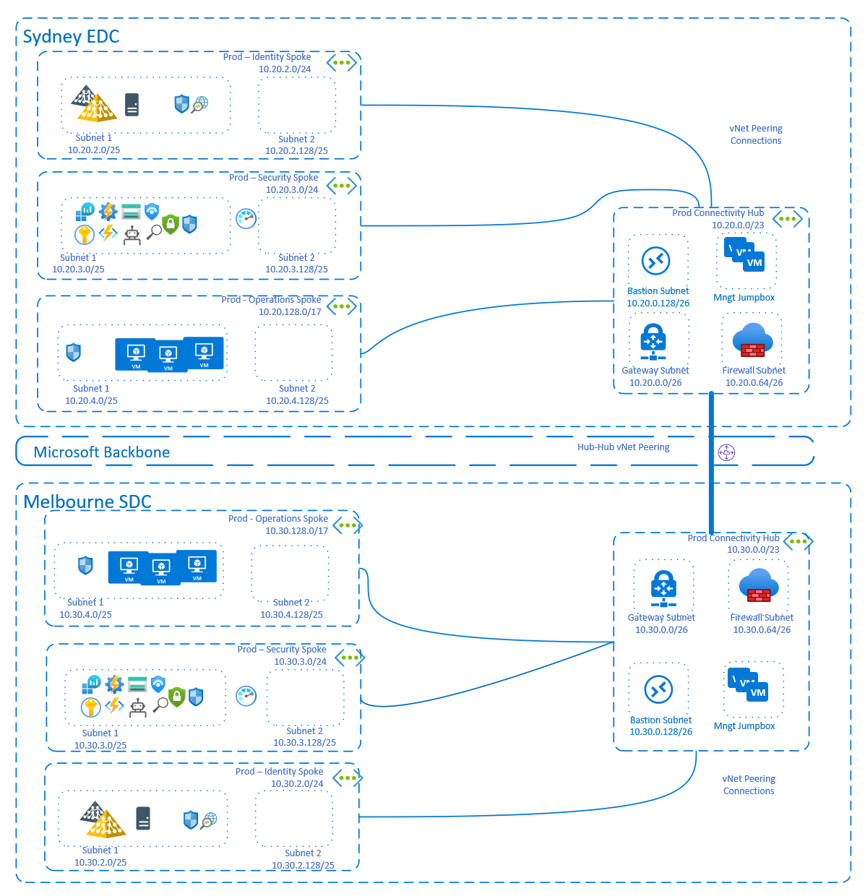

**Network Overview – High Level Design for Prod/Non-prod (different subnets)**

##### Parameter File

**Parameter file**: cfs-virtual-data-centre\CFS.VirtualDataCentre\bicep-templates\deployment

Same with Storage Accounts, each subscription or landing zone will have its own 2 sets of parameter file (nonprod or prod) since the virtual network information will be different per environment.

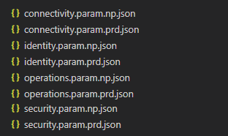

Parameter File structure:

The parameter file uses object type hence can support multiple resource groups and virtual networks inside it. In the image shown below, there are two resource group blocks:

(1) for australiaeast

(2) for australiasoutheast

Inside each resource group block is a virtualNetwork block which can support multiple virtual networks and subnets.

**Virtual Network:**

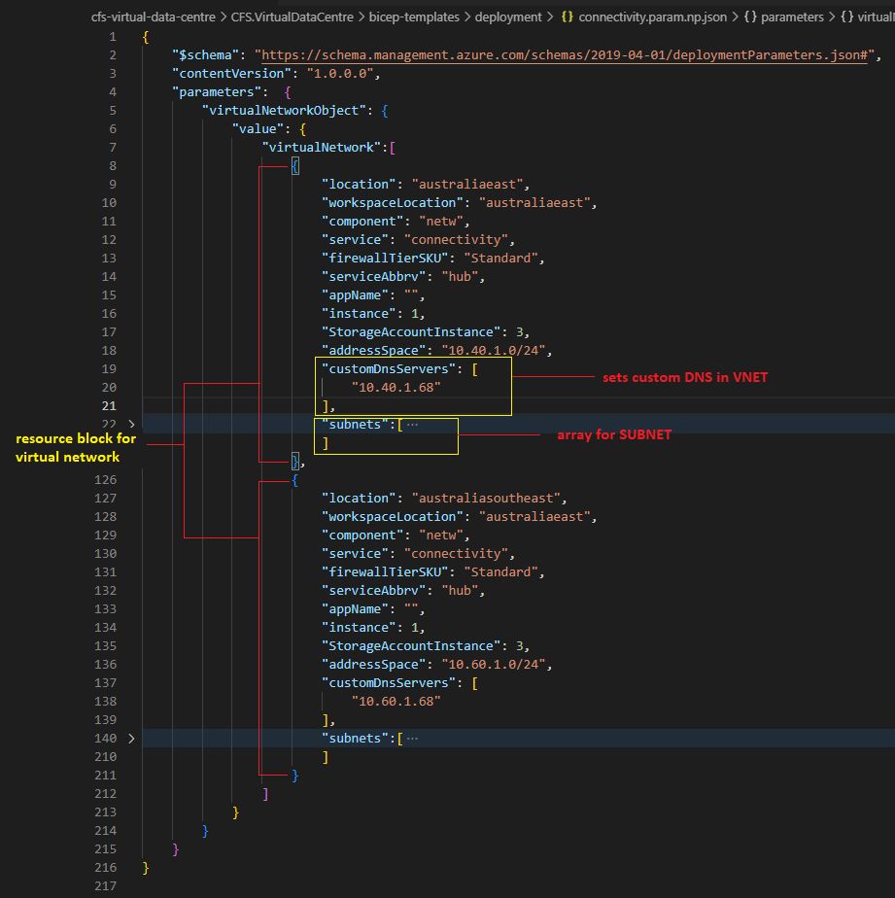

**Subnet array:**

There are 3 special subnets deployed in connectivity subscription. GatewaySubnet, AzureFirewallSubnet and Azure Bastion Subnet. The rest are regular subnet which needs to follow the standard naming convention for subnet.

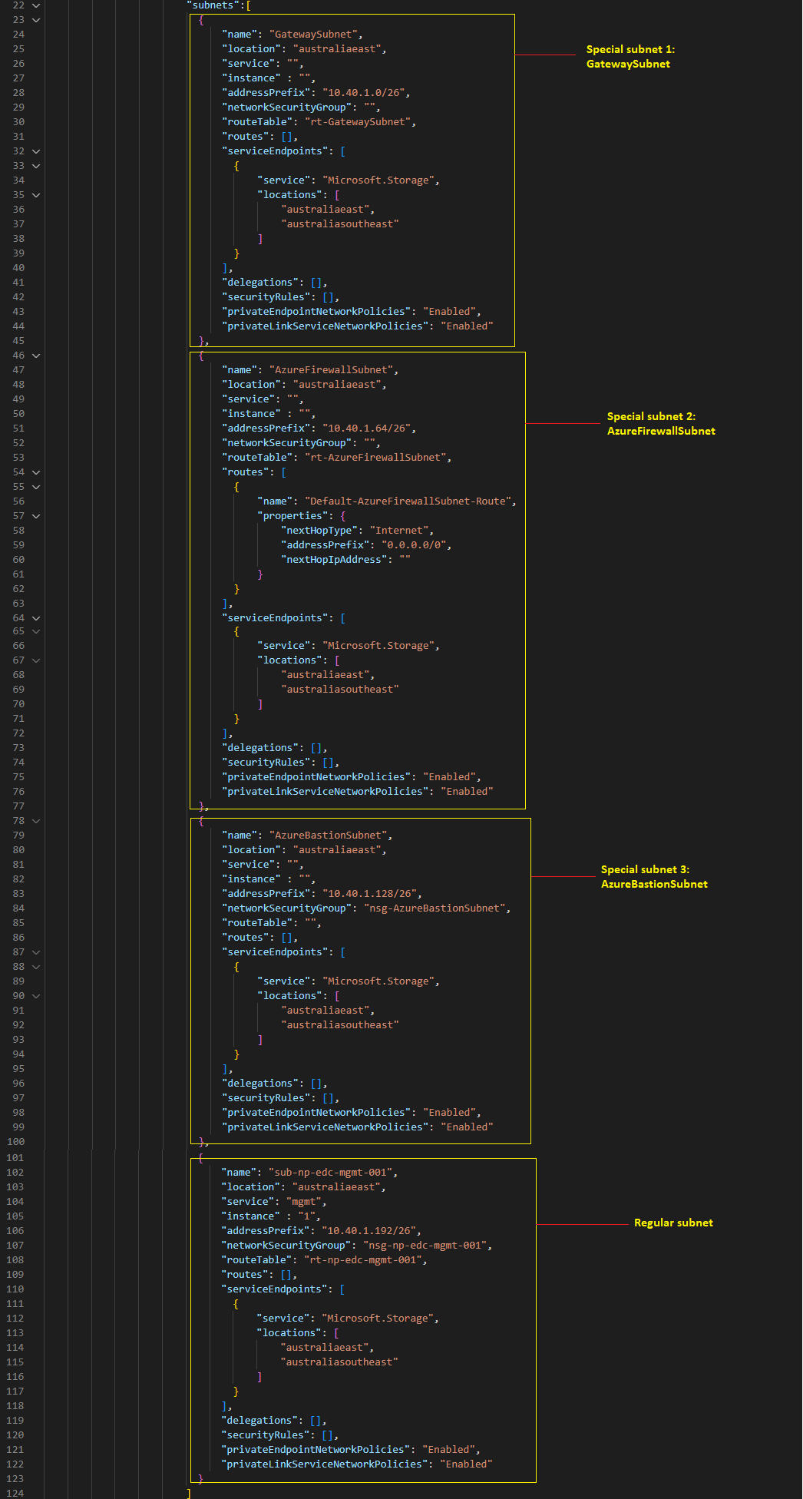

##### Deployment File

**Deployment File**: cfs-virtual-data-centre\CFS.VirtualDataCentre\bicep-templates\deployment\deploy-VDCVirtualNetwork\deploy-VDCVirtualNetwork.bicep

##### Module File

**Module File:** cfs-virtual-data-centre\CFS.VirtualDataCentre\bicep-templates\modules\Microsoft.Network\virtualNetwork\deployVNET.bicep

##### ADO Deployment

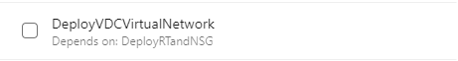

#### **Virtual Network Peering**

##### Parameter File

**HUB <-> HUB**

Since HUB VNet in australiaeast and australiasoutheast are both deployed in the connectivity subscription, it only requires 2 parameters (non-prod and prod) since the virtual network peering details will be different per environment.

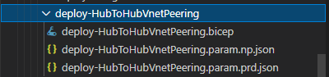

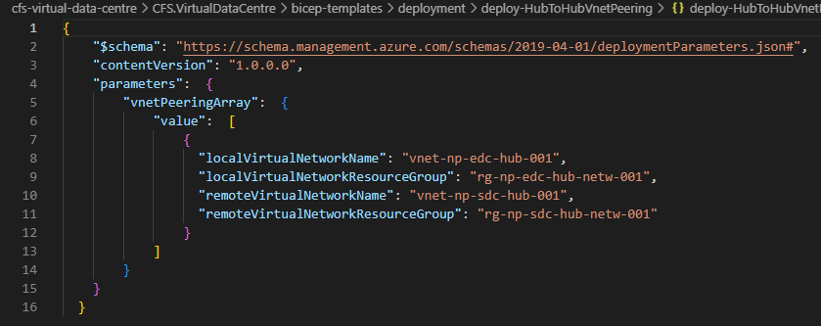

**HUB <-> SPOKE or SPOKE <-> HUB**

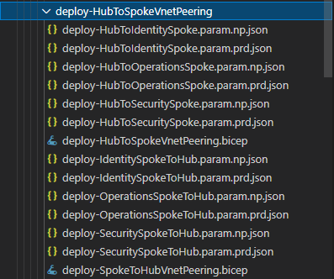

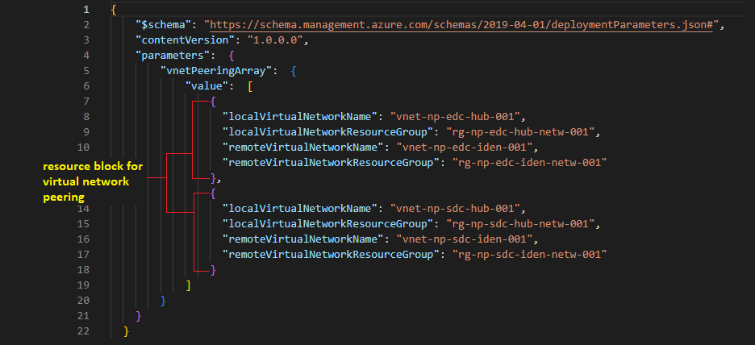

##### Deployment File

HUB <-> HUB

**Deployment File**: cfs-virtual-data-centre\CFS.VirtualDataCentre\bicep-templates\deployment\deploy-HubToHubVnetPeering\deploy-HubToHubVnetPeering.bicep

HUB <-> Spoke : cfs-virtual-data-centre\CFS.VirtualDataCentre\bicep-templates\deployment\deploy-HubToSpokeVnetPeering\deploy-HubToSpokeVnetPeering.bicep

Spoke <-> HUB: cfs-virtual-data-centre\CFS.VirtualDataCentre\bicep-templates\deployment\deploy-HubToSpokeVnetPeering\deploy-SpokeToHubVnetPeering.bicep

##### Module File

HUB <-> HUB

**Module File**: cfs-virtual-data-centre\CFS.VirtualDataCentre\bicep-templates\modules\Microsoft.Network\virtualNetworkPeering\deployVnetPeeringHub.bicep

Spoke <-> HUB

**Module File**: cfs-virtual-data-centre\CFS.VirtualDataCentre\bicep-templates\modules\Microsoft.Network\virtualNetworkPeering\deployVnetPeeringtoHub.bicep

HUB <-> Spoke

**Module File:** cfs-virtual-data-centre\CFS.VirtualDataCentre\bicep-templates\modules\Microsoft.Network\virtualNetworkPeering\deployVnetPeeringtoSpoke.bicep

##### ADO Deployment

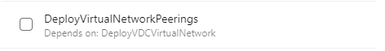

#### **Firewall**

##### Parameter File

Firewall deployment also uses the same parameter file with Virtual Network.

##### Deployment File

**Deployment File**: cfs-virtual-data-centre\CFS.VirtualDataCentre\bicep-templates\deployment\deploy-VDCVirtualNetwork\deploy-Firewall.bicep

##### Module File

**Module File:** cfs-virtual-data-centre\CFS.VirtualDataCentre\bicep-templates\modules\Microsoft.Network\azureFirewall\deployAzureFirewall.bicep

##### ADO Deployment

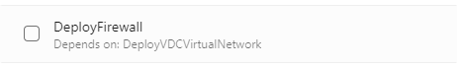

#### **Firewall Policy**

##### Parameter File

Firewall Policy uses a separate parameter file. During Phase1 and early stage of Phase 2.1, firewall policies are being updated by VDC Team. However, this task is already being handled by TCS Team.

##### Deployment File

##### Module File

#### **Bastion**

##### Parameter File

Bastion deployment also uses the same parameter file with Virtual Network.

##### Deployment File

**Deployment File:** cfs-virtual-data-centre\CFS.VirtualDataCentre\bicep-templates\deployment\deploy-VDCVirtualNetwork\deploy-Bastion.bicep

##### Module File

**Module File:** cfs-virtual-data-centre\CFS.VirtualDataCentre\bicep-templates\modules\Microsoft.Network\bastionHosts\deployBastionWithDiagnostic.bicep

##### ADO Deployment

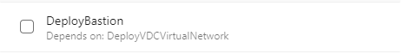

#### **UDR – Route Rules**

##### Parameter File

UDR Route Rules will also require each subscription or landing zone to have its own 2 sets of parameter file (nonprod or prod) since the UDR rules will be different per environment.

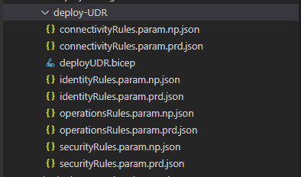

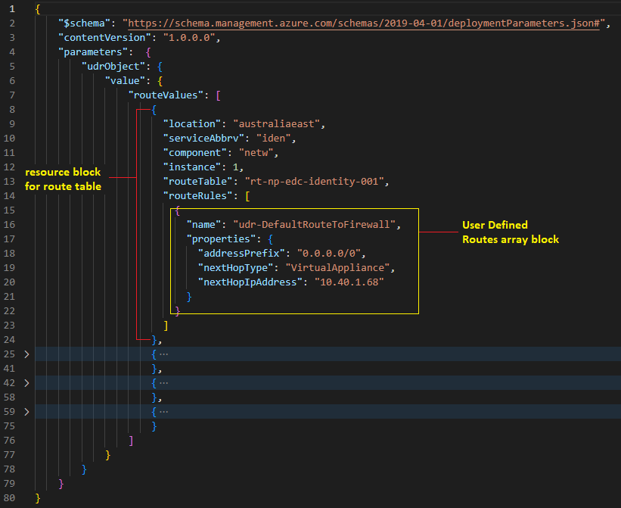

##### Deployment File

**Deployment File**: cfs-virtual-data-centre\CFS.VirtualDataCentre\bicep-templates\deployment\deploy-UDR\deployUDR.bicep

##### Module File

**Module File:** cfs-virtual-data-centre\CFS.VirtualDataCentre\bicep-templates\modules\Microsoft.Network\routeTables\deployRoutes.bicep

##### ADO Deployment

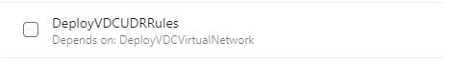

#### **NSG Rules**

##### Parameter File

NSG Rules will also require each subscription or landing zone to have its own 2 sets of parameter file (nonprod or prod) since the NSG rules will be different per environment.

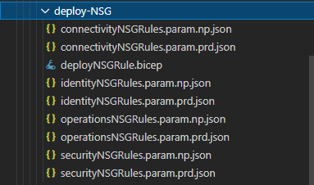

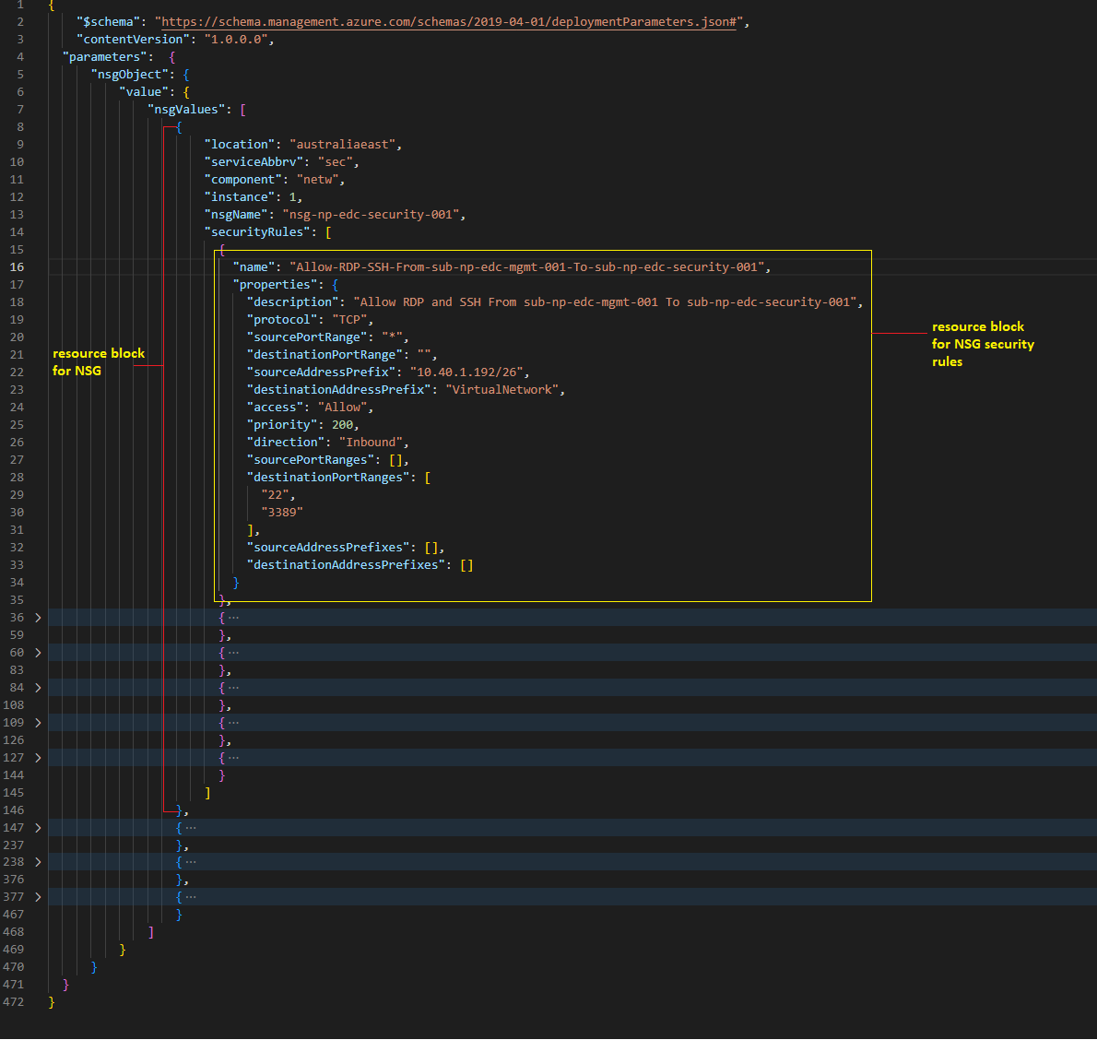

##### Deployment File

**Deployment File**: cfs-virtual-data-centre\CFS.VirtualDataCentre\bicep-templates\deployment\deploy-NSG\deployNSGRule.bicep

##### Module File

**Module File:** cfs-virtual-data-centre\CFS.VirtualDataCentre\bicep-templates\modules\Microsoft.Network\NetworkSecurityGroups\deployNSGRules.bicep

##### ADO Deployment



#### **Recovery Service Vault**

##### Parameter File

Recovery Service Vault will also require each subscription or landing zone to have its own 2 sets of parameter file (nonprod or prod) since the RSV details will be different per environment.

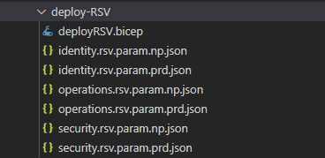

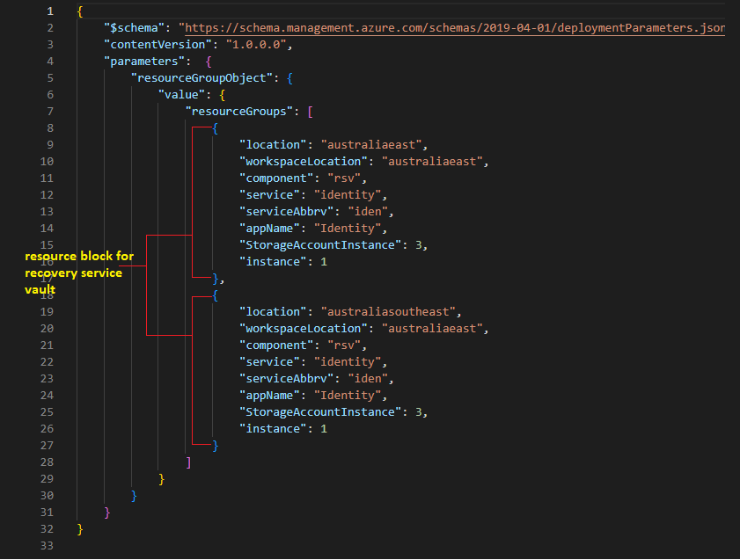

##### Deployment File

**Deployment File**: cfs-virtual-data-centre\CFS.VirtualDataCentre\bicep-templates\deployment\deploy-RSV\deployRSV.bicep

##### Module File

**Module File:** cfs-virtual-data-centre\CFS.VirtualDataCentre\bicep-templates\modules\Microsoft.RecoveryServices\vaults\deployRSV.bicep

##### ADO Deployment



#### **Key Vault**

##### Parameter File

Key Vault will also require each subscription or landing zone to have its own 2 sets of parameter file (nonprod or prod) since the key vault details will be different per environment.

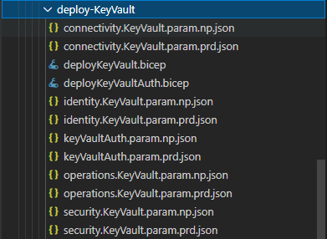

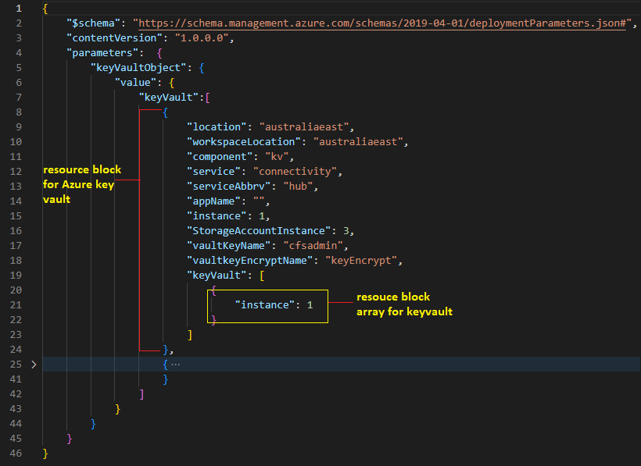

##### Deployment File

**Deployment File:** cfs-virtual-data-centre\CFS.VirtualDataCentre\bicep-templates\deployment\deploy-KeyVault\deployKeyVault.bicep

##### Module File

**Module File:** cfs-virtual-data-centre\CFS.VirtualDataCentre\bicep-templates\modules\Microsoft.KeyVault\deployKeyVault.bicep

##### ADO Deployment

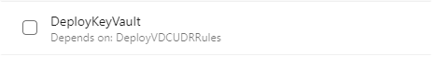

#### **Storage Account (TEMPLATE)**

##### Parameter File

##### Deployment File

##### Module File

### Platform-core deployment (BICEP/ YAML / Azure DEVOPS)

#### Standard Naming Convention encoded in BICEP

When constructing standard naming convention for Azure Resources, identify the key pieces of information that needs reflect in the resource name. The following list provides examples of information that are useful when you construct resource names.

|  |  |
| --- | --- |
| **Naming component** | **Description** |
| **Resource type** | An abbreviation that represents the type of Azure resource or asset. This component is often used as a prefix or suffix in the name. For more information, see Recommended abbreviations for Azure resource types.  Examples: resource grou (rg) and virtual network (vnet) |
| **Deployment environment** | The stage of the development lifecycle for the workload that the resource supports.  Examples: Non-Production (np) and Production (prd) |
| **Subscription type** | Summary description of the purpose of the subscription that contains the resource. Often broken down by deployment environment type or specific workloads. Examples: connectivity, identity, operations, security |
| **Region** | The Azure region where the resource is deployed.  Examples: australiaeast (edc) and australiasoutheast (sdc) |
| **Application or service name** | Name of the application, workload, or service that the resource is a part of.  Examples: DC, AAD, Exchange |

Naming conventions ensure that all the resources have a predictable name, which helps lower the administrative burden associated with managing those resources. Below list provides guiding principles for naming conventions:

* Some part of the name should be unique to all types
* Use two-digit integer to increment duplicate names where needed
* Use a descriptive pattern across all Azure object naming conventions
* Plan for growth and new Azure resource types
* Use lowercase for all Azure resources as not all resources can use UPPERCASE
* Descriptions <Desc> should NOT contain dashes as to confuse with the format types
* Names should be as short as possible while containing required information

|  |  |  |
| --- | --- | --- |
| Object | Nomenclature | Example |
| Resource Groups | rg-<environment>-<location>-<service>-<component>xxx | rg-np-edc-oper-netw-001 rg-np-edc-oper-comp-001 |
| Virtual Network | vnet-<environment>-<location>-<service>-xxx | vnet-np-edc-hub-001 vnet-np-edc-identity-001 |
| Subnets | sub-<environment>-<location>-<service>-xxx | sub-np-edc-mgmt-001 sub-np-edc-identity-001 |
| Storage Accounts | sto<environment><location><resourcetype>xxx | stonpedcdiaglogs001 |
| Key Vaults | kv-<environment>-<location>-<segment>-xxx | kv-np-edc-infra-001 |
| Virtual Machines | vm<environment><location><role>xxx | VMNPEDCADDS001 |
| vNICs | nic-<hostname>-xxx | nic-vmnpedcadds01-001 |
| Availability Set | Avail-<environment>-<location>-<role> | avail-np-edc-adds |
| Public IP | pip-<hostname>-xxx | pip-npedcwap01-001 |
| Load Balancers (Internal) | Ilb-<environment>-<location>-<role>-xxx | Ild-np-edc-ADFS-001 |
| Load Balancers (External) | elb-<environment>-<location>-<role>-xxx | Ilb-np-edc-WAP-001 |
| Application Security Groups | asg-<environment>-<location>-<role>-xxx | asg-np-edc-backup-001 |
| Network Security Groups | nsg-<subnetname>-xxx | nsg-sub-dmz-001-001 |
| Recovery Services Vault | rsv-<environment>-<location>-<segment>-xxx | rsv-np-edc-backup-001 |
| Bastion | bastion-<environment>-<location>-xxx | bastion-np-sdc-001 |
| OSDisk | <VM Name>-osDisk | VMNPEDCDC001-osDisk |
| DataDisk | VMname<diskname>-xx | VMNPEDCDC001-data-01 |
| Subscription | subsc-<environment>-<role>-xxx | subsc-np-identity-001 |
| Management Group | mg-<environment>-<service>-xxx | mg-np-operations-001 |
| Firewall | fw-<environment>-<location>-<service>-xxx | fw-np-edc-hub-001 |
| Workspace | AM-<environment>-<location>-xxx | AM-np-edc-001 |
| Route Table | rt-<environment>-<location>-<service>-xxx | rt-np-edc-identity-001 |
| User Defined Route | udr-<destination> | udr-sub-np-edc-identity-001 |
| Private Endpoint | pvte-<resource> | pvte-kv-np-edc-infra-001 |

Naming conventions in bicep code are parameterized in naming component resource type, deployment environment, subscription type, region and Application or service name.

Here’s an example on how standard naming convention is implemented in bicep codes:

This is a sample deployment file that calls a deployVM.bicep module file.

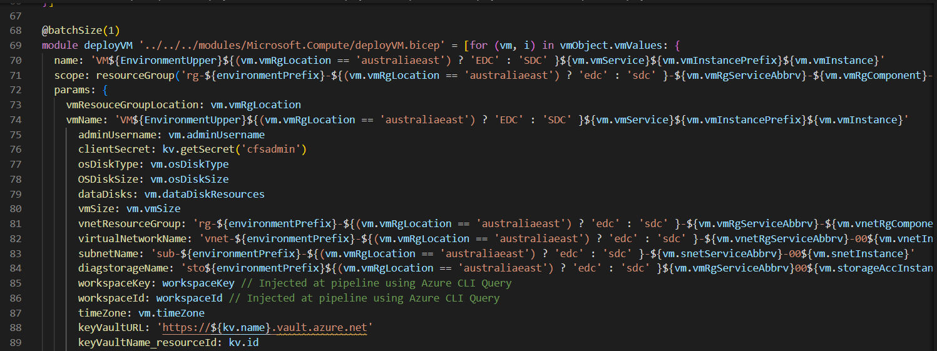

Sample Parameter of VM deployment

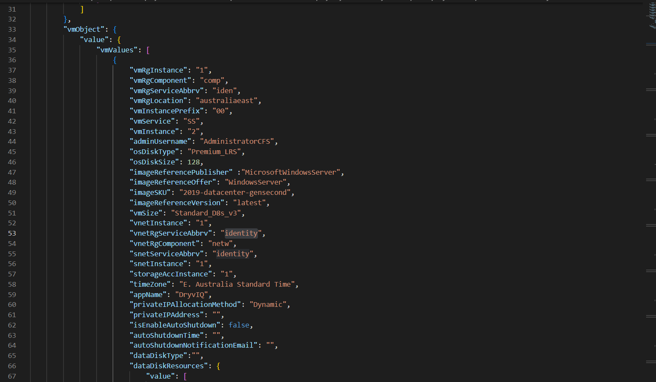

When a module file is called within a bicep deployment file, it also needs to feed a parameter for the module file. Using this approach, the value of parameter is generating the standard naming convention to the resources.

Ex.

subnetName: ‘sub-${environmentPrefix}-${(vm.vmRgLocation == ‘australiaeast’) ? ‘edc’ : ‘sdc’ }-${vm.snetServiceAbbrv}-00${vm.snetInstance}’

|  |  |  |
| --- | --- | --- |
| Parameter | Source | Value |
| ${environmentPrefix} | Pipeline parameter | ‘np’ or ‘prd’ |
| ${(vm.vmRgLocation == ‘australiaeast’) ? ‘edc’ : ‘sdc’ } | Json parameter | ‘edc’ or ‘sdc’ |
| ${vm.snetServiceAbbrv} | Json parameter | Identity |
| ${vm.snetInstance | Json parameter | 1 |

Possible subnet name that will be created:

sub-np-edc-identity-001

sub-np-sdc-identity-001

sub-prd-edc-identity-001

sub-np-sdc-identity-001

#### GitHub Action (Commit, PR, Review and Approve)

CFS uses GitHub Actions to manage deployment codes and generate artifacts that will be used for pipeline deployments.

This section will provide a sample procedure on how to update a parameter of log analytics deployment.

Steps for updating the parameter files or Bicep templates for deployment.

1. From vscode, switch delevop branch

*git checkout develop*

2. Run git pull --> to get the latest copy of the develop branch

*git pull*

3. Go to Azure Devops (PROD), create a work item / task. Take note for the work item number.

Sample:

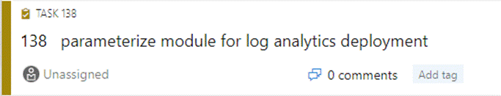

1. Go back to vSCode and create a feature branch.

*git checkout -b feature/138-parameterize-LogAnalytics-module*



5. Edit parameter files to reflect the requirements.

6. Run git add to add the file to be committed.

*git add <filename>*

7. Run git commit. Make sure to put the Work item number so it will reflect Azure Boards.

*git commit -m "****AB#138*** *- updates parameters in LogAnalytics module"*

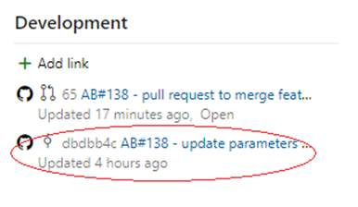

8. Run git push to push it to the repository.

9. Monitor completion in github actions

10. Create PR, PR name should also include the work item number so that it will reflect to Azure Board.

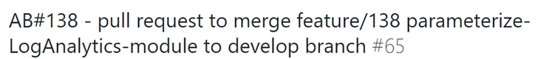

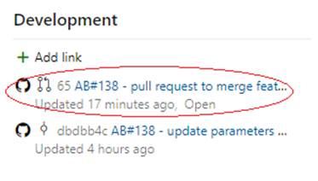

12. Add approvers - (approver will be the one to review if the changes, two approver is required)

13. Merge to develop – Once approved you can merge it to develop. You can choose to auto merge,it will merge automatically once approved.

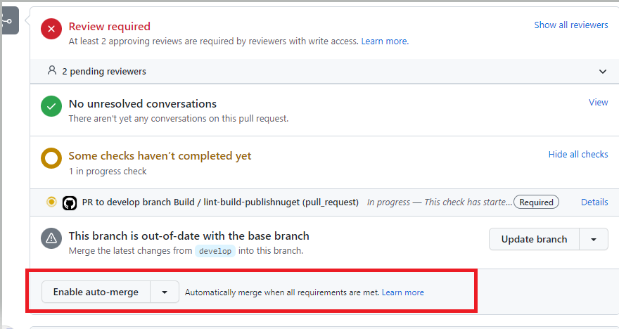

14. Monitor completion in github action

#### Azure Pipeline Overview

CFS use Azure DevOps to automate the deployment of Azure Resources. CFS Master Pipeline is used to deploy platform-core deployments.

This screenshot provides an overview of CFS Master Pipeline including all the deployment stages and dependencies. Each deployment stages requires approval before it can run. One (1) approval required for Non-Production and two (2) approvals required for production.

Deployment stages can be run in independently or by group by selecting the stages you want to run.

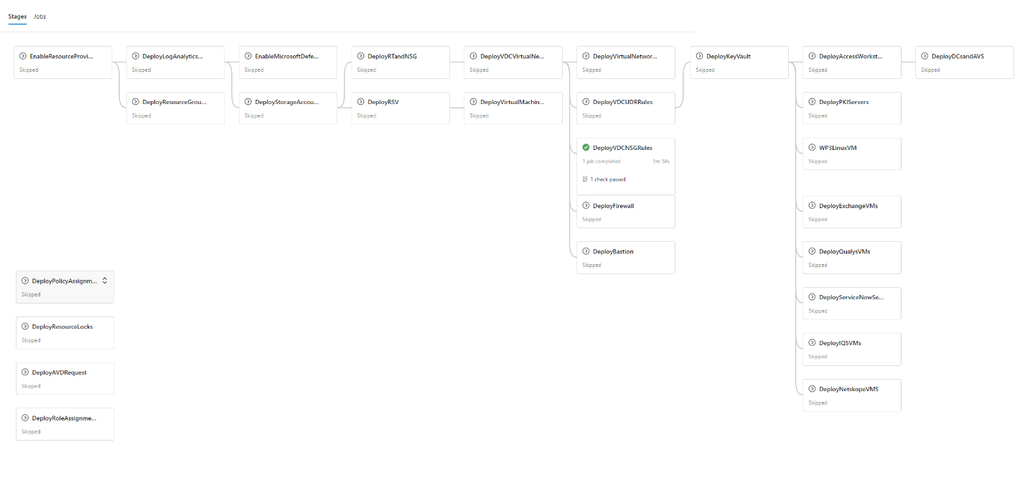

To run the pipeline:

1. Login to Azure DevOps Portal (<https://aex.dev.azure.com>)
2. Choose **core-it** Project
3. Select **Pipelines** and **Pipelines**
4. Select **CFSCO Master Pipeline**
5. Click **Run Pipeline**
6. Select the **Branch/Tag**
7. Set the **Target Deployment Environment**
8. Provide the **Artifact/package Version**
9. Check **Enable Day Light Savings Time** (when needed)
10. Select the **Stages to Run**
11. Click **Run**

|  |  |
| --- | --- |
|  | ***Important Note***  Make sure when you selected specific Stages to run, do not hit back button else it will reset the selection of stages and by default, all stages are selected. |

### Additional Requests - VM Deployment

Access Workstations/Jump Hosts, Domain Controllers and Azure Active Directory Server are the required VMs that were provisioned during Phase1 of the project. This was deployed using CFSCo Master Pipeline in azure devops.

Parameter is composed of:

1. Key Vault details – the key vault details in the parameter file will be used in all the virtual machines that will be created in the vmObject.

**Note:** If there is a requirement to use a different key vault for the virtual machine, a separate parameter file must be created.

1. Resource Group details – rgArray parameter can support multiple resource group, it is advisable to have the same resource group location.
2. VM Details – object for virtual machine can be repeated and the deployment can support multiple virtual machines deployed in single subscription and region.

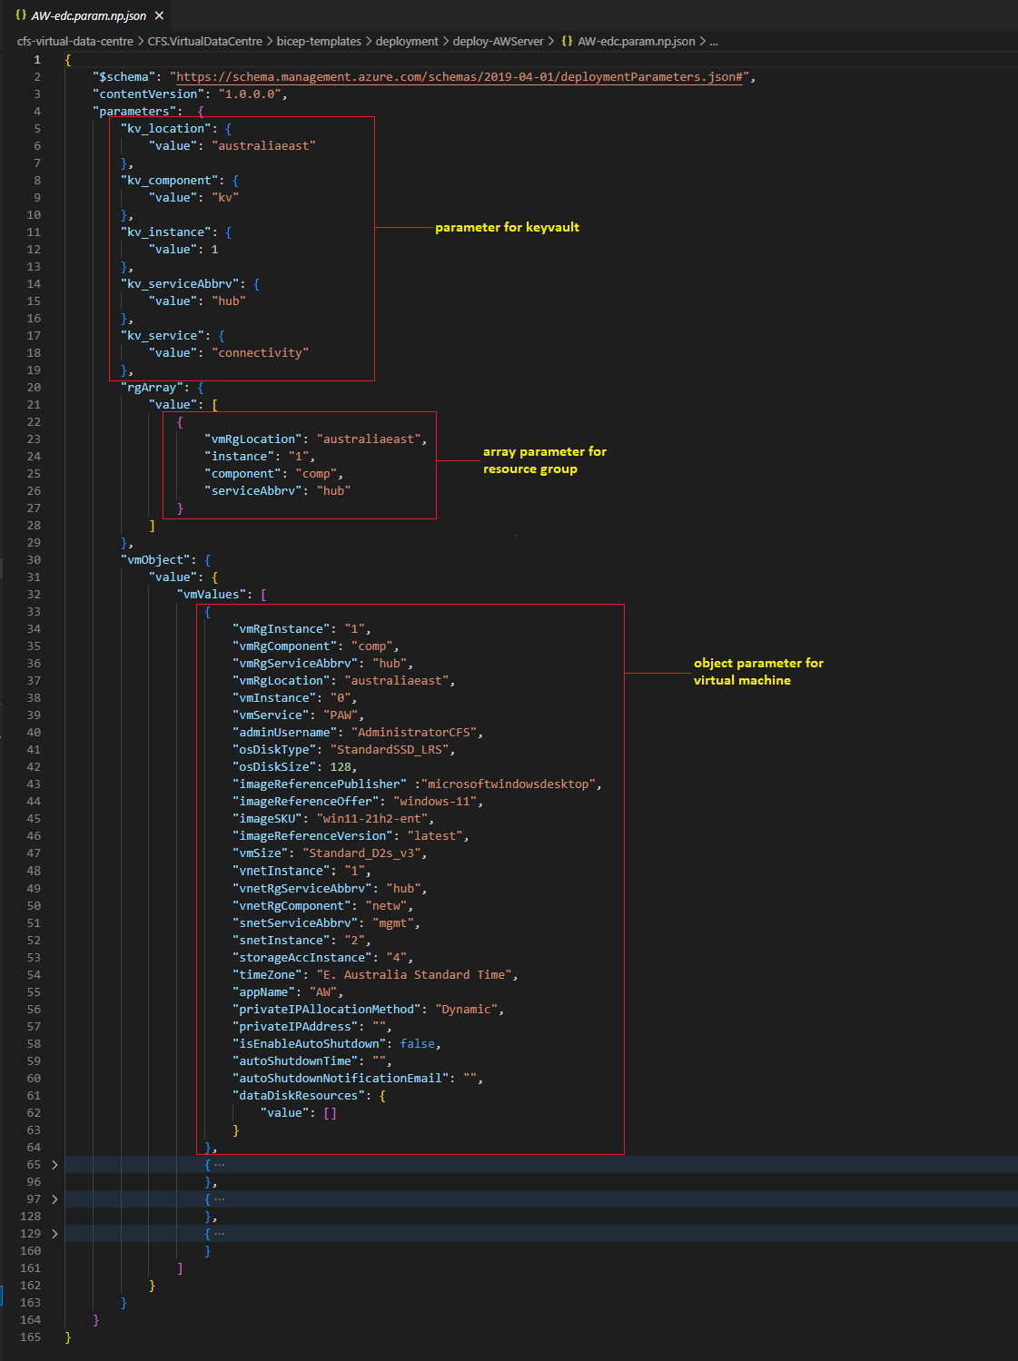

#### **Access Workstation**

##### Parameter File

For Access Workstation, there are separate parameter files per environment and per region.

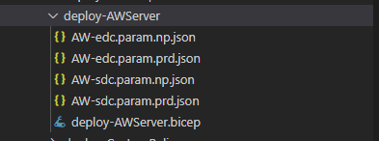

##### Deployment File

**Deployment File:** cfs-virtual-data-centre\CFS.VirtualDataCentre\bicep-templates\deployment\deploy-AWServer\deploy-AWServer.bicep

##### Module File

**Module File:** cfs-virtual-data-centre\CFS.VirtualDataCentre\bicep-templates\modules\Microsoft.Compute\deployVM.bicep

##### ADO Deployment

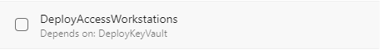

#### **Domain Controllers**

##### Parameter File

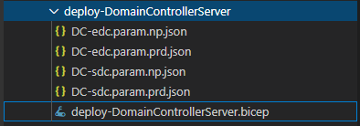

##### Deployment File

**Deployment File:** cfs-virtual-data-centre\CFS.VirtualDataCentre\bicep-templates\deployment\deploy-DomainControllerServer\deploy-DomainControllerServer.bicep

##### Module File

**Module File:** cfs-virtual-data-centre\CFS.VirtualDataCentre\bicep-templates\modules\Microsoft.Compute\deployVMwithAvailabilitySet.bicep

##### ADO Deployment



#### **Azure Active Directory**

##### Parameter File

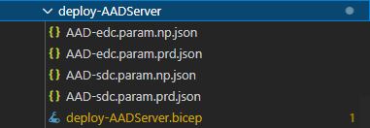

##### Deployment File

**Deployment File**: cfs-virtual-data-centre\CFS.VirtualDataCentre\bicep-templates\deployment\deploy-AADServer\deploy-AADServer.bicep

##### Module File

**Module File**: cfs-virtual-data-centre\CFS.VirtualDataCentre\bicep-templates\modules\Microsoft.Compute\deployVM.bicep

##### ADO Deployment



# Phase 2.1 – Landing Zone

Landing Zone build is part of Phase 2.1 scope. The following table shows the configurations in the Prod and Non-Prod Landing Zones built.

Back Office

|  |  |  |  |  |  |
| --- | --- | --- | --- | --- | --- |
|  | | **Non-Production** | | **Production** | |
| **EDC** | **SDC** | **EDC** | **SDC** |
| **Governance** | **Management Group Name** | mg-np-backoffice-001 | | mg-prd-backoffice-001 | |
| **Subscription** | subsc-np-backoffice-001 | | subsc-prd-backoffice-001 | |
| **Service Connections** | sc-subsc-np-bkof-001 | | sc-subsc-prd-bkof-001 | |
| **Service Principal** | sp-subsc-np-bkof-001 | | sp-subsc-prd-bkof-001 | |
| **Reader Group** | SG-AA-build-bkof-reader | | SG-AA-build-bkof-reader | |
| **Contributor Group** | SG-AA-build-bkof-contributor | | SG-AA-build-bkof-contributor | |
| **Network** | **Resource Group** | rg-np-edc-bkof-netw-001 | rg-np-sdc-bkof-netw-001 | rg-prd-edc-bkof-netw-001 | rg-prd-sdc-bkof-netw-001 |
| **Vnet Name** | vnet-np-edc-bkof-001 | vnet-np-sdc-bkof-001 | vnet-prd-edc-bkof-001 | vnet-prd-sdc-bkof-001 |
| **CIDR Allocation** | 10.43.0.0/16 | 10.63.0.0/16 | 10.23.0.0/16 | 10.33.0.0/16 |
| **Subnet Name** | sub-np-edc-bkof-001 | sub-np-sdc-bkof-001 | sub-prd-edc-bkof-001 | sub-prd-sdc-bkof-001 |
| **Subnet Address Prefix** | 10.43.0.0/24 | 10.63.0.0/24 | 10.23.0.0/24 | 10.33.0.0/24 |
| **Network Security Group** | nsg-np-edc-bkof-001 | nsg-np-sdc-bkof-001 | nsg-prd-edc-bkof-001 | nsg-prd-sdc-bkof-001 |
| **Route Table Name** | rt-np-edc-bkof-001 | rt-np-sdc-bkof-001 | rt-prd-edc-bkof-001 | rt-prd-sdc-bkof-001 |
| **Storage** | **Resource Group** | rg-np-edc-bkof-stor-001 | rg-np-sdc-bkof-stor-001 | rg-prd-edc-bkof-stor-001 | rg-prd-sdc-bkof-stor-001 |
| **Storage Account Name** | stonpedcbkof001 | stonpsdcbkof001 | stoprdedcbkof001 | stoprdsdcbkof001 |
| **Storage Account Type** | StorageV2 | StorageV2 | StorageV2 | StorageV2 |
| **RSV** | **Resource Group** | rg-np-edc-bkof-rsv-001 | rg-np-sdc-bkof-rsv-001 | rg-prd-edc-bkof-rsv-001 | rg-prd-sdc-bkof-rsv-001 |
| **Recovery Service Vault** | rsv-np-edc-bkof-001 | rsv-np-sdc-bkof-001 | rsv-prd-edc-bkof-001 | rsv-prd-sdc-bkof-001 |
| **Key Vault** | **Resource Group** | rg-np-edc-bkof-kv-001 | rg-np-sdc-bkof-kv-001 | rg-prd-edc-bkof-kv-001 | rg-prd-sdc-bkof-kv-001 |
| **Key Vault Name** | kv-np-edc-bkof-001 | kv-np-sdc-bkof-001 | kv-prd-edc-bkof-001 | kv-prd-sdc-bkof-001 |

First Choice

|  |  |  |  |  |  |
| --- | --- | --- | --- | --- | --- |
|  | | **Non-Production** | | **Production** | |
| **EDC** | **SDC** | **EDC** | **SDC** |
| **Governance** | **Management Group Name** | mg-np-digital-001 | | mg-prd-digital-001 | |
| **Subscription** | subsc-np-fcp-001 | | subsc-prd-fcp-001 | |
| **Service Connections** | sc-subsc-np-fcp-001 | | sc-subsc-prd-fcp-0001 | |
| **Service Principal** | sp-subsc-np-fcp-001 | | sp-subsc-prd-fcp-01 | |
| **Reader Group** | SG-AA-build-fcp-reader | | SG-AA-build-fcp-reader | |
| **Contributor Group** | SG-AA-build-fcp-contributor | | SG-AA-build-fcp-contributor | |
| **Network** | **Resource Group** | rg-np-edc-fcp-netw-001 | rg-np-sdc-fcp-netw-001 | rg-prd-edc-fcp-netw-001 | rg-prd-sdc-fcp-netw-001 |
| **Vnet Name** | vnet-np-edc-fcp-001 | vnet-np-sdc-fcp-001 | vnet-prd-edc-fcp-001 | vnet-prd-sdc-fcp-001 |
| **CIDR Allocation** | 10.41.0.0/16 | 10.61.0.0/16 | 10.21.0.0/16 | 10.31.0.0/16 |
| **Subnet Name** | sub-np-edc-fcp-001 | sub-np-sdc-fcp-001 | sub-prd-edc-fcp-001 | sub-prd-sdc-fcp-001 |
| **Subnet Address Prefix** | 10.41.0.0/24 | 10.61.0.0/24 | 10.21.0.0/24 | 10.31.0.0/24 |
| **Network Security Group** | nsg-np-edc-fcp-001 | nsg-np-sdc-fcp-001 | nsg-prd-edc-fcp-001 | nsg-prd-sdc-fcp-001 |
| **Route Table Name** | rt-np-edc-fcp-001 | rt-np-sdc-fcp-001 | rt-prd-edc-fcp-001 | rt-prd-sdc-fcp-001 |
| **Storage** | **Resource Group** | rg-np-edc-fcp-stor-001 | rg-np-sdc-fcp-stor-001 | rg-prd-edc-fcp-stor-001 | rg-prd-sdc-fcp-stor-001 |
| **Storage Account Name** | stonpedcfcp001 | stonpsdcfcp001 | stoprdedcfcp001 | stoprdsdcfcp001 |
| **Storage Account Type** | StorageV2 | StorageV2 | StorageV2 | StorageV2 |
| **RSV** | **Resource Group** | rg-np-edc-fcp-rsv-001 | rg-np-sdc-fcp-rsv-001 | rg-prd-edc-fcp-rsv-001 | rg-prd-sdc-fcp-rsv-001 |
| **Recovery Service Vault** | rsv-np-edc-fcp-001 | rsv-np-sdc-fcp-001 | rsv-prd-edc-fcp-001 | rsv-prd-sdc-fcp-001 |
| **Key Vault** | **Resource Group** | rg-np-edc-fcp-kv-001 | rg-np-sdc-fcp-kv-001 | rg-prd-edc-fcp-kv-001 | rg-prd-sdc-fcp-kv-001 |
| **Key Vault Name** | kv-np-edc-fcp-001 | kv-np-sdc-fcp-001 | kv-prd-edc-fcp-001 | kv-prd-sdc-fcp-001 |

**CFS Wrap**

|  |  |  |  |  |  |
| --- | --- | --- | --- | --- | --- |
|  | | **Non-Production** | | **Production** | |
| **EDC** | **SDC** | **EDC** | **SDC** |
| **Governance** | **Management Group Name** | mg-np-digital-001 | | mg-prd-digital-001 | |
| **Subscription** | subsc-np-fwp-001 | | subsc-prd-fwp-001 | |
| **Service Connections** | sc-subsc-np-fwp-001 | | sc-subsc-prd-fwp-001 | |
| **Service Principal** | sp-subsc-np-fwp-001 | | sp-subsc-prd-fwp-001 | |
| **Reader Group** | SG-AA-build-fwp-reader | | SG-AA-build-fwp-reader | |
| **Contributor Group** | SG-AA-build-fwp-contributor | | SG-AA-build-fwp-contributor | |
| **Network** | **Resource Group** | rg-np-edc-fwp-netw-001 | rg-np-sdc-fwp-netw-001 | rg-prd-edc-fwp-netw-001 | rg-prd-sdc-fwp-netw-001 |
| **Vnet Name** | vnet-np-edc-fwp-001 | vnet-np-sdc-fwp-001 | vnet-prd-edc-fwp-001 | vnet-prd-sdc-fwp-001 |
| **CIDR Allocation** | 10.42.0.0/16 | 10.62.0.0/16 | 10.22.0.0/16 | 10.32.0.0/16 |
| **Subnet Name** | sub-np-edc-fwp-001 | sub-np-sdc-fwp-001 | sub-prd-edc-fwp-001 | sub-prd-sdc-fwp-001 |
| **Subnet Address Prefix** | 10.42.0.0/24 | 10.62.0.0/24 | 10.22.0.0/24 | 10.32.0.0/24 |
| **Network Security Group** | nsg-np-edc-fwp-001 | nsg-np-sdc-fwp-001 | nsg-prd-edc-fwp-001 | nsg-prd-sdc-fwp-001 |
| **Route Table Name** | rt-np-edc-fwp-001 | rt-np-sdc-fwp-001 | rt-prd-edc-fwp-001 | rt-prd-sdc-fwp-001 |
| **Storage** | **Resource Group** | rg-np-edc-fwp-stor-001 | rg-np-sdc-fwp-stor-001 | rg-prd-edc-fwp-stor-001 | rg-prd-sdc-fwp-stor-001 |
| **Storage Account Name** | stonpedcfwp001 | stonpsdcfwp001 | stoprdedcfwp001 | stoprdsdcfwp001 |
| **Storage Account Type** | StorageV2 | StorageV2 | StorageV2 | StorageV2 |
| **RSV** | **Resource Group** | rg-np-edc-fwp-rsv-001 | rg-np-sdc-fwp-rsv-001 | rg-prd-edc-fwp-rsv-001 | rg-prd-sdc-fwp-rsv-001 |
| **Recovery Service Vault** | rsv-np-edc-fwp-001 | rsv-np-sdc-fwp-001 | rsv-prd-edc-fwp-001 | rsv-prd-sdc-fwp-001 |
| **Key Vault** | **Resource Group** | rg-np-edc-fwp-kv-001 | rg-np-sdc-fwp-kv-001 | rg-prd-edc-fwp-kv-001 | rg-prd-sdc-fwp-kv-001 |
| **Key Vault Name** | kv-np-edc-fwp-001 | kv-np-sdc-fwp-001 | kv-prd-edc-fwp-001 | kv-prd-sdc-fwp-001 |

## Initial Setup Tasks

### Management Group and Subscription

This section describes the step-by-step procedure on how platform-core management groups and subscriptions were deployed using the **New-Subscription-Pipeline**. Creation of management groups and subscriptions required a privilege account. CFS Service account was used to create management groups and subscriptions for platform-core.

In Visual Studio Code, prepare the parameter file **Platform-Core.param.json** which will be used for **New-Subscription-Pipeline** deployment.

File location: cfs-virtual-data-centre\CFS.VirtualDataCentre\bicep-templates\deployment\deploy-NewSubscription

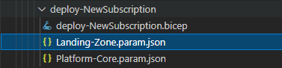

Parameter File structure:

|  |
| --- |
| **subManagementGroupName** = LandingZone  **subManagementGroupDisplayName** = Landing Zone  **instance** = this value will be appended at the end of the subscription name  managementGroup object block:  **name** = management group name  **displayName** =management group display name  subscriptions array block:  **service** = subscription name  workload = Production |

|  |  |
| --- | --- |
|  | ***Important Note***  *In* ***Landing-Zone.param.json****, the structure shows that there will be 2 subscriptions in Digital Channel Management group and 1 subscription in Back Office management group.*  *The complete management group and subscription name is being generated in the bicep template.* |

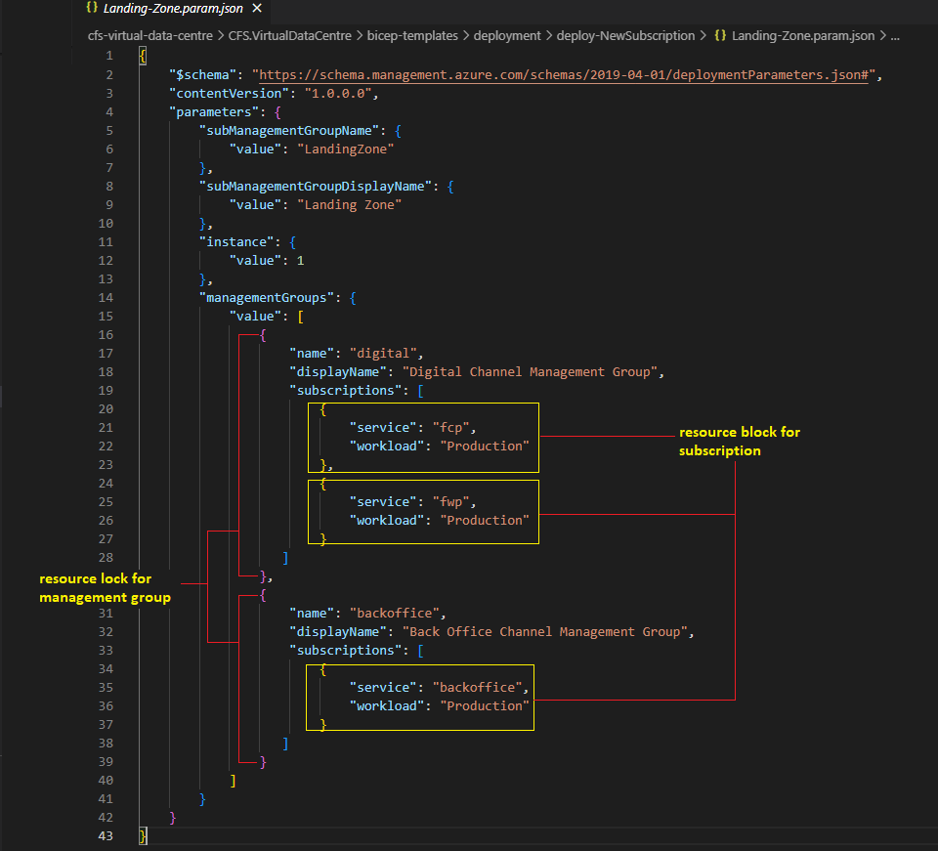

Commit the changes and push the codes in GitHub Repository.

Create a Pull Request to merge codes to develop branch.

|  |  |
| --- | --- |
|  | ***Important Note***  *Develop branch is used for non-production deployment*  *Main branch is used for production deployment* |

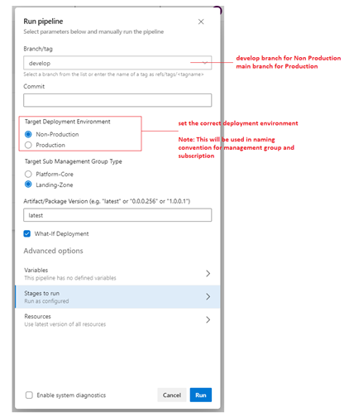

**Validation:**

To validate:

1. Sign in to <https://portal.azure.com> using the CFS Service Account
2. Navigate to Management Groups
3. Validate the Management Groups
4. Expand the Management Groups to verify the subscriptions are created.

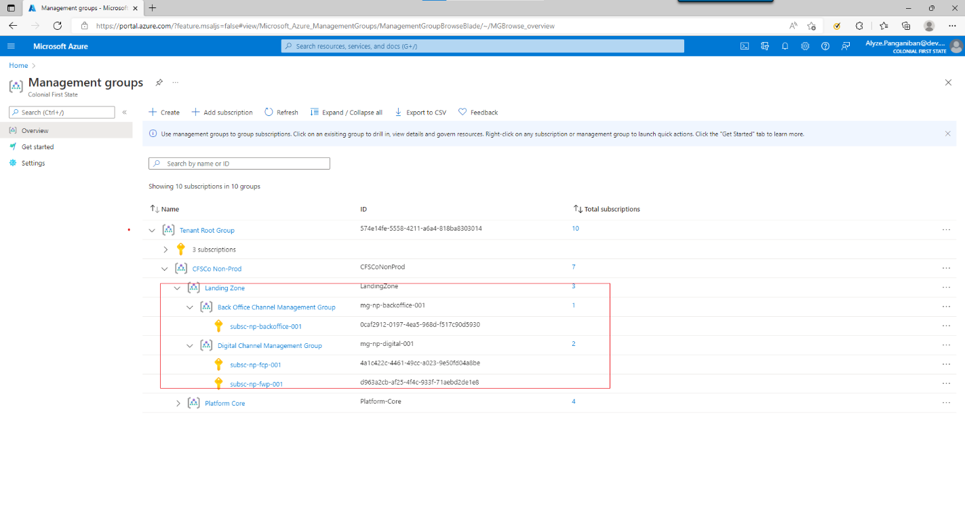

### Service Principal

This section describes the step-by-step procedure on how platform-core service principals were created in Azure Active Directory. The service principals are dependency on creating service connection. Creation of service principals requires privilege account. CFS Service account was used to create service principals for platform-core.

1. Login to **Azure Portal** (<https://portal.azure.com>) using CFS Service Account.
2. Navigate to **Azure Active Directory**, under **Manage**, select **App registrations**
3. click **New Registrations**
4. In Register an application page, input the **service principal** name
5. Use the default selection in **Supported account types** (Accounts in this organizational directory only)
6. Click **Register**





1. Click the **service principal** created
2. under **Manage**, click **Certificates & secrets**
3. select **Client secrets** tab and click **New client secret**
4. in Add a client secret page, in **Description** put the secret name
5. set the **expiry date**, then click **Add**.

|  |  |
| --- | --- |
|  | ***Important Note***  *Make sure to save the secret value since it will be hidden one the page refresh.*  *Client secret value will be used in step 2.3.3: Create platform-core service connection.* |

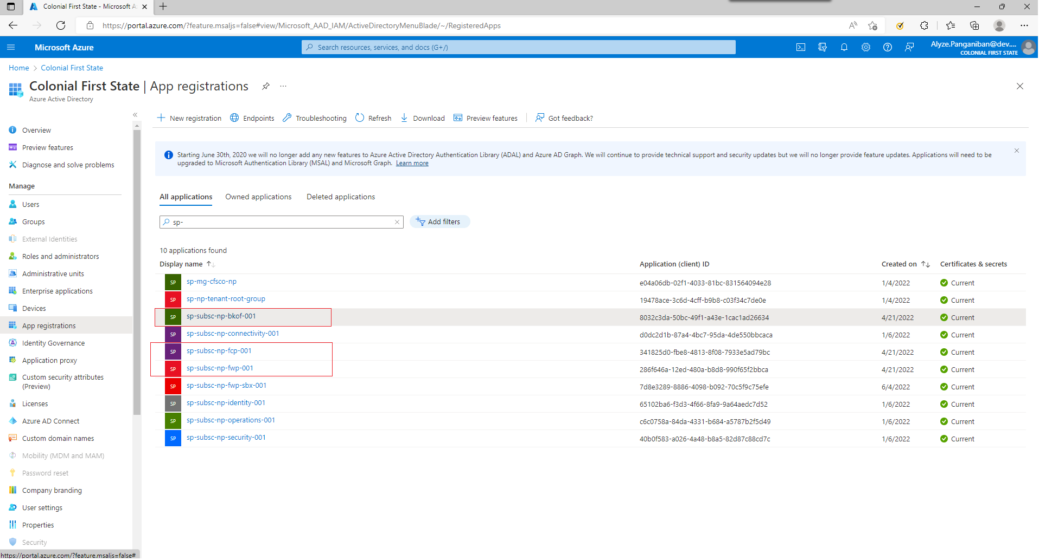

### Service Connection

This section describes the step-by-step procedure on how platform-core service connection were created in Azure DevOps. It is assumed that before doing this step, service principal is completed first. Creation of service connections requires privilege account. CFS Service account was used to create service connections in Azure DevOps.

1. Login to **Azure DevOps** (<https://aex.dev.azure.com/>) using CFS Service Account.
2. click the Azure DevOps Organization: **dev.azure.com/AUSUP**
3. select projects: **core-it**
4. In **Project settings**, under **Pipelines**, select **Service connections**
5. Click **New service connection**
6. In **New service connection** page,select **Azure Resource Manager,** click **Next**
7. In **New Azure service connection** page,select **Service principal (manual)**, click **Next**
8. Environment: Azure Cloud
9. Scope level: Subscription
10. Subscription Id: <put subscription id>
11. Subscription Name: <put subscription name>
12. Service Principal Id: <put Service Principal object ID>
13. Credential: Service principal key
14. Service principal key: <put Service principal secret value>
15. Tenant ID: <input tenant ID or directory ID>
16. Click **Verify** (once the connection is verified)
17. Service connection name: <input service connection name>
18. NOT recommending checking *Grant access permission to all pipelines* box
19. Click **Verify and Save**

Validation:

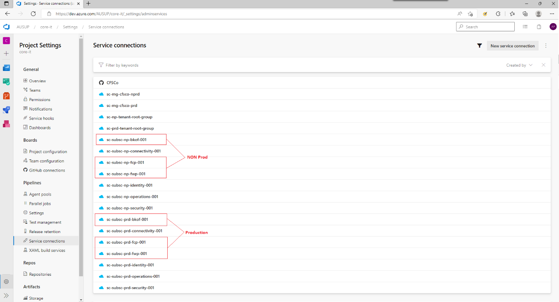

## Landing Zone deployment

### How to deploy Landing Zone

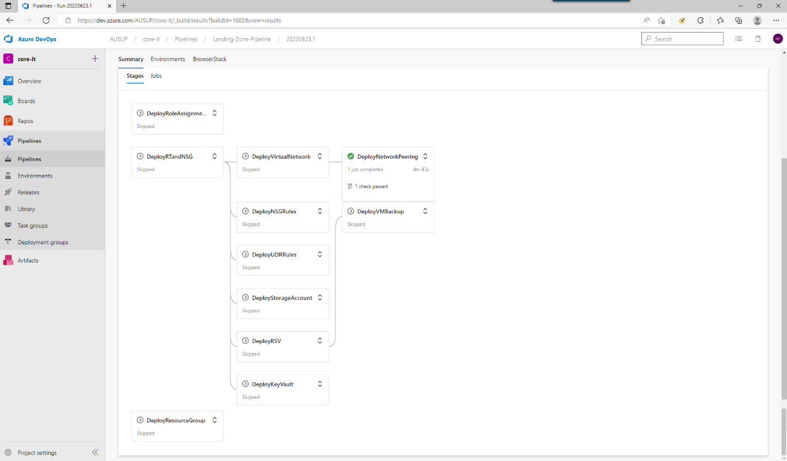

#### Prepare the parameter file

Parameter file location: cfs-virtual-data-centre\CFS.VirtualDataCentre\bicep-templates\deployment\01-Landing-Zone\parameter-files

parameter-files

<landingZoneServiceId>

> 00-**Resource-Group**

>> **Resource-Group**-<landingZoneServiceId>.param.json

> 01-**Role-Assignment**

>> **Role-Assignment**-<landingZoneServiceId>.param.<environment>.json

> 02-**Network**

>> **Network**-<landingZoneServiceId>.param.<environment>.json

>> **NsgRule**-<landingZoneServiceId>.param.<environment>.json

>> **Peering-HubToSpoke**-<landingZoneServiceId>.param.<environment>.json

>> **Peering-SpokeToHub**-<landingZoneServiceId>.param.<environment>.json

>> **UdrRules**-<landingZoneServiceId>.param.<environment>.json

> 03-**Storage-Account**

>> **Storage-Account**-<landingZoneServiceId>.param.<environment>.json

> 04-**RSV**

>> **RSV**-<landingZoneServiceId>.param.<environment>.json

> 05-**Key-Vault**

>> **KeyVault**-<landingZoneServiceId>.param.<environment>.json

>>**KeyVaultAuth**-<landingZoneServiceId>.param.<environment>.json

Sample landing zone parameter for Back Office Landing Zone:

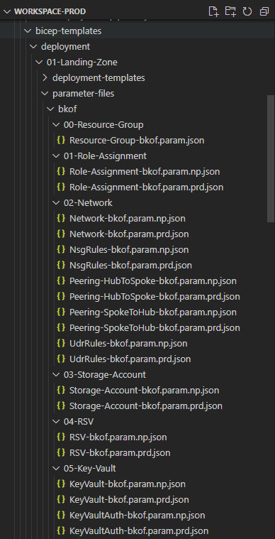

#### Deploy using Deploy using Landing-Zone-Pipeline

|  |  |
| --- | --- |
| Parameter | Remarks |
| Branch/Tag | Feature/branch or develop can be used for Non-Production deployment  Main branch is required for Production deployment |
| Commit | Not required |
| Target Deployment Environment | Non-Production or Production |
| Artifact/Package Version | latest can be used but the exact version is recommended to avoid conflicts if there’s simultaneous github actions running. |
| Landing Zone Subscription Id | bkof  fcp  fwp |
| Landing Zone Subscription Name | Back Office  First Choice  CFS Wrap |
| Enable Daylight Savings Time | Boolean |
| What-If Deployment | Boolean, this will replace “create” with “what-if” when checked.  what-if deployment only plans the deployment and displays the output. |
| Stages | Select the stages to run |

Note: By default, Run all stages is enabled, when specific stages are selected, any changes on the details will reset the specific selection on stages.

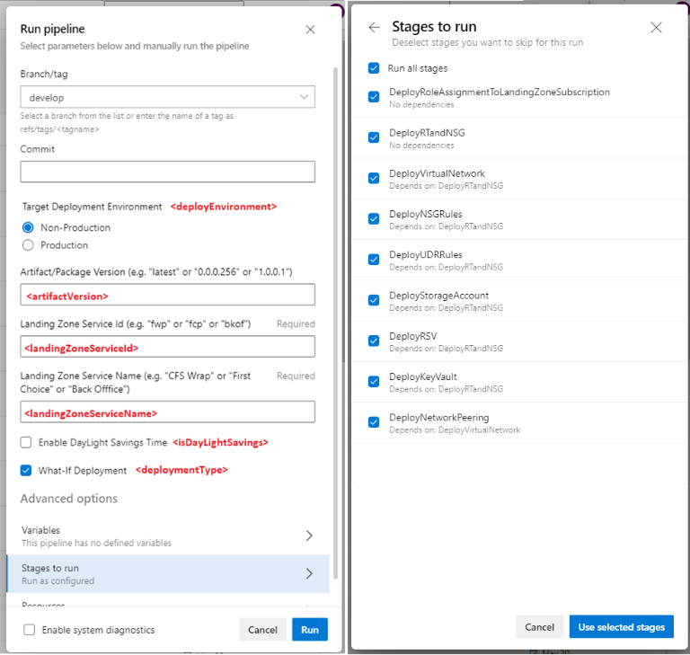

### Role Assignment to Landing Zone Subscription

#### Parameter File

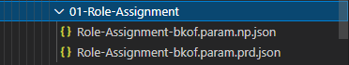

#### Deployment File

**Deployment File**: cfs-virtual-data-centre\CFS.VirtualDataCentre\bicep-templates\deployment\01-Landing-Zone\deployment-templates\deploy-RoleAssignmentToSubscription.bicep

#### Module File

**Module files:**

cfs-virtual-data-centre\CFS.VirtualDataCentre\bicep-templates\modules\Microsoft.Authorization\roleAssignment\subscription\deployContibutorRoleAssignmentToSubscription.bicep

cfs-virtual-data-centre\CFS.VirtualDataCentre\bicep-templates\modules\Microsoft.Authorization\roleAssignment\subscription\deployOwnerRoleAssignmentToSubscription.bicep

cfs-virtual-data-centre\CFS.VirtualDataCentre\bicep-templates\modules\Microsoft.Authorization\roleAssignment\subscription\deployReaderRoleAssignmentToSubscription.bicep

#### ADO Deployment

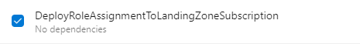

### Route Table and Network Security Group

#### Parameter File

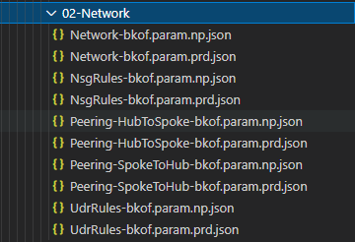

#### Deployment File

**Deployment File:** cfs-virtual-data-centre\CFS.VirtualDataCentre\bicep-templates\deployment\01-Landing-Zone\deployment-templates\deploy-RTandNSG.bicep

#### Module File

**Module File:** cfs-virtual-data-centre\CFS.VirtualDataCentre\bicep-templates\modules\Microsoft.Network\virtualNetwork\deployRTandNSG.bicep

#### ADO Deployment

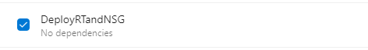

### Virtual Network

#### Parameter File



#### Deployment File

**Deployment File:** cfs-virtual-data-centre\CFS.VirtualDataCentre\bicep-templates\deployment\01-Landing-Zone\deployment-templates\deploy-VDCVirtualNetwork.bicep

#### Module File

**Module File:** cfs-virtual-data-centre\CFS.VirtualDataCentre\bicep-templates\modules\Microsoft.Network\virtualNetwork\deployVNET.bicep

#### ADO Deployment

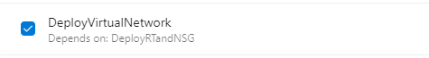

### NSG Rules

#### Parameter File



#### Deployment File

**Deployment File**: cfs-virtual-data-centre\CFS.VirtualDataCentre\bicep-templates\deployment\01-Landing-Zone\deployment-templates\deploy-NsgRule.bicep

#### Module File

**Module File:** cfs-virtual-data-centre\CFS.VirtualDataCentre\bicep-templates\modules\Microsoft.Network\NetworkSecurityGroups\deployNSGRules.bicepADO Deployment

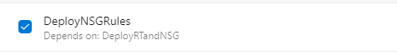

### UDR – Route Rules

#### Parameter File



#### Deployment File

**Deployment File**: cfs-virtual-data-centre\CFS.VirtualDataCentre\bicep-templates\deployment\01-Landing-Zone\deployment-templates\deploy-Udr.bicep

#### Module File

**Module:** cfs-virtual-data-centre\CFS.VirtualDataCentre\bicep-templates\modules\Microsoft.Network\routeTables\deployRoutes.bicep

#### ADO Deployment

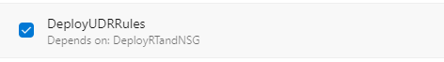

### Storage Account

#### Parameter File

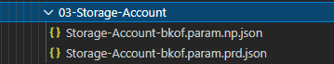

#### Deployment File

**Deployment File**: cfs-virtual-data-centre\CFS.VirtualDataCentre\bicep-templates\deployment\01-Landing-Zone\deployment-templates\deploy-storageAccount.bicep

#### Module File

**Module:** cfs-virtual-data-centre\CFS.VirtualDataCentre\bicep-templates\modules\Microsoft.Storage\deployStorageAccount.bicep

#### ADO Deployment

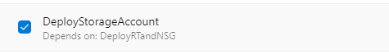

### Recovery Service Vault

#### Parameter File

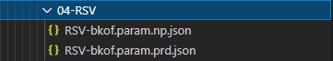

#### Deployment File

**Deployment File:** cfs-virtual-data-centre\CFS.VirtualDataCentre\bicep-templates\deployment\01-Landing-Zone\deployment-templates\deploy-RSV.bicep

#### Module File

**Module File:** cfs-virtual-data-centre\CFS.VirtualDataCentre\bicep-templates\modules\Microsoft.RecoveryServices\vaults\deployRSV.bicep

#### ADO Deployment

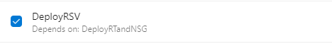

### Key Vault

#### Parameter File

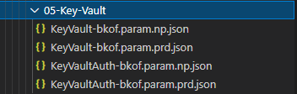

#### Deployment File

**Deployment File:**

cfs-virtual-data-centre\CFS.VirtualDataCentre\bicep-templates\deployment\01-Landing-Zone\deployment-templates\deploy-KeyVault.bicep

cfs-virtual-data-centre\CFS.VirtualDataCentre\bicep-templates\deployment\01-Landing-Zone\deployment-templates\deploy-KeyVaultAuth.bicep

#### Module File

**Module File:**

cfs-virtual-data-centre\CFS.VirtualDataCentre\bicep-templates\modules\Microsoft.KeyVault\deployKeyVault.bicep

cfs-virtual-data-centre\CFS.VirtualDataCentre\bicep-templates\modules\Microsoft.KeyVault\deployKeyVaultAuth.bicep

#### ADO Deployment

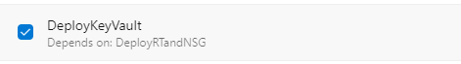

### Network Peering

#### Parameter File



#### Deployment File

**Deployment File:**

cfs-virtual-data-centre\CFS.VirtualDataCentre\bicep-templates\deployment\01-Landing-Zone\deployment-templates\deploy-HubToSpokeVnetPeering.bicep

cfs-virtual-data-centre\CFS.VirtualDataCentre\bicep-templates\deployment\01-Landing-Zone\deployment-templates\deploy-SpokeToHubVnetPeering.bicep

#### Module File

**Module File:**

cfs-virtual-data-centre\CFS.VirtualDataCentre\bicep-templates\modules\Microsoft.Network\virtualNetworkPeering\deployVnetPeeringtoHub.bicep

cfs-virtual-data-centre\CFS.VirtualDataCentre\bicep-templates\modules\Microsoft.Network\virtualNetworkPeering\deployVnetPeeringtoSpoke.bicep

#### ADO Deployment

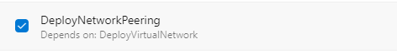

# Phase 2.1 - Common Requests

## VM Build Requests

### Preparing parameter files

VM provisioning is a common request to the VDC team. This section will describe the step-by-step procedure to deploy virtual machine using azure pipeline. The screenshot below will show the file included in VM deployment includes scripts in azure-pipelines which will be used for Azure Pipeline deployment and bicep-templates which are used to create the resources in Azure. Currently the OS supported by automated deployments are Linux, Windows, Qualys, and SailpointVA.

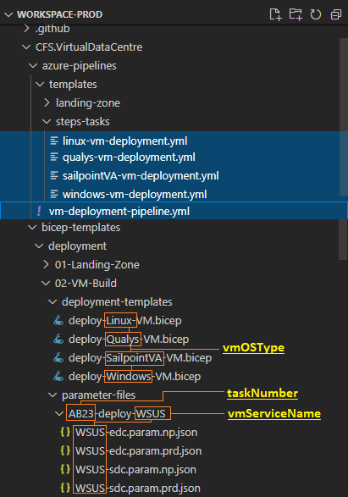

|  |  |
| --- | --- |
|  | ***Important Note***  It is important to provide the correct folder structure and filename when preparing the parameter files for the VM Deployment.  The highlighted **vmOSType**, **taskNumber** and **vmServiceName** are used as parameters in the yaml templates will determine the file path of the deployment template and parameter file to be used so it must be declared properly. |

### Pipeline deployment

To proceed with VM Deployment:

1. Login to <https://aex.dev.azure.com/>
2. Select the **vm-deployment-pipeline** and click **Run Pipeline**
3. Fill out all the required parameter file and click **Run**

|  |  |
| --- | --- |
|  | ***Important Note***  One (1) approval required for non-Production deployment  Two (2) approvals required for Production deployment |

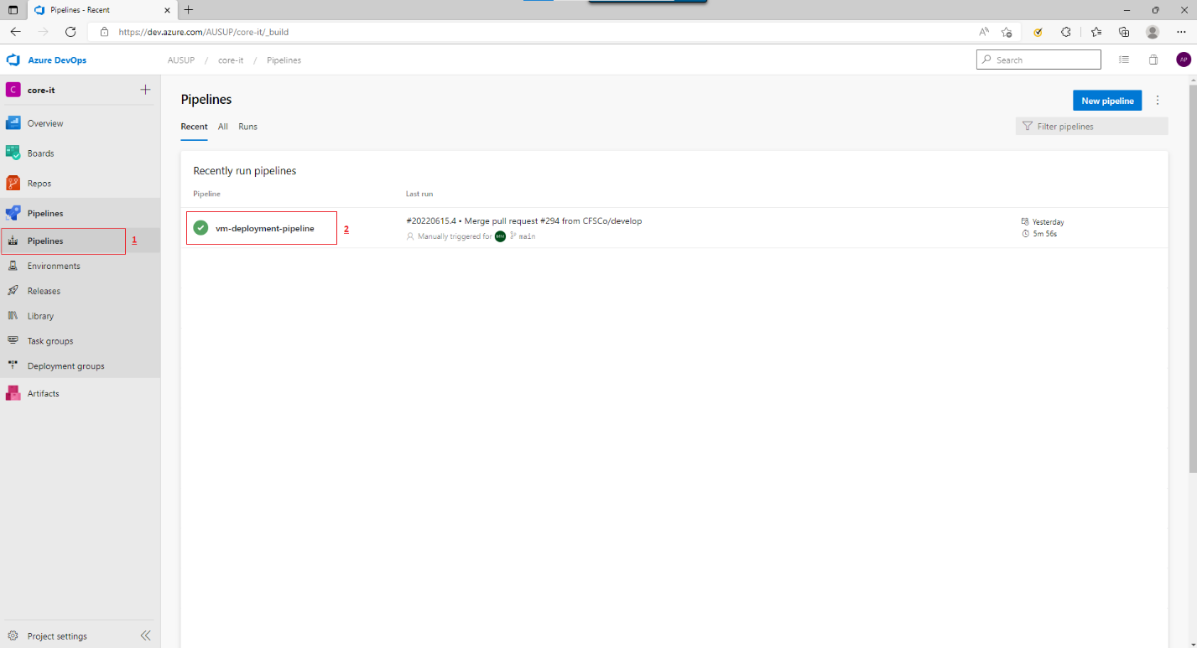

Pipeline parameter guide:

|  |  |
| --- | --- |
| Parameter | Remarks |
| Branch/Tag | Feature/branch or develop can be used for Non-Production deployment  Main branch is required for Production deployment |
| Commit | Not required |
| Target Deployment Environment | Non-Production or Production |
| Artifact/Package Version | latest can be used but the exact version is recommended to avoid conflicts if there’s simultaneous github actions running. |
| Subscription Service Id | connectivity  identity  security  operations  bkof  fcp  fwp |
| Azure DevOps Task Number | ABXXX  This will be included in the folder name |
| VM Type | Linux  Windows  Qualys  SailpointVA  This will determine what deployment template will be used. |
| Key Vault Name | Can put N/A if other vmOSType except Windows  This is used to retrieve the keyvault url for disk encryption |
| Target VM Location Abbreviation | This will determine the location where the vm will be deployed. This will also determine that parameter file will be used during the deployment. |
| Virtual Machine Service Name | This will determine the App Name in the service tag, This will also determine the parameter file that will be used during the deployment. |
| Enable DayLight Savings Time | Boolean |
| What-If Deployment | Boolean, this will replace “create” with “what-if” when checked.  what-if deployment only plans the deployment and displays the output. |

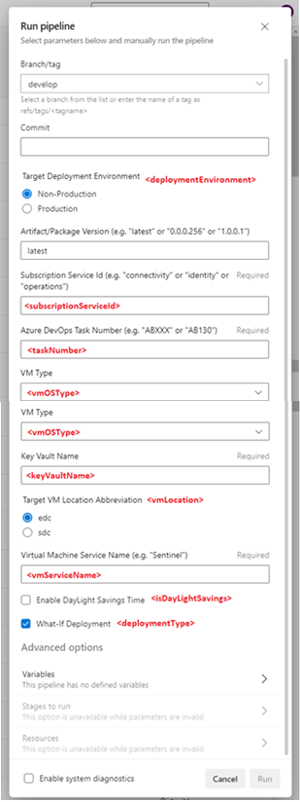

### Deployment Monitoring

To monitor the deployment:

1. Login to Azure Portal (<https://portal.azure.com>)
2. Go to the subscription
3. Select deployment

Sample deployment:

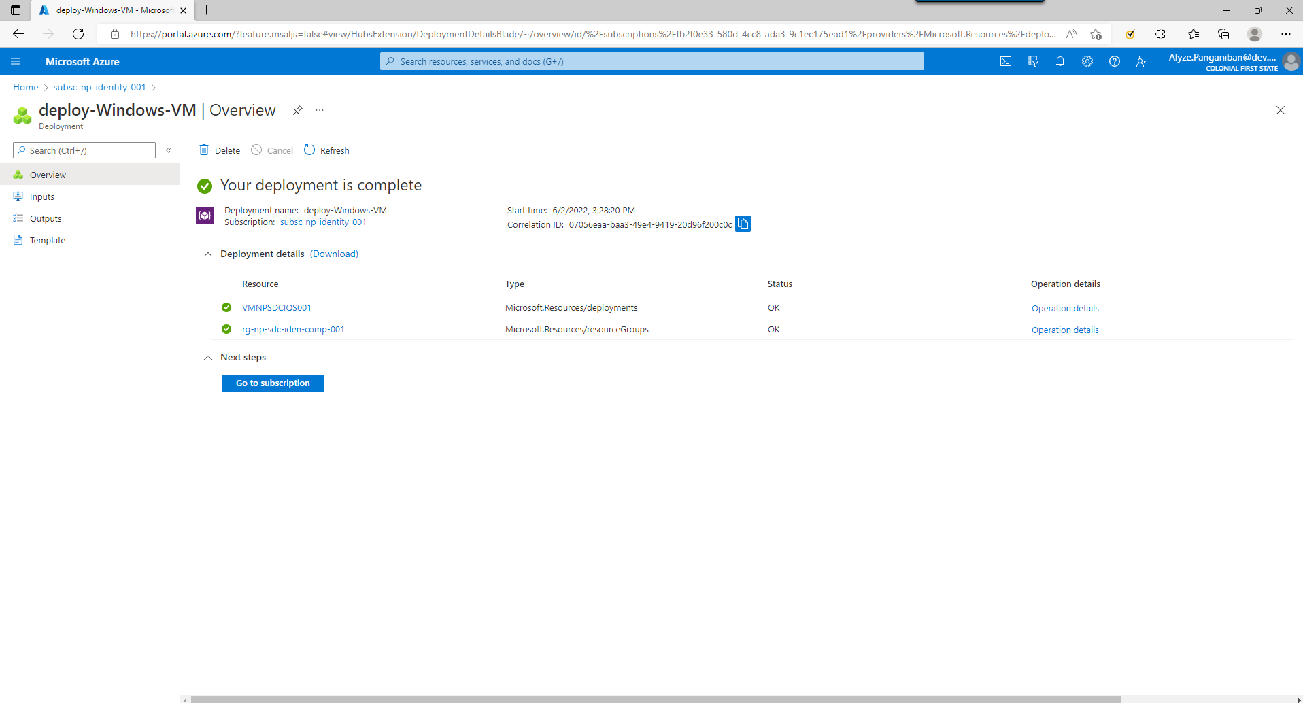

### Validation

To validate the vm deployment:

1. Login to Azure Portal (<https://portal.azure.com>)
2. Go to Virtual Machines
3. Search for the virtual machine created

## Additional IP Range to an existing Virtual Network

Adding IP Range to an existing virtual network requires a network downtime. This activity should be planned and communicated before the implementation.

During Phase 2.1, this activity was implemented to improve the approach in Access Workstation in Non-Production.

### Preparing parameter files

Access workstations are deployed in Connectivity subscription and the parameter file used for connectivity network is cfs-virtual-data-centre\CFS.VirtualDataCentre\bicep-templates\deployment\connectivity.param.np.json

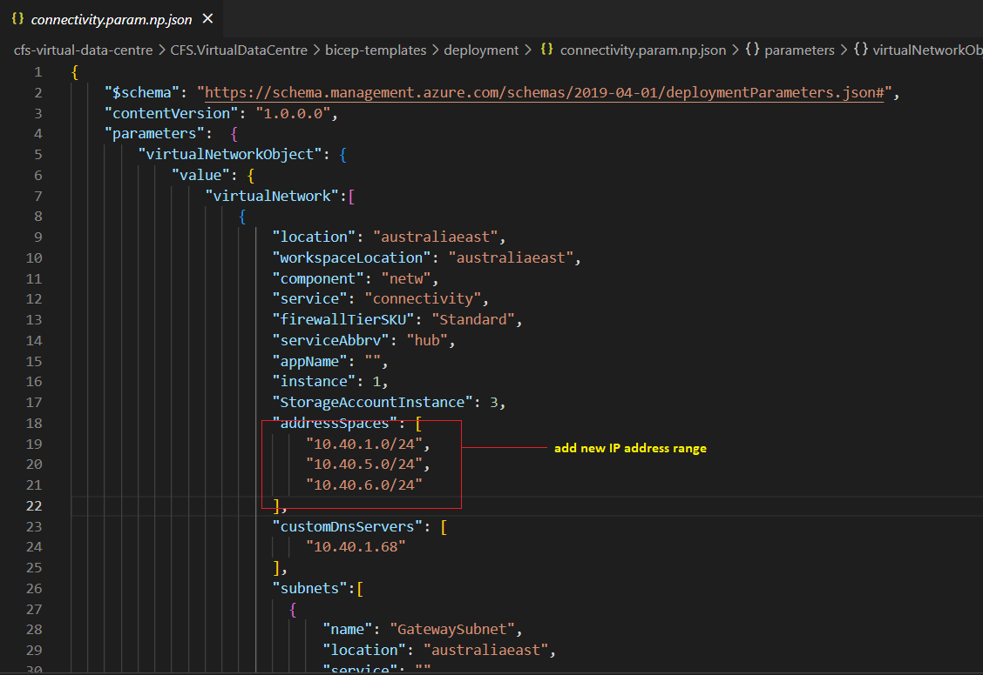

Update the subnet details

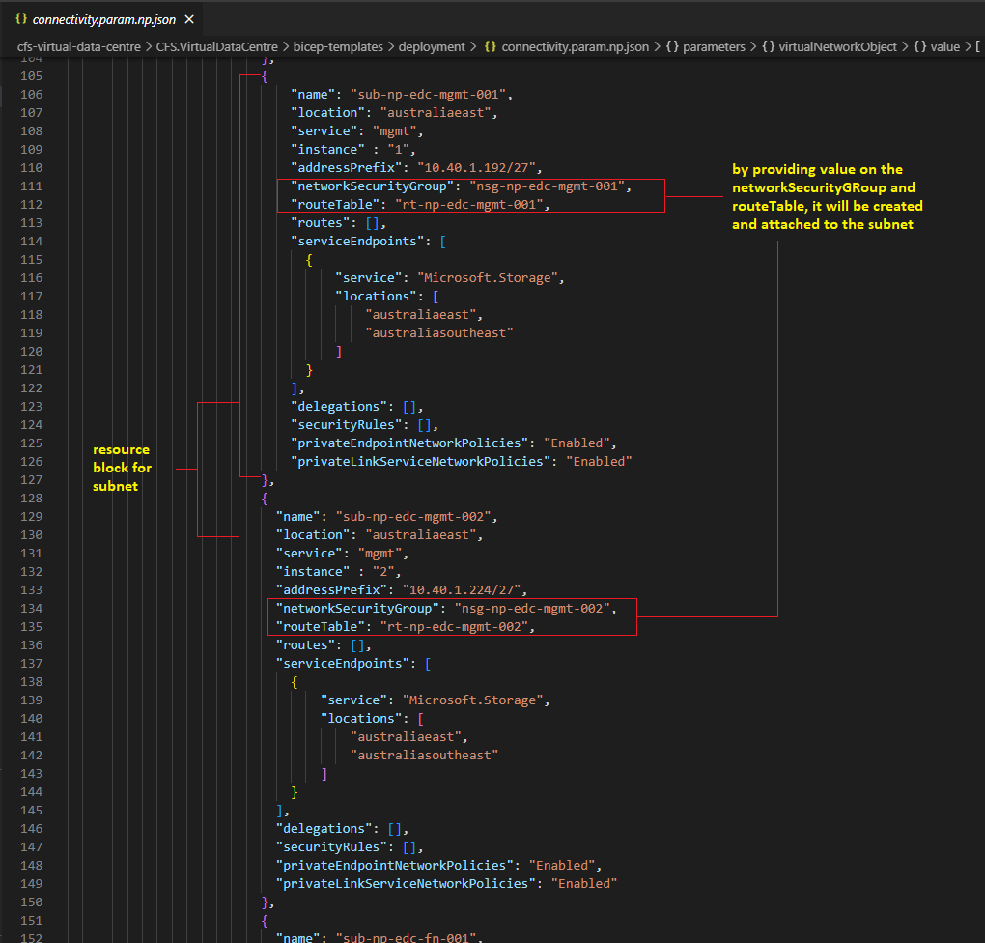

### Pre-deployment

Adding IP range in exiting virtual network requires all the virtual network peering in the vnet to be removed.

1. Login to Azure Portal (<https://portal.azure.com>)
2. Navigate to Virtual Networks and select Hub Vnets (vnet-np-edc-hub-001 and vnet-np-sdc-hub-001)
3. In Settings, select Peerings
4. Select the peering and delete

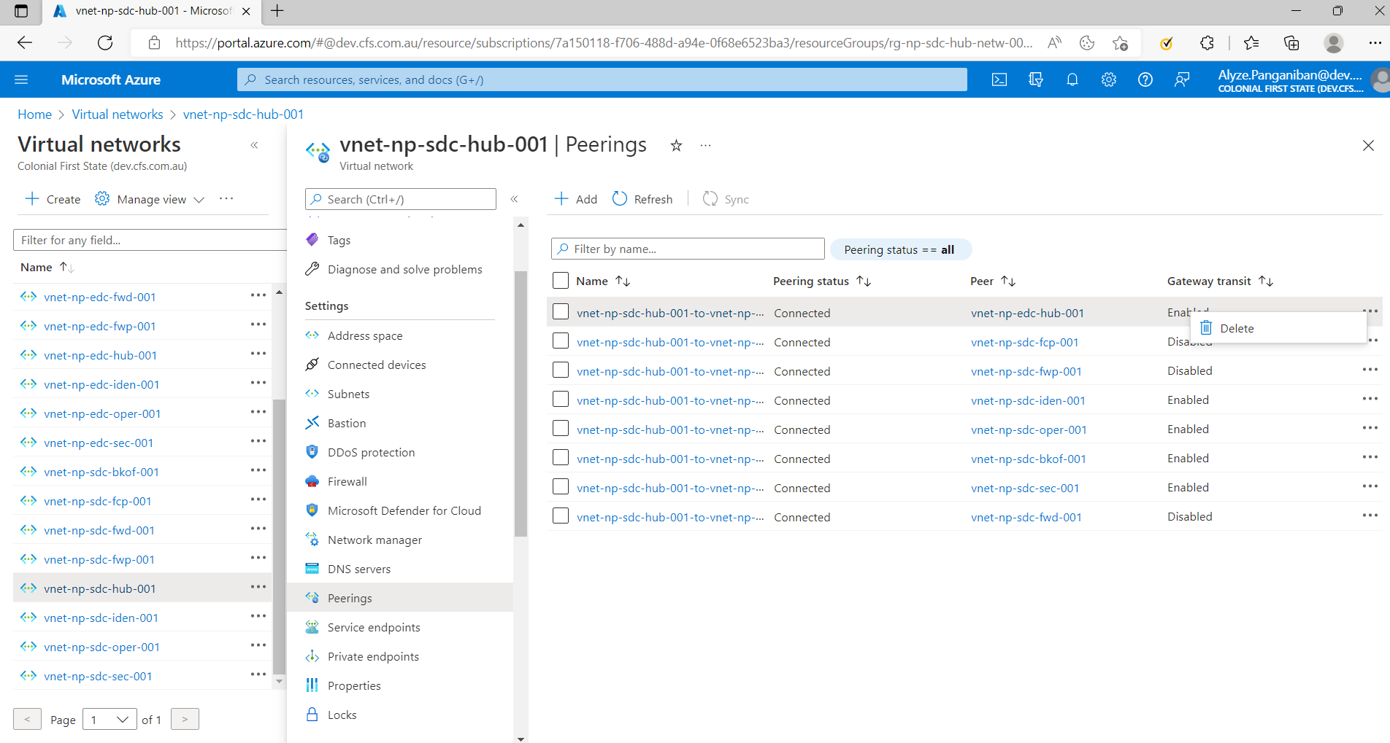

### Pipeline deployment

To implement the change, deploy the following stages in the pipeline:

* DeployRTandNSG – this stage will create the new route table and nsg. Do take note that this action will wipe existing the user defined routes rules and nsg rules since the parameter file does not include them. It will be recreated after running the DeployNetworkUDRRules and DeployNetworkNSGRules stage.
* DeployVDCVirtualNetwork – this stage will update the IP range based on the parameter file. It will also create the new subnets and attach the nsg and route tables to it.
* DeployVirtualNetworkPeerings – this stage will recreate all the network peerings for connectivity, identity, security and operations subscription. A separate pipeline (landing-zone-pipeline) with DeployVirtualNetworkPeerings will be used to redeploy the network peerings to the landing zone.
* DeployNetworkUDRRules – this stage will recreate the UDR rules.
* DeployNetworkNSGRules – this stage will recreate the NSG rules.

### Deployment Monitoring

### Validation

To validate the deployment:

1. Login to Azure Portal (<https://portal.azure.com>)
2. Navigate to Virtual Network and select (vnet-np-edc-hub-001 and vnet-np-sdc-hub-001)
3. In settings, Address space, verify that the IP Address range is added
4. In settings, Subnets, verify that the new subnets are correct and respective NSG and Route table are attached to it.
5. In Settings, Peering, verify that all the network peerings are restored.

Connectivity validation:

1. Login to Access Workstations using bastion connection (make sure that if you are connecting to EDC, use bastion-np-edc-001 and bastion-np-sdc-001 for SDC)
2. Login to any servers from deployed in other virtual network from Access workstation to test the connectivity.

## NSG and Route Table

### Preparing parameter files

Adding NSG and RT is a common request to the VDC team. This section will describe the step-by-step procedure to add NSG and RT using azure pipeline. The screenshot below will show the file included in NSG and RT deployment, includes deploy bicep and parameter files which are used to create the resources in Azure.

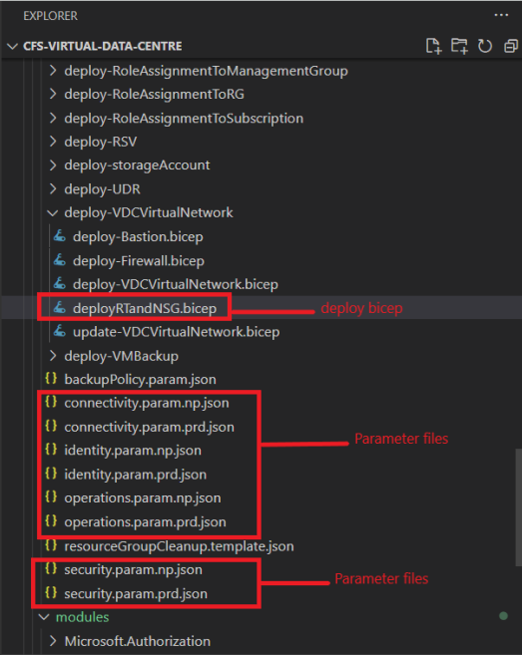

|  |  |
| --- | --- |
|  | ***Important Note***  It is important to provide the correct folder structure and filename when preparing the parameter files for adding NSG and RT.  Subscription and environment are used to name the parameter files, it is used to determine on what file will be use upon running the pipeline. |

### Pipeline deployment

To proceed with VM Deployment:

1. Login to <https://aex.dev.azure.com/>
2. Select the **CFSCo Master Pipeline**and click **Run Pipeline**
3. Fill out all the required parameter file and on the stages to run choose **DeployRTandNSG** and click **Run**

|  |  |
| --- | --- |
|  | ***Important Note***  One (1) approval required for non-Production deployment  Two (2) approvals required for Production deployment |

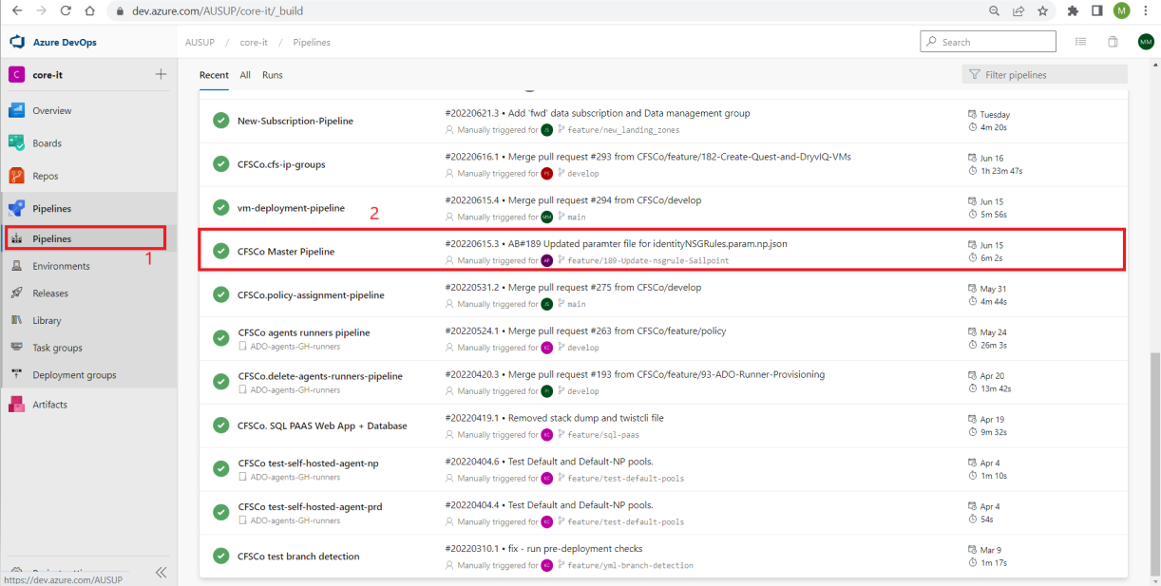

Pipeline parameter guide:

|  |  |
| --- | --- |
| Parameter | Remarks |
| Branch/Tag | Feature/branch or develop can be used for Non-Production deployment  Main branch is required for Production deployment |
| Commit | Not required |
| Target Deployment Environment | Non-Production or Production |
| Artifact/Package Version | latest can be used but the exact version is recommended to avoid conflicts if there’s simultaneous github actions running. |
| Stages to tun | DeployRTandNSG |

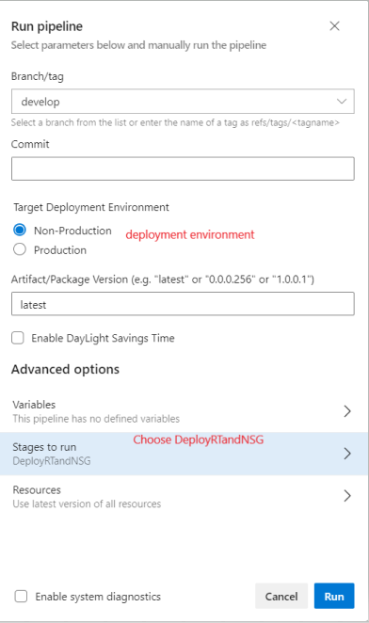

### Deployment Monitoring

To monitor the deployment:

1. Login to Azure Portal (<https://portal.azure.com>)
2. Go to the subscription
3. Select deployment

Sample deployment:

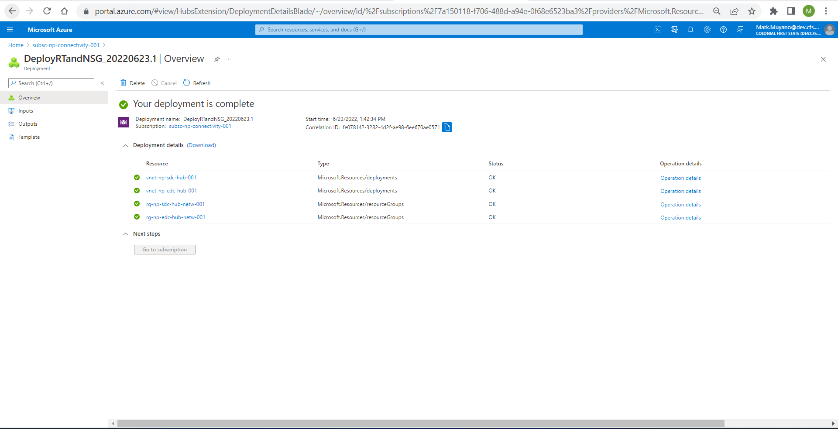

### Validation

To validate the vm deployment:

1. Login to Azure Portal (<https://portal.azure.com>)
2. Go to NSG or Route table
3. Search for the NSG or route table created.

## NSG rules

### Preparing parameter files

Adding NSG rules is a common request to the VDC team. This section will describe the step-by-step procedure to add NSG rules using azure pipeline. The screenshot below will show the file included in NSG rules deployment, includes deploy bicep and parameter files which are used to create the resources in Azure.

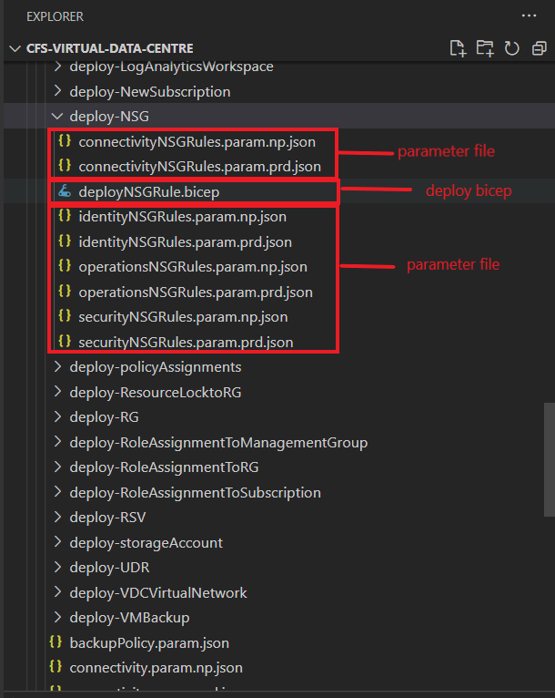

|  |  |
| --- | --- |
|  | ***Important Note***  It is important to provide the correct folder structure and filename when preparing the parameter files for adding NSG and RT  Subscription and environment are used to name the parameter files it is used to determine on what file will be use upon running the pipeline. |

### Pipeline deployment

To proceed with VM Deployment:

1. Login to <https://aex.dev.azure.com/>
2. Select the **CFSCo Master Pipeline**and click **Run Pipeline**
3. Fill out all the required parameter file and on the stages to run choose **DeployRTandNSG** and click **Run**

|  |  |
| --- | --- |
|  | ***Important Note***  One (1) approval required for non-Production deployment  Two (2) approvals required for Production deployment |



Pipeline parameter guide:

|  |  |
| --- | --- |
| Parameter | Remarks |
| Branch/Tag | Feature/branch or develop can be used for Non-Production deployment  Main branch is required for Production deployment |
| Commit | Not required |
| Target Deployment Environment | Non-Production or Production |
| Artifact/Package Version | latest can be used but the exact version is recommended to avoid conflicts if there’s simultaneous github actions running. |
| Stages to tun | DeployRTandNSG |

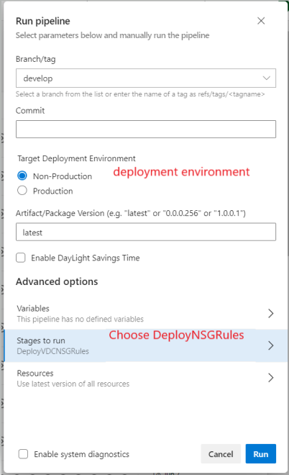

### Deployment Monitoring

To monitor the deployment:

1. Login to Azure Portal (<https://portal.azure.com>)
2. Go to the subscription
3. Select deployment

Sample deployment:

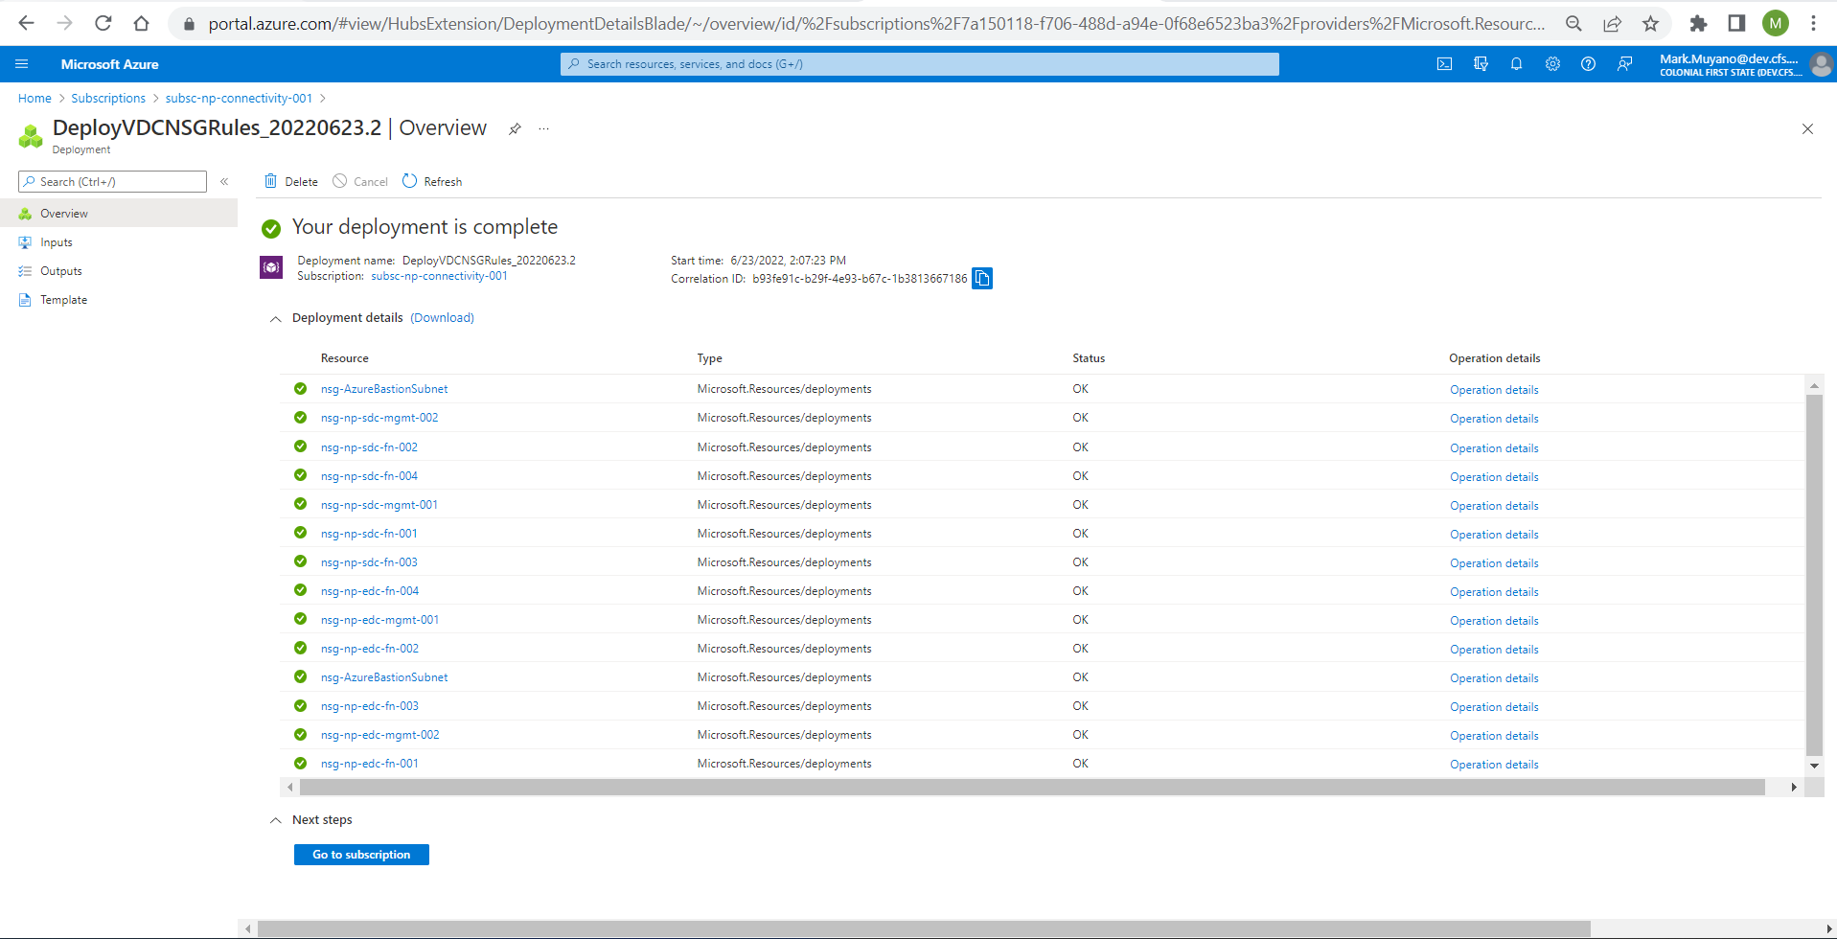

### Validation

To validate the vm deployment:

1. Login to Azure Portal (<https://portal.azure.com>)
2. Go to NSG
3. Search for the NSG rules.

# Phase 2.1 – Azure Service (Application)

|  |  |
| --- | --- |
|  | ***Important Note***  Phase 2.1 does not have definite requirements on building the Azure Services (Application) codes such as how it will be used on the current CFS environment. It is with consideration of minimum requirements to build services using bicep codes. |

## Azure App Service Environment

App Service Environment is a single-tenant deployment of Azure App Service. A virtual network is required deploy one subnet for a deployment of App Service Environment, and this subnet can't be used for anything else.

### Key Components

Key Components to consider when creating Azure App Service Environment:

* Subscription
* Location
* Resource Group
* Azure Virtual Network
* Subnet / Subnet Size – (Note: this will be a delegated subnet to Microsoft.Web/hostingEnvironments. The recommended subnet size is /24.)
* Storage Account – for diagnostic logs
* Log Analytics Workspace –for diagnostic logs

### Task Details

Assumptions before running appServiceEnvironment.bicep

1. Virtual Network – an existing virtual network with available address space to create the dedicated subnet for app service environment.
2. Storage Account – there is an existing storage account, for the case of CFS, this is the diagnostic storage account located in security subscription.
3. Log Analytics Workspace – there is an existing log analytics workspace, for the case of CFS, this is the log analytics workspace used by all the resources, (ws-np-edc-001 or ws-prd-edc-001)

What appServiceEnvironment.bicep deployment file does?

1. The script will check if the resource group specified on the deployment is existing in the subscription
2. It will check if the virtual network is existing.
3. Then it calls the appServiceEnvironment.bicep module file
4. In appServiceEnvironment.bicep module, it will call a nested_existingVirtualNetworkTemplate.bicep module file which will create a dedicated subnet for the App Service Environment.
5. Once subnet is created, it will then create the App Service Environment resource based on the specification in the parameter
6. It will create a Private DNS Zone and a vnet link between private dns zone and virtual network.
7. It will also create an A records and enable diagnostic settings

### Parameter File

**Parameter File:** cfs-application-platform-common/CFS.Application.Platform.Common/bicep-templates/deployment/03-Application-Services/parameter-files/deploy-ASE/ASE.param.np.json

### Deployment File

**Deployment File:** cfs-application-platform-common/CFS.Application.Platform.Common/bicep-templates/deployment/03-Application-Services/deployment-templates/appServiceEnvironment.bicep

### Module File

**Module File:** cfs-application-platform-common/CFS.Application.Platform.Common/bicep-templates/modules/Microsoft.Web/ssappServiceEnvironment.bicep

### ADO Deployment

1. Login to ADO (<https://dev.azure.com>)
2. On the left pane choose the organization and the project.
3. On the left pane click on the pipelines.
4. From the pipeline select and click App-Service-Environment.
5. Click the run pipeline on the upper right.
6. Under the run pipeline pane input the parameters and click run.

* Branch/tag
* Target Deployment Environment (prod or non-prod)
* Target Deployment Location (edc or sdc)
* Target Deployment Resource Group
* Enable Resource Group Lock (check or uncheck) for deployment of resource locks on resource group
* Artifact/Package Version (check it on github)
* Subscription Service Id (bkof, fcp or fwp)
* Enable DayLight Savings Time (check or uncheck)
* What-If Deployment (check or uncheck)

1. Check for the approval, it would need two approvals for prod and one for non-prod.
2. After approved wait until it run.
3. Validate if it runs successfully and check the resources deployed on azure portal.

## Azure API-Management

Azure API Management (APIM) helps organizations publish APIs to external, partner, and internal developers to unlock the potential of their data and services. API Management provides the core competencies to ensure a successful API program through developer engagement, business insights, analytics, security, and protection. APIM enables you to create and manage modern API gateways for existing backend services hosted anywhere.

### Key Components

Key Components to consider when creating API-Management resource.

* Subscription
* Location
* Resource Group
* Azure Virtual Network
* Subnet
* Storage Account – storage account for diagnostic logs
* Log Analytics Workspace – required for diagnostic logs

### Task Details

Assumptions before running apim.bicep

1. Virtual Network - there is an existing virtual network with subnet and available address space where APIM will be deployed.
2. Storage Account – there is an existing storage account, for the case of CFS, this is the diagnostic storage account located in security subscription.
3. Log Analytics Workspace – there is an existing log analytics workspace, for the case of CFS, this is the log analytics workspace used by all the resources, (ws-np-edc-001 or ws-prd-edc-001)

What apim.bicep deployment file does?

1. The script will check if the virtual network is existing.
2. It will then create the API Management resource
3. It will also enable diagnostic settings

### Parameter File

**Parameter File**: cfs-application-platform-common/CFS.Application.Platform.Common/bicep-templates/deployment/03-Application-Services/parameter-files/deploy-APIM/APIM.jsons

### Deployment File

**Deployment File**: cfs-application-platform-common/CFS.Application.Platform.Common/bicep-templates/deployment/03-Application-Services/deployment-templates/apim.bicep

### Module File

N/A

### ADO Deployment

1. Login to ADO (<https://dev.azure.com>)
2. On the left pane choose the organization and the project.
3. On the left pane click on the pipelines.
4. From the pipeline select and click Api-Management.
5. Click the run pipeline on the upper right.
6. Under the run pipeline pane input the parameters and click run.

* Branch/tag
* Target Deployment Environment (prod or non-prod)
* Target Deployment Location (edc or sdc)
* Target Deployment Resource Group
* Enable Resource Group Lock (check or uncheck) for deployment of resource locks on resource group
* Artifact/Package Version (check it on github)
* Subscription Service Id (bkof, fcp or fwp)
* Enable DayLight Savings Time (check or uncheck)
* What-If Deployment (check or uncheck)

1. Check for the approval, it would need two approvals for prod and one for non-prod.
2. After approved wait until it run.
3. Validate if it runs successfully and check the resources deployed on azure portal.

## Azure Application gateway/Web Application Firewall

Azure Application Gateway is a web traffic load balancer that enables you to manage traffic to your web applications. Traditional load balancers operate at the transport layer (OSI layer 4 - TCP and UDP) and route traffic based on source IP address and port, to a destination IP address and port.

Application Gateway can make routing decisions based on additional attributes of an HTTP request, for example URI path or host headers. For example, you can route traffic based on the incoming URL. So, if /images is in the incoming URL, you can route traffic to a specific set of servers (known as a pool) configured for images. If /video is in the URL, that traffic is routed to another pool that's optimized for videos.

|  |  |
| --- | --- |
|  | ***Important Note***  For testing purposes in Application Gateway, we used self-signed certificate, this is only for test purposes. |

### Key Components

**Web Application Firewall:**

1. Subscription
2. Location
3. Resource Group
4. Web Application Firewall

**Azure Application Gateway:**

1. Subscription
2. Location
3. Resource Group
4. Managed Identity
5. Azure Virtual Network
6. Key Vault
7. Certificate
8. Backend Pool – (for the POC, the backend pool is APIM)
9. Web Application Firewall
10. Log Analytics Workspace

### Task Details

**Web Application Firewall**

Web Application Firewall is does not depend on any resource for it to be deployed.

One webApplicationFirewall.bicep it to create the Web Application Firewall based on parameter file.

**Azure Application Gateway**

Assumptions before running applicationGateway.bicep:

1. Managed Identity – a managed identity that has the required permission to have access on the certificate.

**Access Policies: Get** for **Secret permissions to Azure Key Vault.**

**Azure role-based access control: Key Vault Secrets User** role to the Azure Key Vault.

1. Public IP Address – this will be used as external Frontend IP
2. Virtual Network – an existing virtual network and subnet where the Frontend Private IP Address will be created.
3. Certificate – a software-validated certificate should be upload to a keyvault
4. Web Application Firewall – an existing web application firewall
5. Log Analytics Workspace – there is an existing log analytics workspace, for the case of CFS, this is the log analytics workspace used by all the resources, (ws-np-edc-001 or ws-prd-edc-001)

What applicationGateway.bicep deployment file does?

1. The script will check the existing managed identity resource
2. It will also check the existing public IP Address, virtual network, and Web Application Firewall
3. It will then create the Application Gateway resource based on the parameter file, the application gateway uses managed identity to retrieve the certificate from the keyvault.
4. It will also enable diagnostic settings

**Parameter File:**

cfs-application-platform-common/CFS.Application.Platform.Common/bicep-templates/deployment/03-Application-Services/parameter-files/deploy-ApplicationGateway/applicationGateway.param.json

cfs-application-platform-common/CFS.Application.Platform.Common/bicep-templates/deployment/03-Application-Services/parameter-files/deploy-WebApplicationFirewall/webApplication.param.json

### Deployment File

**Deployment File**:

cfs-application-platform-common/CFS.Application.Platform.Common/bicep-templates/deployment/03-Application-Services/deployment-templates/applicationGateway.bicep

cfs-application-platform-common/CFS.Application.Platform.Common/bicep-templates/deployment/03-Application-Services/deployment-templates/webApplicationFirewall.bicep

### Module File

N/A

### ADO Deployment

1. Login to ADO (<https://dev.azure.com>)
2. On the left pane choose the organization and the project.
3. On the left pane click on the pipelines.
4. From the pipeline select and click Azure-Application-Gateway.
5. Click the run pipeline on the upper right.
6. Under the run pipeline pane input the parameters and click run.

* Branch/tag
* Target Deployment Environment (prod or non-prod)
* Target Deployment Location (edc or sdc)
* Target Deployment Resource Group
* Enable Resource Group Lock (check or uncheck) for deployment of resource locks on resource group
* Artifact/Package Version (check it on github)
* Subscription Service Id (bkof, fcp or fwp)
* Enable DayLight Savings Time (check or uncheck)
* What-If Deployment (check or uncheck)

1. Check for the approval, it would need two approvals for prod and one for non-prod.
2. After approved wait until it run.
3. Validate if it runs successfully and check the resources deployed on azure portal.

## Azure Container Registry

Azure Container Registry is a managed, private Docker registry service based on the open-source Docker Registry 2.0. Create and maintain Azure container registries to store and manage your private Docker container images and related artifacts.

Use Azure container registries with your existing container development and deployment pipelines or use Azure Container Registry Tasks to build container images in Azure. Build on demand, or fully automate builds with triggers such as source code commits and base image updates.

### Key Components

* managed Identity - to authenticate to an Azure container registry from another Azure resource, without needing to provide or manage registry credentials.
* Virtual Network with subnet - Private endpoints are accessible from within the virtual network, using private IP addresses.
* Private endpoint - Limit access to a registry by assigning virtual network private IP addresses to the registry endpoints
* KeyVault with keyEncrypt- Azure Container Registry encryption is supported through integration with Azure Key Vault.

### **Tasks Details**

1. Create a Managed Identity – a manage identity that will be Key Vault Crypto Service Encryption User role assigned to the key vault that will be used on encryption.
2. Create a Private Endpoint - A virtual network and subnet in which to set up the private endpoint, registry has an approved private endpoint and public network access is disabled, repositories and tags can't be listed outside the virtual network using the Azure portal, Azure CLI, or other tools.
3. Create Azure Container Registry – a container registry with SKU of Premium to enable the Private endpoint and encryption.
4. Create a test VM – a test VM that is within same Vnet and subnet. Not in the code
5. Install docker on the test VM - <https://docs.docker.com/engine/install/centos/>. Not in the code
6. Install CLI on the test VM - <https://docs.microsoft.com/en-us/cli/azure/install-azure-cli-linux?pivots=dnf>. Not in the code
7. Restrict Access using private endpoint- <https://docs.microsoft.com/en-us/azure/container-registry/container-registry-private-link> . Not in the code

Test the ACR – login to the Private link and try to push and pull image to registry <https://docs.microsoft.com/en-us/azure/container-registry/container-registry-get-started-portal>

### Parameter File

**Parameter File**: cfs-application-platform-common/CFS.Application.Platform.Common/bicep-templates/deployment/03-Application-Services/parameter-files/deploy-ACR/ACR-edc-param.np.json

### Deployment File

**Deployment File:** cfs-application-platform-common/CFS.Application.Platform.Common/bicep-templates/deployment/03-Application-Services/deployment-templates/azureContainerRegistry.bicep

### Module File

N/A

### ADO Deployment

1. Login to ADO (<https://dev.azure.com>)
2. On the left pane choose the organization and the project.
3. On the left pane click on the pipelines.
4. From the pipeline select and click Container-Registry-Pipeline.
5. Click the run pipeline on the upper right.
6. Under the run pipeline pane input the parameters and click run.

* Branch/tag
* Target Deployment Environment (prod or non-prod)
* Target Deployment Location (edc or sdc)
* Target Deployment Resource Group
* Enable Resource Group Lock (check or uncheck) for deployment of resource locks on resource group
* Artifact/Package Version (check it on github)
* Subscription Service Id (bkof, fcp or fwp)
* Enable DayLight Savings Time (check or uncheck)
* What-If Deployment (check or uncheck)

1. Check for the approval, it would need two approvals for prod and one for non-prod.
2. After approved wait until it run.
3. Validate if it runs successfully and check the resources deployed on azure portal.

## Azure Data Factory

Azure Data Factory is a cloud-based data integration service that allows you to create data-driven workflows in the cloud for orchestrating and automating data movement and data transformation. The aim of Azure Data Factory is to fetch data from one or more data sources and convert them into a format that we process.

### **Key Components**

* Pipelines - container for activities.
* Activities - Activities are definitions of what actions to perform on your data, eg. using the copy activity to move data from one data store to another data store. Activities can also be configured to run conditionally, such as on failure or on success, etc.
* Datasets - representative structures of data within datastores.
* Linked Services - connection needed to connect to external resources outside of Azure Data Factory.

### **Tasks Details**

1. Create Data Factory – platform to use to create data-driven workflows
2. Create Integration Runtimes - is the compute infrastructure used by Azure Data Factory pipelines to provide the following data integration capabilities across different network environments. It can be Azure hosted or Self-hosted.
3. Create Managed Virtual Network - When you create an Azure integration runtime within Azure Data Factory managed virtual network, the integration runtime will be provisioned with the managed virtual network and will use private endpoints to securely connect to supported data stores.
4. Create Managed Private Endpoints - private endpoints created in the Azure Data Factory managed virtual network establishing a private link to Azure resources.
5. Create SQL server database - it will be the destination of sample activity wherein data from azure blob storage will be copied in an SQL database table.
6. Create Azure Blob Storage – not yet included in the code

### Parameter File: cfs-application-platform-common\CFS.Application.Platform.Common\bicep-templates\deployment\03-Application-Services\parameter-files\deploy-ADF\deploy-ADF-param.json

### Deployment File: cfs-application-platform-common\CFS.Application.Platform.Common\bicep-templates\deployment\03-Application-Services\deployment-templates\azureContainerRegistry.bicep

### Module File:

N/A

### ADO Deployment

1. Login to ADO (<https://dev.azure.com>)
2. On the left pane choose the organization and the project.
3. On the left pane click on the pipelines.
4. From the pipeline select and click Azure-DataFactory-Pipeline.
5. Click the run pipeline on the upper right.
6. Under the run pipeline pane input the parameters and click run.

* Branch/tag
* Target Deployment Environment (prod or non-prod)
* Target Deployment Location (edc or sdc)
* Target Deployment Resource Group
* Enable Resource Group Lock (check or uncheck) for deployment of resource locks on resource group
* Artifact/Package Version (check it on github)
* Subscription Service Id (bkof, fcp or fwp)
* Enable DayLight Savings Time (check or uncheck)
* What-If Deployment (check or uncheck)

1. Check for the approval, it would need two approvals for prod and one for non-prod.
2. After approved wait until it run.
3. Validate if it runs successfully and check the resources deployed on azure portal.

## Azure SQL IaaS

SQL Server on Azure Virtual Machines enables you to use full versions of SQL Server in the cloud without having to manage any on-premises hardware. SQL Server virtual machines (VMs) also simplify licensing costs when you pay as you go.

Azure virtual machines run in many different geographic regions around the world. They also offer a variety of machine sizes. The virtual machine image gallery allows you to create a SQL Server VM with the right version, edition, and operating system. This makes virtual machines a good option for many different SQL Server workloads.

The SQL Server IaaS Agent extension (SqlIaasExtension) runs on SQL Server on Windows Azure Virtual Machines (VMs) to automate management and administration tasks.

### Key Components

* Create SQL VM - Deploying a SQL Server VM Azure Marketplace image will automatically register the SQL Server VM with the extension in full. SQL Server VM with the SQL Server IaaS Agent extension to create the SQL virtual machine resource.
* SQL Server IaaS Agent extension - The extension unlocks several automation feature benefits, such as portal management, license flexibility, automated backup, automated patching and more.
* Additional Data Disk – Disk for database Data default drive letter F and for database log default drive letter G.
* SQL Server 2019 - Microsoft SQL Server is a relational database management system developed by Microsoft. Supported on windows server 2019.

### Task Details

1. Create a VM with the following:

* SQL Server 2019 Enterprise on Windows Server 2019 - Gen2.
* SQL Server IaaS Agent extension (SqlIaasExtension).
* Additional data disk.

1. Create a database. <https://docs.microsoft.com/en-us/sql/relational-databases/databases/create-a-database?view=sql-server-ver15>
2. Backup database. <https://docs.microsoft.com/en-us/sql/t-sql/statements/backup-transact-sql?view=sql-server-ver15>
3. Restore database. <https://docs.microsoft.com/en-us/sql/t-sql/statements/restore-statements-transact-sql?view=sql-server-ver15>
4. View list of databases on SQL Server. <https://docs.microsoft.com/en-us/sql/relational-databases/databases/view-a-list-of-databases-on-an-instance-of-sql-server?view=sql-server-ver15>
5. Verify database data and log file location. Run the command below.

SELECT name, physical_name AS CurrentLocation

FROM sys.master_files

WHERE database_id = DB_ID(N'database name')

GO

### Parameter File

**Parameter File:** cfs-application-platform-common/CFS.Application.Platform.Common/bicep-templates/deployment/03-Application-Services/parameter-files/deploy-IAAS/IAAS.param.np.json

### Deployment File

**Deployment File**: cfs-application-platform-common/CFS.Application.Platform.Common/bicep-templates/deployment/03-Application-Services/deployment-templates/IAAS.bicep

### Module File

**Module File**: cfs-application-platform-common/CFS.Application.Platform.Common/bicep-templates/modules/Microsoft.Compute/deployIAASVM.bicep

### ADO Deployment

1. Login to ADO (<https://dev.azure.com>)
2. On the left pane choose the organization and the project.
3. On the left pane click on the pipelines.
4. From the pipeline select and click Sql-Iaas-Pipeline.
5. Click the run pipeline on the upper right.
6. Under the run pipeline pane input the parameters and click run.

* Branch/tag
* Target Deployment Environment (prod or non-prod)
* Target Deployment Location (edc or sdc)
* Target Deployment Resource Group
* Enable Resource Group Lock (check or uncheck) for deployment of resource locks on resource group
* Task number (check parameter folder and parameter name)
* vmServiceName (check parameter folder and parameter name)
* Artifact/Package Version (check it on github)
* Subscription Service Id (bkof, fcp or fwp)
* Enable DayLight Savings Time (check or uncheck)
* What-If Deployment (check or uncheck)

1. Check for the approval, it would need two approvals for prod and one for non-prod.
2. After approved wait until it run.
3. Validate if it runs successfully and check the resources deployed on azure portal.

## Azure SQL PaaS (Single Database and Elastic Pools)

A single database can be moved into or out of an elastic pool for resource sharing. For many businesses and applications, being able to create single databases and dial performance up or down on demand is enough, especially if usage patterns are relatively predictable. But if you have unpredictable usage patterns, it can make it hard to manage costs and your business model. Elastic pools are designed to solve this problem. The concept is simple. You allocate performance resources to a pool rather than an individual database and pay for the collective performance resources of the pool rather than for single database performance.

### Key Components

* Subscription –a default requirement when provisioning Azure Resources.
* Resource Group – a new or existing resource group will be used to group the azure resources that will be created during the deployment.
* Key Vault – an existing key vault will be used to retrieve the password for the sql server.

### Task Details

Assumptions before running singleDatabaseWithElasticPool.bicep

1. Key Vault – an existing key vault where the secret value of sql server is stored
2. Virtual Network – an existing virtual network and subnet with enough address space to be used in creating sql server

What singleDatabaseWithElasticPool.bicep deployment file does?

1. It will check the existing resource group name where sql resource will be placed once provisioned.
2. It will also check if the key vault resource is existing
3. The script will check call a deployPrivateDnsZone.bicep module which creates the Private DNS zone and creates a network link between virtual network and private dns zone.
4. The script will then call a sql.server.bicep module which will create the sql server
5. Then the script will call sql.elasticPool.bicep module to create the elastic pool and enable diagnostic settings for elastic pool resource.
6. Then it will call sql.database.bicep module, to create the sql database in the sql server and add it on the elastic pool. This script will also enable the diagnostic settings of the database resource.

### Parameter File

**Parameter file**: cfs-application-platform-common/CFS.Application.Platform.Common/bicep-templates/deployment/03-Application-Services/parameter-files/deploy-PaasSQL/PaasSQL.param.np.jsons

### Deployment File

**Deployment File:** cfs-application-platform-common/CFS.Application.Platform.Common/bicep-templates/deployment/03-Application-Services/deployment-templates/singleDatabaseWithElasticPool.bicep

### Module File

**Module File:**

cfs-application-platform-common/CFS.Application.Platform.Common/bicep-templates/modules/Microsoft.Network/privateDnsZones/deployPrivateDnsZone.bicep

cfs-application-platform-common/CFS.Application.Platform.Common/bicep-templates/modules/Microsoft.Sql/sql.server.bicep

cfs-application-platform-common/CFS.Application.Platform.Common/bicep-templates/modules/Microsoft.Sql/sql.elasticPool.bicep

cfs-application-platform-common/CFS.Application.Platform.Common/bicep-templates/modules/Microsoft.Sql/sql.elasticPool.bicep

### ADO Deployment

1. Login to ADO (<https://dev.azure.com>)
2. On the left pane choose the organization and the project.
3. On the left pane click on the pipelines.
4. From the pipeline select and click Sql-Paas-Pipeline.
5. Click the run pipeline on the upper right.
6. Under the run pipeline pane input the parameters and click run.

* Branch/tag
* Target Deployment Environment (prod or non-prod)
* Target Deployment Location (edc or sdc)
* Target Deployment Resource Group
* Enable Resource Group Lock (check or uncheck) for deployment of resource locks on resource group
* Artifact/Package Version (check it on github)
* Subscription Service Id (bkof, fcp or fwp)
* Enable DayLight Savings Time (check or uncheck)
* What-If Deployment (check or uncheck)

1. Check for the approval, it would need two approvals for prod and one for non-prod.
2. After approved wait until it run.
3. Validate if it runs successfully and check the resources deployed on azure portal.

# Phase 2.1 – IaaS OS patching Solution

The HLSD calls for patch management to be entirely accomplished using Azure Automated Update Management. However, it does not currently support Windows Server 2022, or Windows client OS, which make up the bulk of the VDC fleet at present. Until this solution is ready, updates will be managed as follows:

* Windows Client OS – Managed by InTune
* Windows Server – Managed by WSUS
* Linux – Patched manually

## Azure Automation Account

There is an automation account in each of Prod and Non-Prod that can be used to view the patch status of each Azure VM through querying Log Analytics

|  |  |  |
| --- | --- | --- |
| Property | Non-Prod | Prod |
| **Account Name** | auto-np-edc-sec-001 | auto-prd-edc-sec-001 |
| **Subscription** | subsc-np-security-001 | subsc-prd-security-001 |
| **Resource Group** | rg-np-edc-sec-sec-001 | rg-prd-edc-sec-sec-001 |
| **Private Endpoint Name** | pvte-auto-np-edc-sec-001 | pvte-auto-prd-edc-sec-001 |
| **Subnet** | vnet-np-edc-sec-001  sub-np-edc-security-001 | vnet-prd-edc-sec-001  sub-prd-edc-security-001 |
| **Identity** | System assigned managed identity | System assigned managed identity |

Table 6 Azure Automation Account Properties

If a new automation account needs to be deployed (eg. if a new log analytics workspace gets deployed), the following steps should be taken to enable update management

1. Under Shared Resources -> Modules, add the following modules from the gallery:
   1. AzureRM.profile
   2. AzureRM.OperationalInsights
2. Add Azure VMs – add just one VM initially to enable the management blade. The click on Manage machines and Enable on all available and future machines

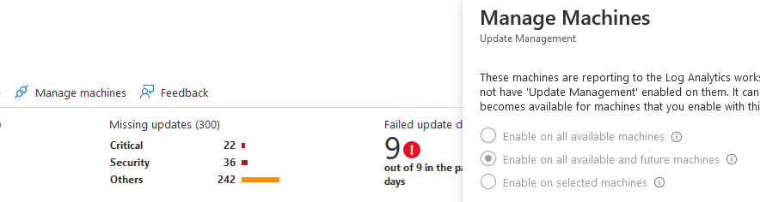

The management blade will list all VMs and their patch status. VMs missing critical patches will be listed first.

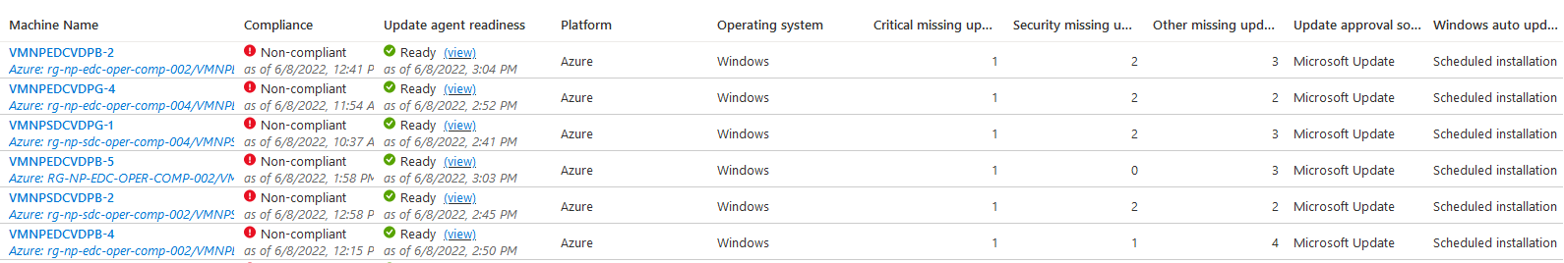

Clicking on the VM name runs a log analytics query that displays the details of the missing patches. The patches can then be manually applied depending on the patching method.

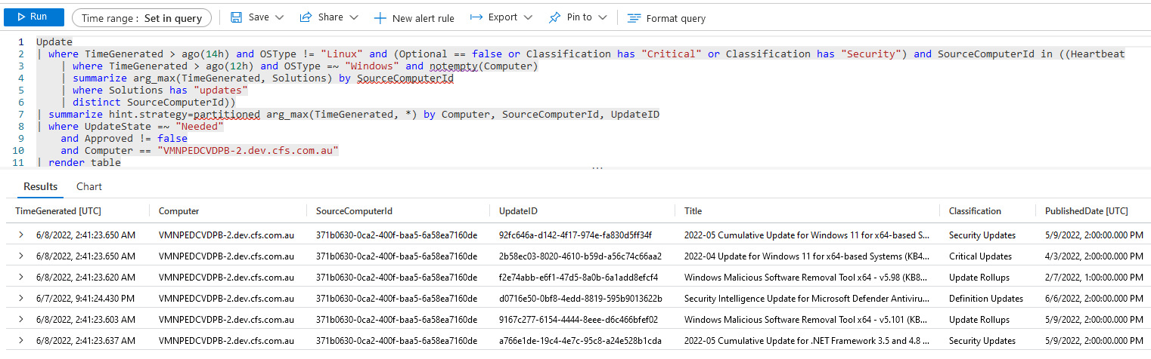

## WSUS

Windows Server Update Services (WSUS) has been deployed in each region of Non-Prod and Prod

|  |  |  |  |  |
| --- | --- | --- | --- | --- |
| Property | Non-Prod | | Prod | |
| **Subscription** | subsc-np-security-001 | subsc-np-security-001 | subsc-prd-security-001 | subsc-prd-security-001 |
| **Resource Group** | rg-np-edc-sec-comp-002 | rg-np-sdc-sec-comp-002 | rg-prd-edc-sec-comp-002 | rg-prd-sdc-sec-comp-002 |
| **VM Name** | VMNPEDCWU001 | VMNPSDCWU001 | VMPRDEDCWU001 | VMPRDSDCWU001 |
| **Subnet** | vnet-np-edc-sec-001  sub-np-edc-security-001 | vnet-np-sdc-sec-001  sub-np-sdc-security-001 | vnet-prd-edc-sec-001  sub-prd-edc-security-001 | vnet-prd-sdc-sec-001  sub-prd-sdc-security-001 |
| **Domain** | dev.cfs.com.au | dev.cfs.com.au | cfs.com.au | cfs.com.au |

Table 7 WSUS VM Details

Each WSUS server automatically downloads Critical, Security and other important updates for each of the supported Microsoft OSes in VDC. Optional updates and major updates like features and service packs are optional and can be installed manually through Microsoft Update. Click on the Check online for updates from Microsoft Update in the Windows Update screen as per below, or download and install manually.

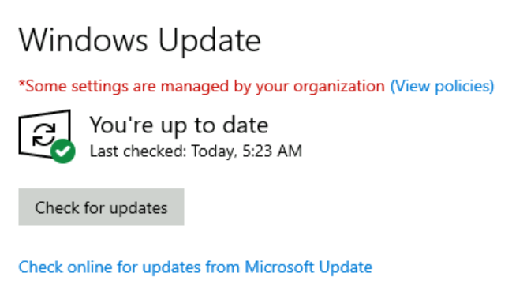

Figure 2 Windows Update on a WSUS connected VM

### GPO Settings

A GPO enforces each domain joined server to automatically install these patches from their regional WSUS server. They are then scheduled a monthly reboot on a rolling basis. This schedule ensures that any services in a high-availability scenario do not reboot at the same time and that in the event a patch needs to be rolled back, there is time to prevent its installation on the paired server.

The GPO itself has three settings under Computer\Policies\Administrative Templates\Windows Components\Windows Update to specify the WSUS policy, plus a WMI filter to ensure the correct location and schedule is applied.

|  |  |  |  |  |
| --- | --- | --- | --- | --- |
| Property | EDC | | SDC | |
| **GPO Name** | WSUS EDC - odd numbers | WSUS EDC - even numbers | WSUS SDC - odd numbers | WSUS SDC - even numbers |
| **Applies to** | Odd Numbers | Even Numbers | Odd Numbers | Even Numbers |
| **Target Day** | 2nd Sunday of the month | 1st Sunday of the month | 2nd Saturday of the month | 1st Saturday of the month |
| **Target VM name example** | VMNPEDCWEB001 | VMNPEDCWEB002 | VMNPSDCWEB001 | VMNPSDCWEB002 |
| **Allow non-administrators to receive update notifications** | Enabled | Enabled | Enabled | Enabled |
| **Configure Automatic Updates** | Enabled | Enabled | Enabled | Enabled |
| Configure automatic updating | 4 - Auto download and schedule the install | 4 - Auto download and schedule the install | 4 - Auto download and schedule the install | 4 - Auto download and schedule the install |
| Install during automatic maintenance | Enabled | Enabled | Enabled | Enabled |
| Scheduled install day | 1 - Every Sunday | 1 - Every Sunday | 7 - Every Saturday | 7 - Every Saturday |
| Scheduled install time | 03:00 | 03:00 | 03:00 | 03:00 |
| Every week | Disabled | Disabled | Disabled | Disabled |
| First week of the month | Disabled | Enabled | Disabled | Enabled |
| Second week of the month | Enabled | Disabled | Enabled | Disabled |
| Third week of the month | Disabled | Disabled | Disabled | Disabled |
| Fourth week of the month | Disabled | Disabled | Disabled | Disabled |
| Install updates for other Microsoft products | Disabled | Disabled | Disabled | Disabled |
| **Specify intranet Microsoft update service location** | Enabled | Enabled | Enabled | Enabled |
| Set the intranet update service for detecting updates: | Prod: http://vmprdedcwu001.cfs.com.au:8530  Non-Prod: http://vmnpedcwu001.dev.cfs.com.au:8530 | Prod: http://vmprdedcwu001.cfs.com.au:8530  Non-Prod: http://vmnpedcwu001.dev.cfs.com.au:8530 | Prod: http://vmprdsdcwu001.cfs.com.au:8530  Non-Prod: http://vmnpsdcwu001.dev.cfs.com.au:8530 | Prod: http://vmprdsdcwu001.cfs.com.au:8530  Non-Prod: http://vmnpsdcwu001.dev.cfs.com.au:8530 |
| Set the intranet statistics server: | Prod: http://vmprdedcwu001.cfs.com.au:8530  Non-Prod: http://vmnpedcwu001.dev.cfs.com.au:8530 | Prod: http://vmprdedcwu001.cfs.com.au:8530  Non-Prod: http://vmnpedcwu001.dev.cfs.com.au:8530 | Prod: http://vmprdsdcwu001.cfs.com.au:8530  Non-Prod: http://vmnpsdcwu001.dev.cfs.com.au:8530 | Prod: http://vmprdsdcwu001.cfs.com.au:8530  Non-Prod: http://vmnpsdcwu001.dev.cfs.com.au:8530 |
| Set the alternate download server: | *<Leave blank>* | *<Leave blank>* | *<Leave blank>* | *<Leave blank>* |
| Download files with no Url in the metadata if alternate download server is set. | Disabled | Disabled | Disabled | Disabled |
| Do not enforce TLS certificate pinning for Windows Update client for detecting updates. | Disabled | Disabled | Disabled | Disabled |
| Select the proxy behavior for Windows Update client for detecting updates | Only use system proxy for detecting updates (default) | Only use system proxy for detecting updates (default) | Only use system proxy for detecting updates (default) | Only use system proxy for detecting updates (default) |
| **WMI Filter** | Select * FROM Win32_ComputerSystem WHERE ((Name LIKE "%1") OR (Name LIKE "%3") OR (Name LIKE "%5") OR (Name LIKE "%7") OR (Name LIKE "%9")) AND ((Name LIKE "%EDC%")) | Select * FROM Win32_ComputerSystem WHERE ((Name LIKE "%2") OR (Name LIKE "%4") OR (Name LIKE "%6") OR (Name LIKE "%8") OR (Name LIKE "%0")) AND ((Name LIKE "%EDC%")) | Select * FROM Win32_ComputerSystem WHERE ((Name LIKE "%1") OR (Name LIKE "%3") OR (Name LIKE "%5") OR (Name LIKE "%7") OR (Name LIKE "%9")) AND ((Name LIKE "%SDC%")) | Select * FROM Win32_ComputerSystem WHERE ((Name LIKE "%2") OR (Name LIKE "%4") OR (Name LIKE "%6") OR (Name LIKE "%8") OR (Name LIKE "%0")) AND ((Name LIKE "%SDC%")) |

Table 8 WSUS GPO Settings

|  |  |
| --- | --- |
|  | ***Important Note***  It should be noted that the timing for reboots is arbitrary and should be coordinated by Operations with other batch processes to ensure no interruption of service. |

All four GPOs are linked at the root of any OU containing server computer objects. The exceptions are domain controllers, which should be patched manually and the AVDs, which are managed by InTune.

Non-Prod Linked OUs:

* DEVCFS\Admin\T0\T0-Servers
* DEVCFS\Servers

Prod Linked OUs:

* CFS\Admin\T0\T0-Servers
* CFS\Servers

### WSUS Settings

WSUS Settings are managed with the WSUS console on each server. Both servers can be managed from the one location by connecting remotely to the other. All WSUS VMs have the same settings but are not synchronised. Changes should be made on each VM separately.

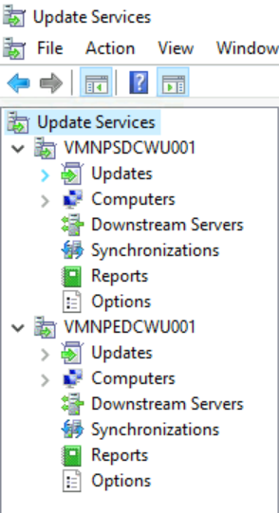

Figure 3 Both Non-Prod WSUS servers managed from a single console

The Updates view shows all available updaters based on what is synchronised according to the Products and Classifications rules.

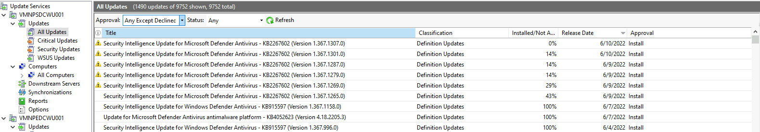

Figure 4 WSUS Updates View

There are various filters and columns to choose from but the one in the view above is probably most useful. It shows all updates sorted by release date with their installation rates across the fleet. While WSUS does have internal reporting capability, the reporting feature of Azure Update Automation is more powerful and useful.

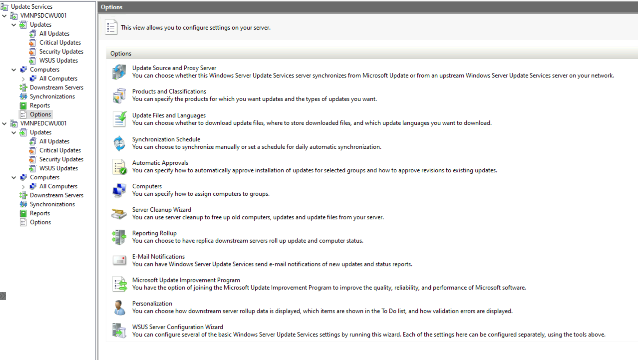

Figure 5 WSUS Options

The various components of the Options pane are explained below:

#### Update Source and Proxy Server

Synchronize from Microsoft Update – this ensures that each WSUS VM is able to download updates independently of the status of the other region.

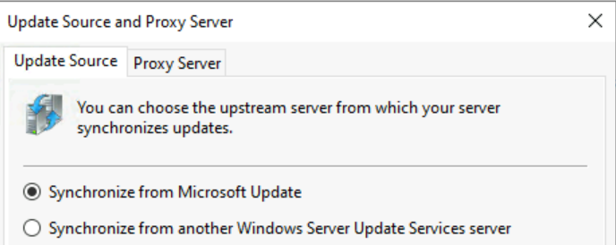

Figure 6 WSUS Update Source

#### Products & Classifications

The list of products is too extensive to list here. The products selected can be summarised as:

* Windows 10 & 11
* Windows Server 2016, 2019 & 2022
* SQL Server 2016, 2017 & 2019
* .Net & Visual Studio
* Assorted utilities

Any other products released into Windows VMs in VDC, including new OS and SQL should be enabled here.

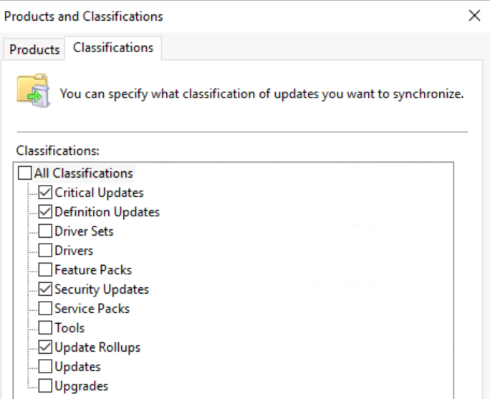

Figure 7 WSUS Patch Classifications

The patch classifications specified are Critical Updates, Definition Updates, Security Updates and Update Rollups. These 4 classifications encompass all the patches and definition updates that encompass everything required to keep products secure. The other classifications include things like Feature Packs and Service Packs that could cause application compatibility issues if installed automatically. These updates are still available through Microsoft Update to be manually installed on individual VMs.

#### Update Files & Languages

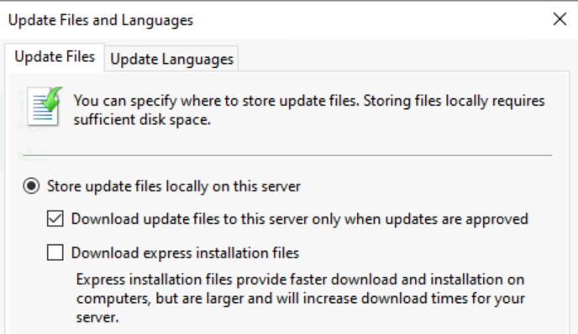

Figure 8 WSUS Update Storage Options

These are the default settings. Updates are only downloaded in English.

#### Synchronization Schedule

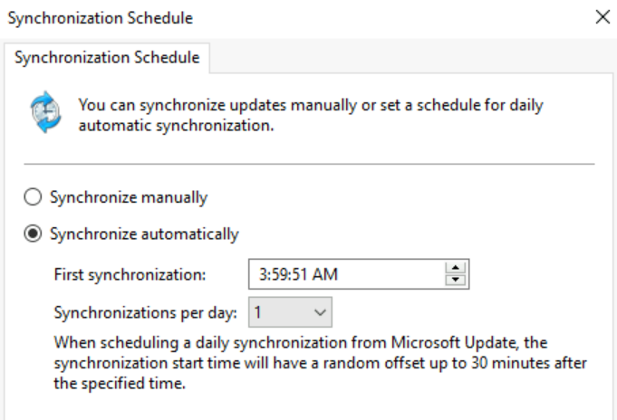

Figure 9 WSUS Synchronization Schedule

The internal database is set to update every night. Delta synchs only take around 5 minutes, so can be scheduled at any time.

#### Automatic Approvals

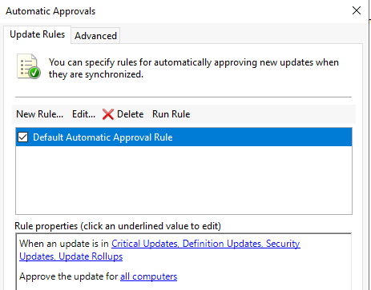

Figure 10 WSUS Automatic Approvals

The selected updated classifications are automatically approved with these settings and will be downloaded as they become available. Ensure the box is ticked next to the rule name so that the rule is active.

#### Computers

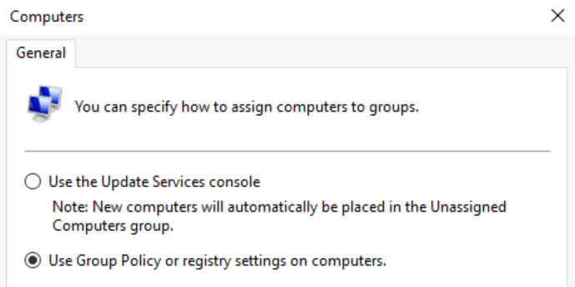

Figure 11 WSUS Computer Assignment Setting

This is a single setting to assign computers via GPO

#### Server Cleanup Wizard

This Wizard can be run periodically to clean up unused patches.

#### Reporting Rollup

This setting is not required as reporting is not used

#### E-mail notifications

Email notifications can be specified if required.

#### Microsoft Update Improvement Program

This setting is disabled

#### Personalization

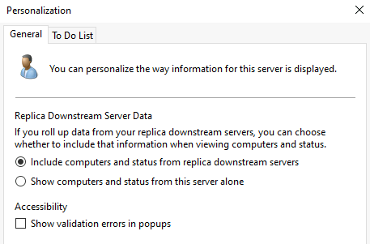

Figure 12 WSUS Personalization Settings

This is set to default values

#### WSUS Server Configuration Wizard

This wizard steps through most of the above settings as per the initial setup.